Fowey Primary School Computing Policy

Policy Agreed:
Policy Review Date:

Contents:

- Curriculum Statement

- Teaching and Learning

- Assessment

- Planning and Resources

- Organisation

- EYFS

- Key Stage 1

- Key Stage 2

- Equal Opportunities

- Inclusion

- Role of the Subject Leader

Curriculum Statement

Intent
At Fowey School, our role when providing this computing curriculum is to prepare pupils with the skills to manage an ever-changing and increasingly technological world.
We aim to provide pupils with the confidence, skills and curiosity to take on computing challenges, develop their own coding programs and to fully understand the digital footprint they leave on the world. We understand that computing is now part of many industries and that pupils must have secure computing knowledge in order to open up as many opportunities as possible in later life. We want to equip pupils with the knowledge and skills to keep themselves safe online and the tools they will need to support them if something makes them feel unsafe.

Teaching and Learning
We implement our curriculum through Purple Mash. This is an online program that supports the teaching of computing in sequential, small steps. Teaching is centred around three key strands of learning: Computer Science, Digital Literacy and Information Technology. Teaching provides regular opportunities for pupils to code and debug, explore networks and databases and create in a variety of different programs using a range of computing devices. Pupils have the opportunity to explore a range of different software throughout their time at Fowey School, building their knowledge of how to use technology in a purposeful way. In addition, they receive regular opportunities to discuss appropriate behaviour online and how to identify and seek support if they feel unsafe.
We at Fowey School, are firm believers that high quality teaching will enable pupils to engage in high quality learning. We therefore ensure that pupils are taught the skills they need to be successful in a series of small steps. These are taught through the use of exploration, trial and error, shared experiences and modelling. Teachers lead pupils to a place of confidence where they feel able to challenge themselves to apply new skills, solve problems and think about alternative approaches.
Each half term pupils explore either one or two units of computing in detail, building on skills they have acquired in previous year groups or terms. Plans are sequential and require learners to put their developing skills into practical use. When revisiting units, pupils demonstrate their understanding before embarking on the next part of their learning journey. This helps to ensure they have the fundamental knowledge and skills needed to be successful in the lesson and that information and skills are retained.

Assessment
We utilise two main assessment tools in computing. Following each session set as a ‘2Do’ on Purple Mash, teachers can mark the work based on the set learning objective, success criteria and National Curriculum objective. The work they produce and their participation within the lesson will inform the teacher’s judgement. This demonstrates pupils’ journeys throughout each unit of work. The folder of work is then used by the teacher to assess each pupil using a ‘below, ‘working towards’, ‘expected’ or ‘greater depth’ judgement which is recorded on INSIGHT (whole school assessment tracker) at the end of each term. This is monitored by the subject leader and the senior leadership team.

Planning and Resources
Computing planning follows the Purple Mash program ensuring that lessons are taught in a sequential system that develops skills and knowledge outlined in the national curriculum over time. Purple Mash units are mapped out across the academic year for Y1-Y6 to ensure there are opportunities for pupils to build upon their current knowledge from previous years and for them to deepen their knowledge through planned, purposeful learning.
Pupils are encouraged to recall and use previous learning whilst learning new knowledge. The progression of knowledge and skills is divided into three main areas of computing: computer science, digital literacy and information technology.
Carefully considered investments are made in hardware including smartboards and desktop computers for Year 5 and Year 6 classrooms as well as a set of Surface Go devices for each year group in Year 3 and 4. Each key stage has allocated devices that are maintained by CELT contractors. We are continually improving and reviewing the use of devices to ensure pupils have the appropriate tools to access their learning.
Furthermore, staff also make use of purchased software including Tapestry, Seesaw, Class Dojo, TT Rockstars, Spelling Shed, Accelerated Reader, OneDrive and eSchools to support teaching and learning and deliver a high quality, well-resourced curriculum.

Organisation
The teaching of computing is split into three key strands: computer science, digital literacy and information technology.
Pupils will develop their understanding of algorithms through coding units. They will learn how to create algorithms, debug programs and develop their logical reasoning skills to make predictions. They will develop an understanding of computer networks including the Internet.
The digital literacy strand of each unit will include learning about how to stay safe online in an increasingly technological world. Pupils will learn how to use the internet safely and respectfully and how to identify and report any concerns they may have. This is explicitly taught in online safety units at the beginning of each academic year but is also weaved into all remaining units taught.
The information technology strand of each unit will develop pupils’ understanding of how to use search engines effectively and acquire an ability to identify reliable, trusted information. They will also use technology purposefully through a range of programs to design, create, present, collect and evaluate information in a range of ways.

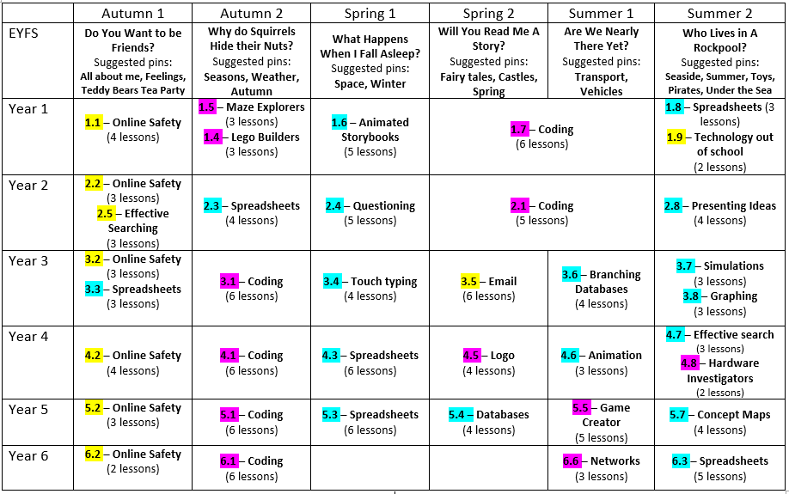

EYFS
EYFS pupils will begin their computing curriculum journey with ‘MiniMash’ which focuses on developing their understanding of the technological world around them. This provides opportunities for children to explore a range of different programs whereby they can problem solve, create and match in an EYFS based environment linking to the characteristics of effective learning. MiniMash provides opportunities for pupils to play and explore online; actively engaging in learning and persevering when finding something difficult. The program also provides opportunities for pupils to create and think critically by developing their own ideas.
‘Pins’ are set for pupils in MiniMash which provide activities linked to their current imaginative learning project. Pupils are encouraged to explore MiniMash within continuous provision in addition to adult led sessions. Furthermore, each pupil has an online ‘tray’ in which they can save their work which in turn is reviewed by the class teacher. Pupils have ample opportunity to explore new technology including audio equipment, iPads, cameras, telephones, computers and keyboards alongside Beebots to develop programming as part of their play and exploration.

Key Stage 1
Throughout key stage 1, pupils develop early skills in computer science, digital literacy and information technology.

Computer Science:
Pupils begin to learn about algorithms and understand what an algorithm is. They will begin to create simple programs and understand how to ‘debug’ using logical reasoning.

Digital Literacy:
Pupils develop an understanding of the common uses of information technology beyond school which is important in this increasingly technological world. They learn how to use technology safely and respectfully, building their understanding why we must keep personal information private and identifying where to go for support when they have concerns about content or contact online.

Information Technology:
Pupils learn how to use technology purposefully to create, organise and retrieve digital content. They begin to present information in different ways when using a range of programs.

Key Stage 2
Throughout key stage 2, pupils continue their computing journey by building on knowledge and skills taught previously; providing opportunity for them to deepen their understanding of computing.

Computer Science:
Pupils develop an understanding of coding by developing detailed and complex algorithms. They learn how to design, write and debug programs that accomplish specific goals. Learners use logical reasoning to explain how simple algorithms work and to detect and correct errors in programming. Pupils develop an understanding of the internet; how multiple services can be accessed through the web and the opportunities offered for communication and collaboration online.

Digital Literacy:
This is a key focus of the computing curriculum. It reinforces the importance of how to stay safe online. It continues to develop the pupils’ knowledge of acceptable and unacceptable behaviour online and how to identify this. Pupils build knowledge in a range of ways and repeatedly consider and recall ways to report any concerns they may have.

Information Technology:
Pupils develop an understanding of how to use search engines effectively; making decisions about the reliability of content online. They select, use and combine a variety of software to design and create a range of programs that accomplish given goals.

Equal Opportunities
At Fowey School equal opportunities for all is central to the curriculum offer. This includes access to high quality, digital equipment and teaching. Pupils have access to key stage specific devices that are maintained by school staff and the IT team. During periods of home learning, those who do not have access to computers are prioritised when laptops are distributed to ensure equality for all. Staff remain aware that for families with few or no devices or for large families where devices may be shared, home learning can be a challenge. This is something we take in to consideration when setting, marking and celebrating homework.

Inclusion
At Fowey School, we believe fully that each pupils is entitled to acquire a confidence in computing skills. This includes ensuring that pupils have access to appropriate software that enable them to engage fully in lessons and develop the skills set out in the school curriculum offer. Class teachers adapt their teaching to meet the needs of all learners in their class, taking consideration of their abilities and needs.

We strive to make computing available and accessible for everyone in our school community. By identifying some of the computing challenges our families face, we constantly consider which barriers we need to try and remove so that pupils can become confident in the digital world and so that parents feel empowered to support their children in this.

Role of the Subject Leader
The leadership of the computing curriculum is the responsibility of the subject leader who:
  - ensures the school has an effective computing curriculum for staff to follow. They ensure staff new to the school, including ECTs understand the computing curriculum and how to deliver it effectively;
  - supports colleagues in their teaching by keeping them informed in current developments in computing primary education;
  - writes a subject action plan, informed by the whole school improvement plan;
  - carries out triangulated monitoring to identify strengths across the school, CPD priorities and inform action planning;
  - delivers and/or sources appropriate training for staff;
  - tracks progress across the school with particular emphasis on identified target pupils;
  - leads planning, preparation and effective execution of national online safety days and/or STEAM events;
  - ensures computing resources required to deliver effective class teaching, are looked after and updated/replaced as necessary.
  - will work with the CELT IT helpdesk team to ensure that Fowey School has computing equipment that is fit for purpose.
  - plays an active role in the Trust Primary computing group and ensures content is disseminated to staff.

Policy Agreed: Policy Review Date:

