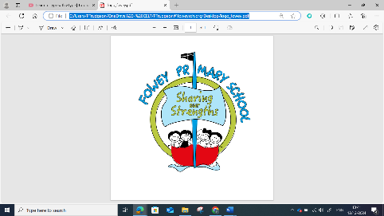
Computing Assessment Year 6
Year 6 Assessment Overview
Children will be understanding of the capabilities of the World Wide web (CS) while searching online (IT).
• They will be developing their understanding of appropriate behaviour online (DL) skills while learning about searching the Internet (IT).
At all times children will be learning about using technology safely and respectfully (DL).
• In most units for all strands, children will be developing their general information technology skills (IT).
• This overlap, repetition and reinforcement helps to give children a deeper understanding of the knowledge and skills across all strands and of their integrated nature in the real-world.
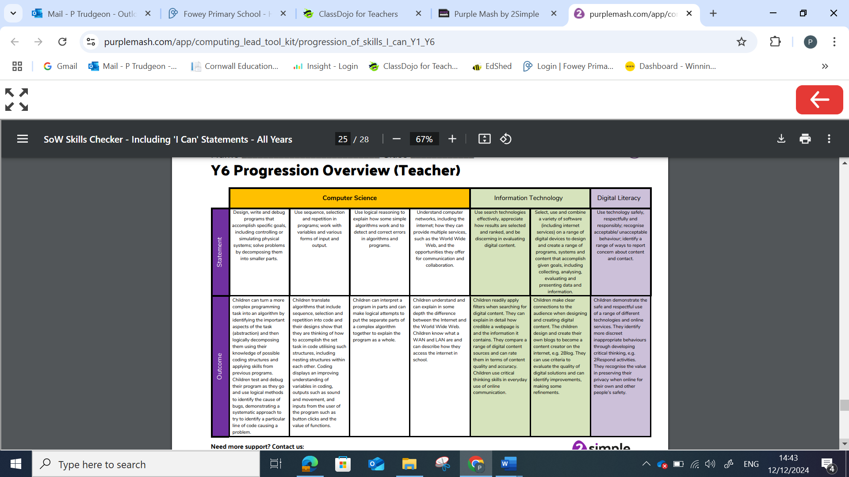

Year 6
Computer Science: | WTS | EXS | GDS
I can turn a complex programming task into an algorithm. (6.1) |  | Rest of class
I can identify the important aspects of a programming task (abstraction). (6.1) |  | Rest of class
I can decompose important aspects of a programming task in a logical way, identifying appropriate coding structures that would work. (6.1) |  | Rest of class
I can test and debug my program as I work on it and use logical methods to identify a cause of a bug. (6.1) |  | Rest of class
I can identify a specific line of code that is causing a problem in my program and attempt a fix. (6.1) |  | Rest of class
I can translate algorithms that include sequence, selection and repetition into code and nest these structures within each other. (6.1) |  | Rest of class
I can use inputs and outputs within my coded programs such as sound, movement and buttons and represent the state of an object (6.1, 6.8) |  | Rest of class
I can interpret (understand) a program in parts and can make logical attempts to put the separate parts together in an algorithm to explain the program as a whole. (6.1) |  | Rest of class
I can explain the difference between the internet and the World Wide Web. (6.6)
I can explain what a WAN and LAN is and describe the process of how access to the internet in school is possible. (6.6)

Year 6
Information Technology: Online Safety 6.2 | WTS | EXS | GDS
I can use filters when searching for digital content. ( 6.2) |  | Rest of class
I can explain in detail how accurate and reliable a webpage and its content is. (knowledge from 6.2) |  | Rest of class
I can compare a range of digital content sources and rate them in terms of content quality and accuracy. (all units) |  | Rest of class
I can consider the intended audience carefully when I design and make digital content. (all units) |  | Rest of class
I can use criteria to evaluate the quality of my own and others digital solutions, suggesting refinements. (all units) |  | Rest of class
 |  | Rest of class

Year 6
Digital Literacy: Online Safety 6.2, Blogging 6.4 | WTS | EXS | GDS
I can demonstrate safe and respectful use of a range of different technologies and online services. (6.2, 6.4) |  | Rest of class
I can identify more discrete inappropriate behaviours online. For example, someone who may be trying to groom me or someone else. (6.2) |  | Rest of class
I can use critical thinking to help me stay safe online. (6.2) |  | Rest of class
I know the value of protecting my privacy and others online. (6.2, 6.4) |  | Rest of class
I can design and create my own online blogs ensuring that my content is appropriate. (6.4) |  | Rest of class
 |  | Rest of class

