Humanities One: What happened before I was born?

What should I already know?  The countries of the UK and the geography of our local area. | Key Experiences  Visit to Restormel Castle  Visit to Pendennis Castle with ‘Now and Then’ workshop  Last Night of the Proms event on the field with families  Re-enactment of The Great Fire of London
Key Vocabulary  Key Term Definition  monarch  king  queen  monarchy  republic  constitutional monarchy  Union Jack  United Kingdom  wattle and daub  motor neurone disease | The UK National Anthem  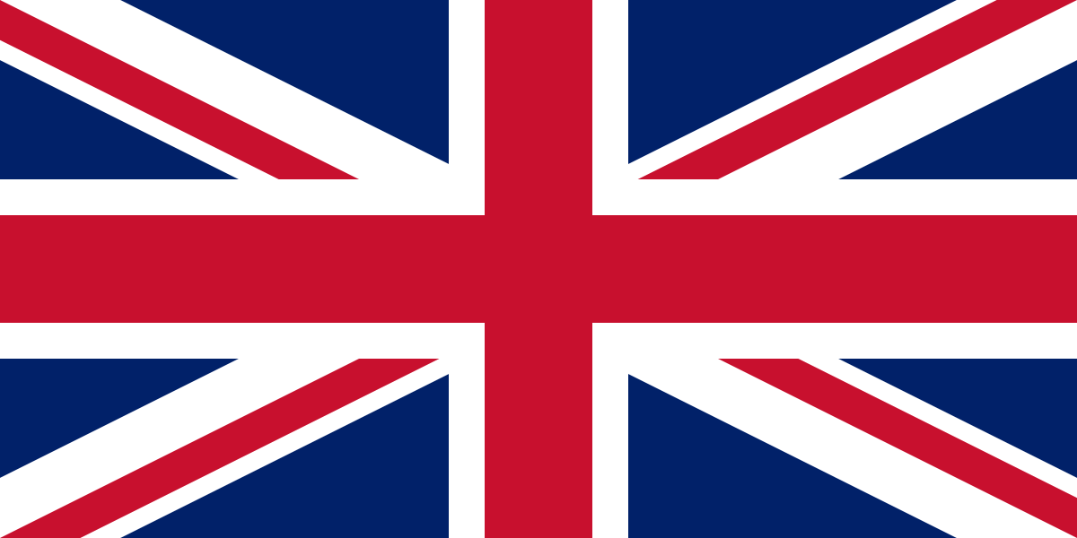  God save our gracious Queen!  Long live our noble Queen!  God save The Queen!  Send her victorious  Happy and glorious  Long to reign over us  God save the Queen!  The Union Jack is the flag of the UK. It is made from elements of three older flags; the red cross of St George for the Kingdom of England, the white saltire of St Andrew for Scotland and the red saltire of St Patrick to represent Ireland. Wales is not represented.
Significant Events which led to change: The Great Fire of London
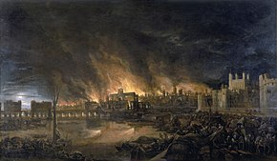
The Great Fire of London started on 2nd September 1666 and lasted just under five days. It was one of the worst disasters in London's history. There were fires in the crowded city every few years but none had caused this much damage.

At 1 a.m. on 2nd September, the fire began in Thomas Farriner's bakery on Pudding Lane. Historians think that a spark from his oven may have fallen onto wood for fuel nearby and caught fire.
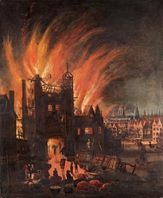
The London summer of 1666 had been very hot with no rain. As a result, the city was very dry, which meant the wooden houses and buildings caught fire extremely easily. In addition, there were many warehouses nearby which were full of flammable materials such as wood and oil. This helped to spread the fire.

Rather than trying to help to put out the flames, many Londoners tried to flee the fire and initially there were no organised firefighters to put out the blaze. There was also a very strong wind which blew the fire from house to house in the narrow London streets.

At first, Londoners tried to put out the fire with buckets of water. They also tried to pull down houses to stop the fire but the fire was spreading so fast it was always ahead of them.

On Tuesday 4th September, gunpowder began to be used to blow up the houses. The wind finally dropped and 'posts' of 130 firefighters were set up around London to help bring the fire under control.
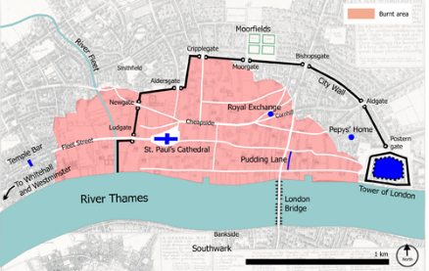
During this time, at least 70,000 people became homeless and about one-third of London was destroyed. Over 90 churches were destroyed, including St Paul's cathedral.

After the fire new building regulations were put into place to stop it happening again. New houses were built in brick rather than wood on wide streets to ensure that such a disaster would never happen again.

Monarchy

England has been a monarchy for over a thousand years. For about 50 years in the 1600’s England was a republic, which meant there was no King or Queen. Since then there has always been one.

A monarchy is a form of government that has a single person known as a monarch at its head. Monarchs use such titles as king, queen, emperor, or empress. Monarchies were once common throughout the world, but now they are rare.

Monarchs generally reign for life. Also, most monarchies are hereditary. This means that when the monarch dies, a son, daughter, or other relative becomes the next monarch. Our Monarch is Queen Elizabeth II. When she dies, Charles II will become our King.

Our monarchy is a kind called a constitutional monarchy. This means that while the Queen is our head of state, the people of the United Kingdom elect a government that run the country, on our behalf.
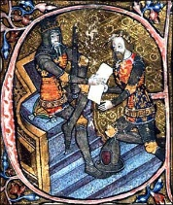
Edward, the Black Prince (1330-1376)
Link to Restormel Castle Visit
- Edward was born on 15 June 1330 at Woodstock in Oxfordshire, the eldest son of Edward III.
- He was given the titles of Prince of Wales and was the first Duke of Cornwall. He owned Restormel castle and lots of the area around Lostwithiel. He visited several times.
- He showed military brilliance at an early age, playing a key role in the defeat of the French army at the Battle of Crecy when he was only 16.
- He died aged 45 and so never became King.

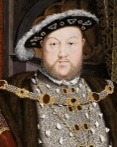
King Henry VIII (1509-1547)
Link to Pendennis Castle Visit
- King Henry VIII had six wives. Most of his wives were not treated well. Two of them were beheaded!
- He wanted to look rich and strong. He had jewels sewn into his clothes and ate the finest foods.
- He also set up the Church of England.
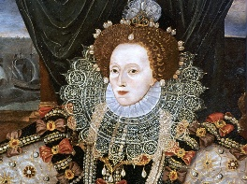
Elizabeth 1 (1558-1603)
- Queen Elizabeth I’s time in power is known as the ‘Elizabethan Age’.
- She ruled England alone. She did not marry. So, although she was queen, England had no king.
- Some people felt only men should be rulers. Elizabeth proved them wrong.

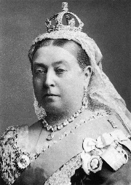
Victoria (1837-1901)
- Queen Victoria was born on 24 May 1819 in Kensington Palace in London, England. Her full name was Alexandrina Victoria.
- Victoria became Queen of England in June 1837, when she was just 18 years old.
- Queen Victoria’s husband was Albert of Saxe-Coburg-Gotha – her first cousin, who she married in February 1840.They had a whopping nine children together.
- Victoria and Albert brought the first Christmas tree to England.
- Albert died in December 1861, when the Queen was 42 years old. The Queen never recovered from his death, and dressed in black as a sign of mourning for the rest of her life.

Queen Elizabeth II (1952- )
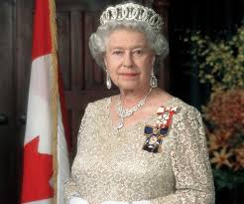
- Our Queen, Queen Elizabeth II is the longest reigning monarch ever. She became Queen in 1952.
- She married Prince Phillip in 1947 and they have four children.
- She is the only person in the UK who is allowed to drive without a licence.
- She has two birthdays!
- The Queen lives at Buckingham Palace in London as well as at Balmoral in Scotland and at Windsor Castle.
- She has lots of corgi dogs and loves horses.

Significant People in History
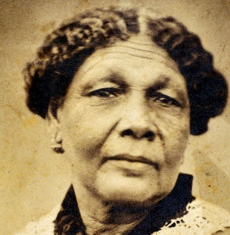
Mary Seacole

Mary Seacole lived more than 150 years ago and had an adventurous life travelling across many lands to run businesses and help people in need. She was born in Kingston, Jamaica.

Her dad was a Scottish soldier and her mum was Jamaican, so Mary was mixed race. Mary's mum ran a hotel where wounded soldiers sometimes stayed. She taught Mary how to use plants to help care for them.

At that time a disease called cholera spread across Kingston. Mary helped those who were sick. Cholera was a terrible disease. When Britain sent soldiers to war in Crimea, disease was more dangerous than the enemy. Thousands of soldiers died from it. Because Mary knew how to treat cholera she wanted to go to Crimea as a nurse, but she wasn't chosen. Mary went anyway, using her own money to pay for her journey.

When she reached Crimea, she set up a hotel right on the battlefront.

She sold hot meals and looked after wounded and sick soldiers. But helping the soldiers cost so much money that when the war ended Mary was very poor. To pay her debts, she wrote a book called ‘The Wonderful Adventures of Mrs Seacole in Many Lands’.

After she died, people forgot Mary Seacole, but we remember her today as a woman of mixed race who lived an exciting and unusual life. She owned a business, travelled to many places and went to a war zone, bravely helping others.

Professor Steven Hawkins
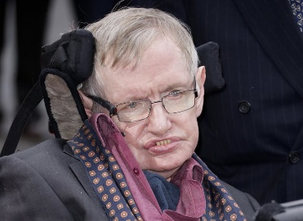
In the 20th century, Professor Stephen Hawking made a huge difference to the world by solving some of the biggest mysteries of the universe and helping ordinary people to understand science.

Born in 1942, Stephen was clever, curious and loved mathematics!

He studied and worked at two of the world's most famous universities, Oxford and Cambridge. He said his goal was to have a complete understanding of the Universe.

But when he was 21, Stephen’s body developed a disease. His brain stopped sending messages to his body properly. He was told he only had two years to live. Nevertheless, he carried on with his work. After a few years, he couldn't walk or talk and needed a special wheelchair. But he had lived longer than anyone expected. Over 50 years longer!

To help ordinary people understand science, Stephen published a book called A Brief History Of Time in 1998. Then in 2007, he wrote a book for children.

Despite his disease, Stephen had a great sense of fun and was determined to do as much as he could. He had three children, wrote 15 books and even flew like an astronaut!

Stephen Hawking died, aged 76 in 2018.

He said, "Remember to look up at the sky, and not down at your feet. However difficult life may seem, there is always something you can do and succeed at. It matters that you don't give up". Because Stephen didn't give up, we can all understand more about the Universe!

