Humanities Three: What did the Romans bring to Britain?
What should I already know?  Monarchy and notable kings/queens including Elizabeth I , UK history including London as capital city and countries of the UK  Notable people in history (explorers Francis Drake and Christopher Columbus, Professor Stephen Hawkins and Mary Seacole). The Great Fire of London.  Stone Age, Iron Age and Bronze Age. Study of Maya and Indus Valley people. | Key Experiences  Overnight visit to Bath (visit to the Roman Baths and schools workshop, visit to Bristol Museum and workshop)  Visit to Truro Museum- Life at Magor Villa workshop
Key Vocabulary  Key Term Definition  archaeologist someone who studies the past by exploring old remains  artefact an object from the past that shows evidence of what life was like  emperor somebody who rules an empire or is the head of state in an empire  empire a number of individual nations that are all controlled by the government or ruler of one particular country  fortress a castle or other large strong building, or a well-protected place, which is intended to be difficult for enemies to enter influence to have an effect on  infrastructure the basic facilities such as transport, communications, power supplies, and buildings, which enable a place to work  invasion to try and take over a place by force  Jutes people from the Jutland peninsula (Germany and Southern Denmark) who invaded Britain around AD 410  legacy a direct result of something in history and which continues to exist after it is over  nation all the people who live in a particular country  Picts ancient tribes who lived in northern Scotland province a large section of a country  Queen Boudica leader of the Iceni tribe who led a rebellion against the Roman invasion  raid . a sudden armed attack against a place  rebellion fighting back and opposing the people who have attacked you  Roman related to or connected with ancient Rome and its empire  Scots people from Ireland who eventually settled in Scotland  settler/ settlement people who migrate to a new place. When people start a community, this is a settlement. | Timeline of Key Events  55-54: BC Julius Caesar first invades Britain  27 BC: Augustus becomes the first elected emperor  AD 43: The Romans conquer Britain (marking the end of the Iron Age)  AD 44: The Romans capture Colchester. It is the first fortress in Roman Britain.  AD 80: Pompeii was destroyed by the volcano, Vesuvius.  AD 100: London grows to become an important location in Britain. At the same time, the Colosseum, in Rome, was completed.  AD 122: Hadrian’s Wall is built to protect against the raiding Northern tribes, the Picts.  AD 212: Roman Britain- a plan was created to rule Britain. It is divided into two provinces.  AD 250: Picts from Scotland, Scots from Ireland, Angles, Saxons and Jutes from Germany and Scandinavia begin to threaten the Romans in Britain.  AD 314: Christianity becomes legal in the Roman Empire.  AD 410: Romans leave Britain to defend Rome which was under attack. Angles, Saxons and Jutes make their way from Germany and South Denmark.
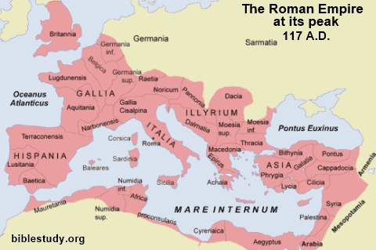
Key Facts

The Romans in Britain

The Romans originated in the city of Rome in modern-day Italy. However, the Romans ruled countries across the globe - including Great Britain - which was called the Roman Empire.

The Empire had a huge effect on the language, culture and history of countries in Europe, the Middle East and even Northern Africa. Ancient Rome had a huge impact on many areas of contemporary life, such as engineering and government, and they ruled for nearly 1000 years.

As the city of Rome grew in power, it began to invade other areas of the world. By AD 117, the Roman Empire included North Africa, most of modern-day Europe, Great Britain (as far as Scotland) and many of the lands in the Middle East.

Roman leader Julius Caesar was the first to attempt an invasion of Britain. His first attempt was 55 BC but this failed. A second attempt in 54 BC established trading links with the Celtic tribes who lived in Britain.

In AD 43, Emperor Claudius was successful in conquering much of Britain. Some Celtic tribes were able to retain their kingdoms but had to obey Roman laws and pay money (a tribute) to Rome.
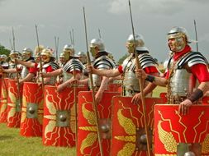
Much of Rome’s strength lay in its army. The Roman Army was divided into groups known as legions, with around 5,000 soldiers in each. A legion was split into groups of 80 soldiers. These groups were called ‘centuries’ and were ruled by a man known as a ‘centurion’.

The Roman army had the most advanced equipment at that time. They used huge catapults that could fling rocks to knock down city walls and cross bows that could throw arrows that were as big as spears.

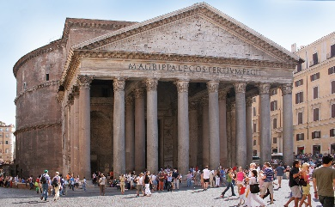
At first, the Romans worshipped a number of gods and goddesses, each of whom represented different elements of Roman life. Jupiter was the king of the gods; Juno was the queen of the gods; Mars was the god of war; and Venus was the goddess of love. These gods were the same as the gods the Ancient Greeks worshipped, just with Roman names: Jupiter was Zeus, Juno was Hero, Mars was Ares and Venus was Aphrodite.

Romans worshipped in temples. Most temples were dedicated to one god. A temple where all the gods were worshipped was known as a pantheon.

Roman society was divided into citizens, non-citizens and slaves. Citizens had made rights, including the right to vote (although only male citizens had this right) and the right to a fair trial. Unless they were found guilty of treason, citizens could not be sentenced to death.

Latin was the main language of the Roman Empire.

Women, whether citizen or not, had very few rights in Rome. They received a very basic education and were expected to take a traditional role in the household, preparing and cooking meals, making clothes and raising children. They lived under the authority of their father or husband at all times.

Poor Romans in towns and cities lived in apartment-style buildings called ‘insulae’. Rich Romans in towns and cities lived in houses called a ‘domus’; those in the countryside lived in villas.

Poor Romans ate meals consisting mainly of vegetables and porridge. Rich Romans enjoyed food such as dormice, wild boar and venison. At dinner parties, Romans ate lying down on couches. They mainly ate with their fingers.
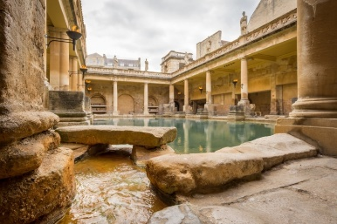
The Romans enjoyed watching chariot races at a stadium. A Roman stadium was a long rectangular course with curves at both ends. The Circus Maximum in Rome is a stadium that seated 150,000 spectators. Slaves fought as gladiators in amphitheatres such as the Colosseum in Rome. Each town or city would have a complex of public baths, known as the ‘thermae’, where Romans would go to keep clean.

Queen Boudicca

We don't know much about Boudicca, because she lived many years ago. And only two people, called Tacitus and Dio, wrote about her at the time, but their stories were very different. Her name comes from the word 'Bouda'. This means victory.

There are no pictures of Boudicca, so we don’t know what she looked like. Tacitus said she had long red hair that hung below her waist.

Boudicca was married to Prasutagus, the King of the Iceni in Eastern England. Back then, parts of Britain were ruled by the Roman Empire. Prasutagus trusted the Romans and promised to leave half his land to them and half to Boudicca. But when he died, the Romans took everything and were very cruel to Boudicca and her two daughters.

In the year 60, Boudicca fought to take back her land.

The Roman army was fighting in North Wales, too far away to save the Roman towns that Boudicca's army attacked. Her army destroyed the towns of St Albans, Colchester and London and killed thousands of people. Boudicca’s soldiers painted themselves blue to make themselves look more frightening! But when the Roman army returned, it tricked Boudicca's army into a narrow valley, where it was trapped and beaten. This was called the Battle of Watling Street, and afterwards, Rome ruled most of Britain for 350 years.

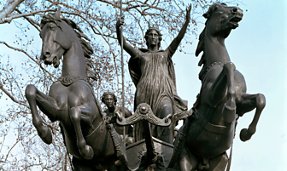
Nobody knows for sure how Boudicca died. But archaeologists - scientists who dig up buried objects from the past - have found things that help us understand her story, like the burnt soil in Colchester, where she destroyed the city.

Outside the Houses of Parliament in London, there is a statue of Boudicca. It reminds us that she was brave and fierce, and refused to be ruled by another country!

