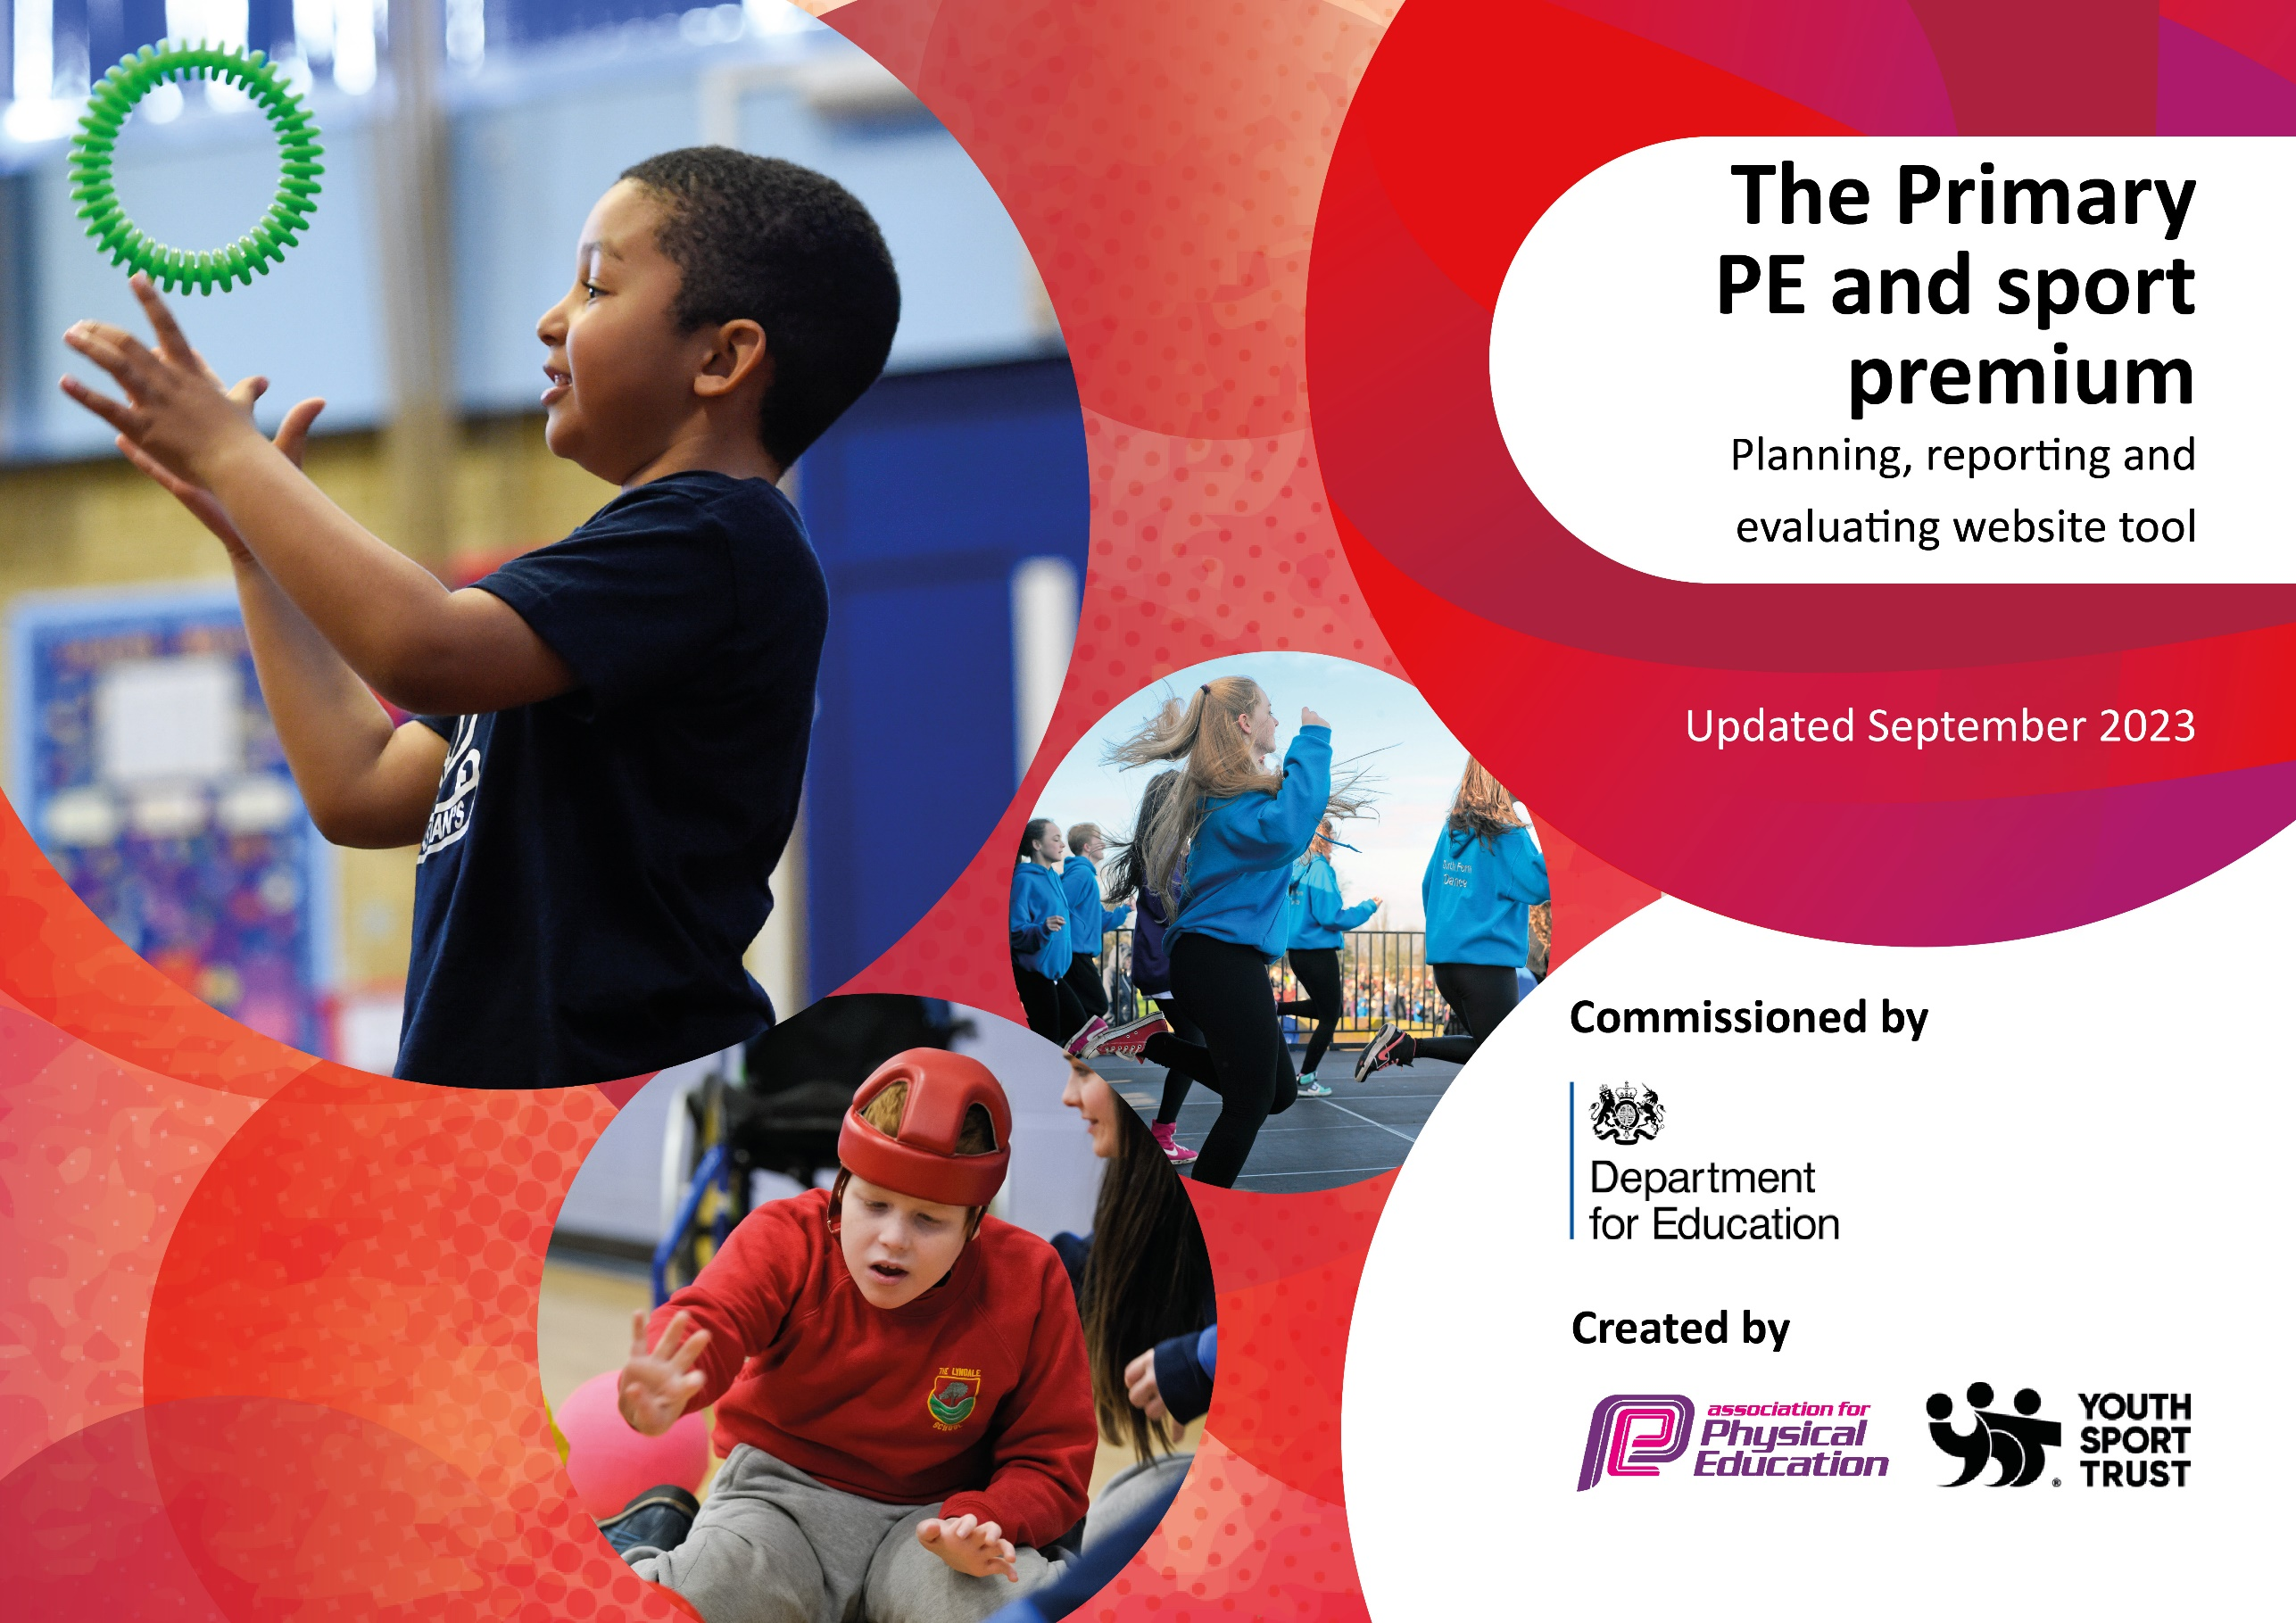

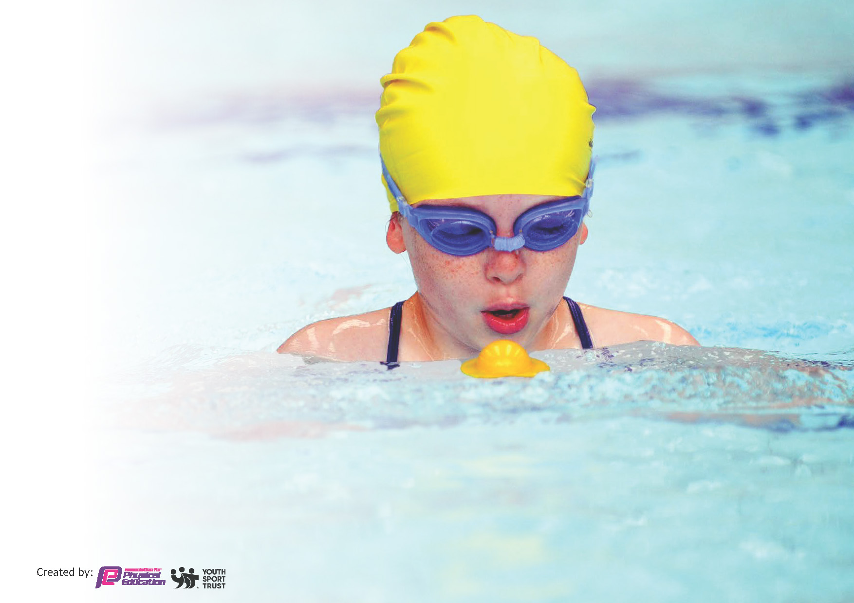
This template can be used for multiple purposes:
by:
- It enables schools to effectively plan their use of the Primary PE and sport premium
- It helps schools to meet the requirements (as set out in guidance) to publish information on their Primary PE and sport premium
- It will be an effective document to support Ofsted inspections enabling schools to evidence progress in Physical Education (PE) and evidence swimming attainment, which forms part of the PE National Curriculum. We would recommend schools consider
the Intent, Implementation and Impact of any spend, as examined within the Education Inspection Framework.

It is important that your grant is used effectively and based on school need.

Schools must use the funding to make additional and sustainable
improvements to the quality of the PE, School Sport and Physical Activity (PESSPA)
they offer. This means that you should use the Primary PE and sport premium to:

- Build capacity and capability within the school to ensure that improvements made now will benefit pupils joining the school in future years
- Develop or add to the PESSPA activities that your school already offers.

The Primary PE and sport premium should not be used to fund capital spend projects; the school’s core budget should fund these. Further detail on capital expenditure can be found in the updated Primary PE and sport premium guidance.

The Primary PE and sport premium guidance, outlines 5 key priorities that funding should be used towards. It is not

necessary that spending has to meet all the key priorities, you should select the priorities that you aim to use any funding towards.

Although completing this template is not a requirement for schools, schools are required to publish details of how they spend this funding. Schools must also outline what the impact this funding has had on pupils’ PE and sport participation and attainment and how any spending will be sustainable in the future. All funding must be spent by 31st July 2024.

The Department for Education has worked closely with the Association for Physical Education (afPE) and the Youth Sport Trust (YST) to develop this template and encourages schools to use it. This template is an effective way of meeting the reporting requirements of the Primary PE and sport premium.
Review of last year’s spend and key achievements (2022/2023)

We recommend you start by reflecting on the impact of current provision and reviewing your previous spend.

Activity/Action | Impact | Comments
Key indicator 1: Increased confidence, knowledge and skills of all staff in teaching PE and Sport.  Develop PE through the use of Striver Scheme to support delivery.  Whole School Assessment for pupils in KS1 and KS2 were sed for the second year with the initial support from Go Active. Following no appointment of a HLTA, teachers were asked to carry out the assessments themselves with Go Active lead support. | Planning and delivery ensures progression and allows children to follow a curriculum that teaches them skills which build each year.  Teachers have expressed greater confidence in teaching PE and knowledge of sports/ activities that can be carried forward in teaching.  Teachers found it challenging to carry out their own assessments at the end of each half term/unit. Moving forward, Go Active lead will carry out these assessments with the support of the class teacher. | Following a review of the Striver scheme and recommendations from other schools, Fowey will be adopting a new scheme for the 2024-25 academic year – Get Set 4 PE.

Key priorities and Planning
This planning template will allow schools to accurately plan their spending.

Action – what are you planning to do | Who does this action impact? | Key indicator to meet | Impacts and how sustainability will be achieved? | Cost linked to the action
Ensure children have the opportunity for leadership within PE lessons and during break and lunch times.  Introduce active lunchtime games led by Play leaders and Duty Staff with PE Lead/Go Active to oversee.  Continue to use Play Leaders to promote physical activity during lunchtimes: This will also develop Play Leader’s knowledge and ability to lead physical activities.  Train Duty staff to support with this. Ensure that less active pupils are taking part in regular physical activity through intervention and sporting events with PSSP. Ensure that Pupil Premium pupils are given the opportunity to take part in extracurricular sporting activities and encouraged to attend after school sports clubs. | Year 5/6 pupils to run small games for KS1 children during their lunchbreak. Play leaders placed on infant and junior playground at lunch and break times, running games and small group activities.  Go Active to set up other side of playground with activities children can access independently. Sport to change each half term.  Go Active to provide training for Y5/6 Play Leaders to promote physical activity during playtimes across the school. PE lead to provide training for Duty Staff to help oversee this. Resources and Y5/6 Play Leaders on infant playground to promote physical activity – supervising staff to support Play Leaders and engage with pupils (monitored regularly).  Targeted clubs and events for children who do not participate in any physical activity (also part of pupil premium planning this year). Y6 Sports leaders to support Sporting events such as Sports Day and Charity sports events. Celebrate school sport through website and newsletters. | Key Indicator 3  The profile of PE and sport is raised across the school as a tool for whole school improvement. | Year 5/6 Sports leaders to become able to plan, set up and lead small physical activities, developing their knowledge and understanding towards the teaching and coaching of PE.  Teachers to gain a better understanding of their pupils ability and skill.  PE lead to also gain a better understanding of where intervention and support may be needed | Sports Leader  training- Go Active  training £400  New resources: £650

Deliver exciting PE lessons that are well sequenced and build on knowledge and skills over time.  All staff increase confidence in teaching Striver PE lessons Pupils to have a range of active play and lunchtime activities to choose from  Ensure that Pupil Premium pupils are given first options/opportunity to take part in extracurricular sporting activities and encouraged to attend afterschool sports clubs.  Provide additional coaches for swimming sessions to support Year 5 and 6 learners | Develop the use of PE scheme lesson sequences that build on knowledge and skills.  PE Lead to give further training to teaching and support staff to support high quality PE lessons. The scheme also provides opportunities for teachers to develop their subject knowledge through teaching videos and lesson plans.  With the support of Go Active to lead on the delivery of numerous sporting activities including lessons and after school clubs.  Go Active to train Sports Leaders for lunchtime Club provision  Work with local secondary school to enter local primary sport festivals  Subscribe to Fowey Sports Partnership to engage in a range of competitive and non competitive sporting events/sporting festivals  Organise and take part in year football fixtures and netball fixtures- part of SADFANA District Football and Netball League. | Key indicator 2  Engagement of all pupils in regular physical activity. | Teachers and support staff will have a clear understanding of what they need to teach within their year group as well as understanding what the children have already.  Questionnaire to children to monitor engagement and enjoyment – Spring 2024  Tracker document to be continued to monitor who is attend clubs and identify where intervention or support may be needed.  Go Active specialist teachers will be working during afternoons to support teachers in lessons and expertise in sport will be shared with teachers to support planning.  Increased numbers of pupils participating in competitive opportunities within school Increased numbers of pupils participating in competitive opportunities against other schools.  Pupils choose to partake in sporting/active games at play and lunch times. | Striver Scheme PE- £350  Resources for new scheme  £2750  Training and support:  £1000  Go Active £7885  Mid- Cornwall Sports  Partnership (Fowey) £200  Swimming coaching provision  £1240  Fixtures transport- £1200
Variety of sporting clubs available to all children with support of Go Active to offer ‘non traditional’ sporting alternatives including sailing.  PE curriculum and extra curricular for school to be progressive and offering a range of sports and activities to benefit all children’s development.  Encourage PP children to attend a sports club every half term and support parents with this If needed. | Sailing opportunities provided for Year 6 and links established with Fowey Gallants- local community.  (Further grants secured to increase number of year groups engaging in sailing activities – Pro Bleu)  Club timetable produced and offered to all children termly. This to include a range of sport e.g. football, netball, dodgeball, Athletics, rugby…)  Change4 life cards and resource boxes available to support activity ideas and engagement.  Zoning of playground to allocated sports and activities. If PP pupils are not attending a club, speak with parents and encourage them to do so. Offer transport, equipment etc to enable this to happen where possible. | Key indicator 4  Broader experience of a range of sports and activities offered to all pupils. | Children will talk positively about the range of activities on offer at the school and develop physical skills in sports they enjoy most.  Staff will have a clear understanding of the PE curriculum. Children will be able to discuss what they have learned in previous years and know where their learning journey is heading.  Teachers encouraged to offer clubs and will use the skills and confidence gained in PE subject/Striver PE training to run these. Positive habits grown to encourage continued engagement. | £2005  Go Active  after school provision

Key achievements 2023-2024
This template will be completed at the end of the academic year and will showcase the key achievements schools have made with their Primary PE and sport premium spending.

Activity/Action | Impact | Comments
Support swimming through deployment of additional swimming teachers.  Following a review of the Striver PE scheme and resources, new Get Set 4 PE scheme will be introduced and developed for 2024-25 with the relevant resources already purchased.  Employment of specialist Go Active coaches to engage learners in alternative sports provision and extra curricular activities.  Develop the range of sporting activities offered by the school to include sailing and developing strong links with our local area and nearby clubs | High percentage of children able to swim 25m by the end of Year 6 (93%)  High quality PE sessions delivered with appropriate resources. New resources to support the new scheme have helped to engage children with the activities. Teaching and support staff who have previously lacked confidence with the Striver scheme have reported increased confidence and therefore the quality of their delivery. The resources available for the start and the end of  the lessons have increased the pupils’ understanding as well as their ability to retain information they’ve been taught.  Children expressed their enjoyment of the alternative sailing provision. The school was able to secure further funding to enable more pupils from Years 4 and 5 to access sailing. As a result, children have also signed up to attend clubs outside of school as well.  Upleveling Teacher/LSA skills through coaching support. Sports Days led by Playleaders to improve offer/experience for our younger pupils. Playleaders understanding on leading activities and ability to do so improved. | Continue with this for next academic year

Swimming Data
Meeting National Curriculum requirements for swimming and water safety.
Priority should always be given to ensuring that pupils can perform safe self-rescue even if they do not fully meet the first two requirements of the National Curriculum programme of study

Question | Stats: | Further context  Relative to local challenges
What percentage of your current Year 6 cohort can swim competently, confidently and proficiently over a distance of at least 25 metres? | 93% | 1 child with a range significant special educational needs.
What percentage of your current Year 6 cohort can use a range of strokes effectively [for example, front crawl, backstroke, and breaststroke]? | 89%

What percentage of your current Year 6 cohort are able to perform safe self-rescue in different water-based situations? | 89% | .
If your schools swimming data is below national expectation, you can choose to use the Primary PE and sport premium to provide additional top-up sessions for those pupils that did not meet National Curriculum  requirements after the completion of core lessons. Have you done this? | Yes/No | Additional specialist swim teachers employed to support learners.
Have you provided CPD to improve the knowledge and confidence of staff to be able to teach swimming and water safety? | Yes/No | See above

Signed off by:

Head Teacher: | Liz Measom
Subject Leader or the individual responsible for the Primary PE and sport premium: | Alfie Havenhand
Governor: | RIG
Date: | 25-07-2024

