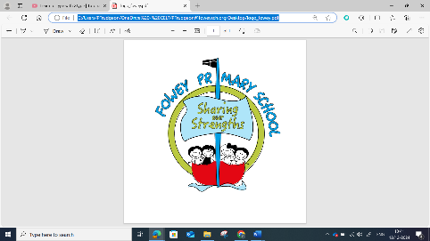
Computing Assessment Year 5
Year 5 Assessment Overview
Children will be understanding of the capabilities of the World Wide web (CS) while searching online (IT).
• They will be developing their understanding of appropriate behaviour online (DL) skills while learning about searching the Internet (IT).
At all times children will be learning about using technology safely and respectfully (DL).
• In most units for all strands, children will be developing their general information technology skills (IT).
• This overlap, repetition and reinforcement helps to give children a deeper understanding of the knowledge and skills across all strands and of their integrated nature in the real-world.
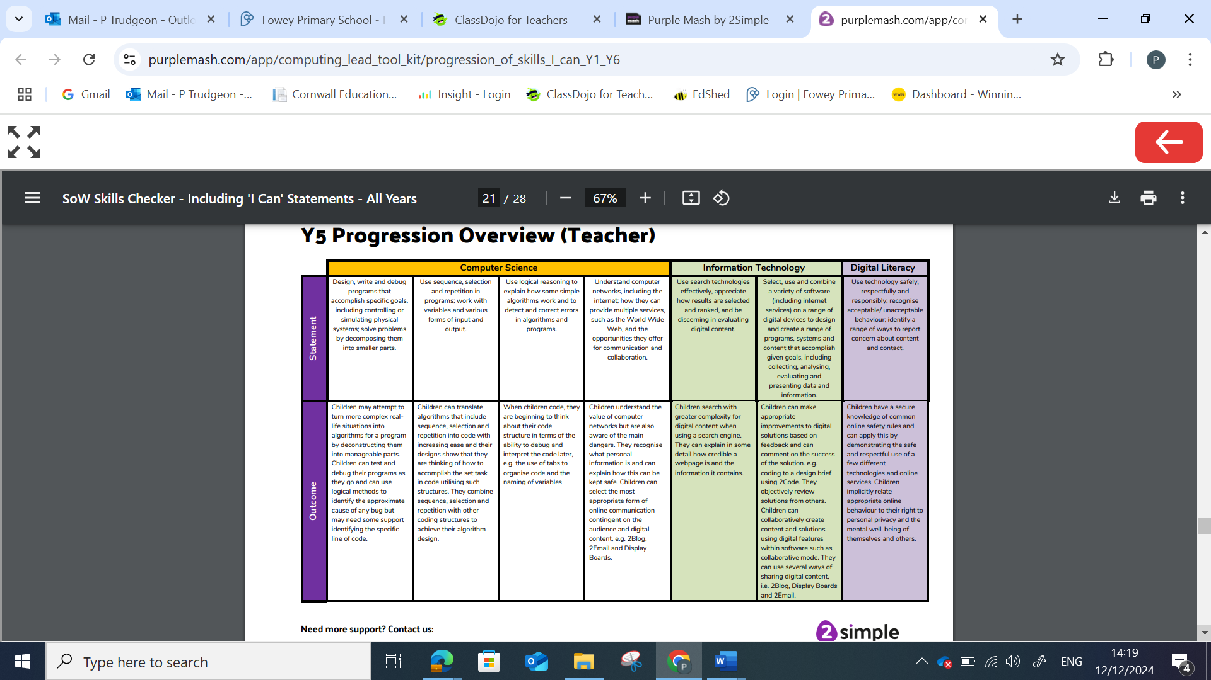

Year 5
Computer Science: Coding 5.1, Game Creator 5.5 | WTS | EXS | GDS
I can make more complex real-life problems into algorithms for a program. (5.1) |  | Rest of class
I can test and debug my programs as I work. (5.1, 5.5) |  | Rest of class
I can convert (translate) algorithms that contain sequence, selection and repetition into code that works. (5.1) |  | Rest of class
I can use sequence, selection, repetition, and some other coding structures in my code. (5.1) |  | Rest of class
I can organise my code carefully, for example, by naming variables and using tabs. I know this will help me debug more efficiently. (5.1) |  | Rest of class
I can use logical methods to identify the cause of any bug with support to identify the specific line of code. (5.1) |  | Rest of class
 |  | Rest of class
 |  | Rest of class

Year 5
Information Technology: Spreadsheets 5.3, Databases 5.4, 3D modelling 5.6, Concept Maps 5.7 | WTS | EXS | GDS
I can make appropriate improvements to the digital work I have created. (Across units) |  | Rest of class
I can comment on how successful a digital solution is that I have created. For example, a program built in 2Code that sorts decimals numbers. (Across units) |  | Rest of class
I can work collaboratively with others creating solutions to problems using appropriate software such as 2Code. (Across units) |  | Rest of class
I can use collaborative modes such as within 2Connect to work with others and share it. (5.7) |  | Rest of class
I can search precisely when using a search engine. For example, I know I can add additional words or remove words to help find better results. (5.2) |  | Rest of class
I can explain in detail how accurate, safe and reliable the content is on a webpage. (5.2) |  | Rest of class
I know the importance of computer networks and how they help solve problems and enhance communication. (5.2) |  | Rest of class

Year 5
Digital Literacy: Online Safety 5.2 (and across units) | WTS | EXS | GDS
I recognise the main dangers that can be perpetuated via computer networks. (5.2) |  | Rest of class
I can explain what personal information is and know strategies for keeping this safe. (5.2) |  | Rest of class
I can use the most appropriate form of online communication according to the digital content. For example, use 2Email, 2Blog and Display Boards. (5.2 & others) |  | Rest of class
I have a clear knowledge of online safety rules taught at school. (5.2 & across units) |  | Rest of class
I can demonstrate the safe and respectful use of different online technologies and online services. (5.2 & across units) |  | Rest of class
I always relate appropriate online behaviour to my right to have personal privacy. (5.2 & across units) |  | Rest of class
I know how to not let my mental well-being or others be affected by the use of online technologies and services. (5.2 & across units) |  | Rest of class

