Year 6
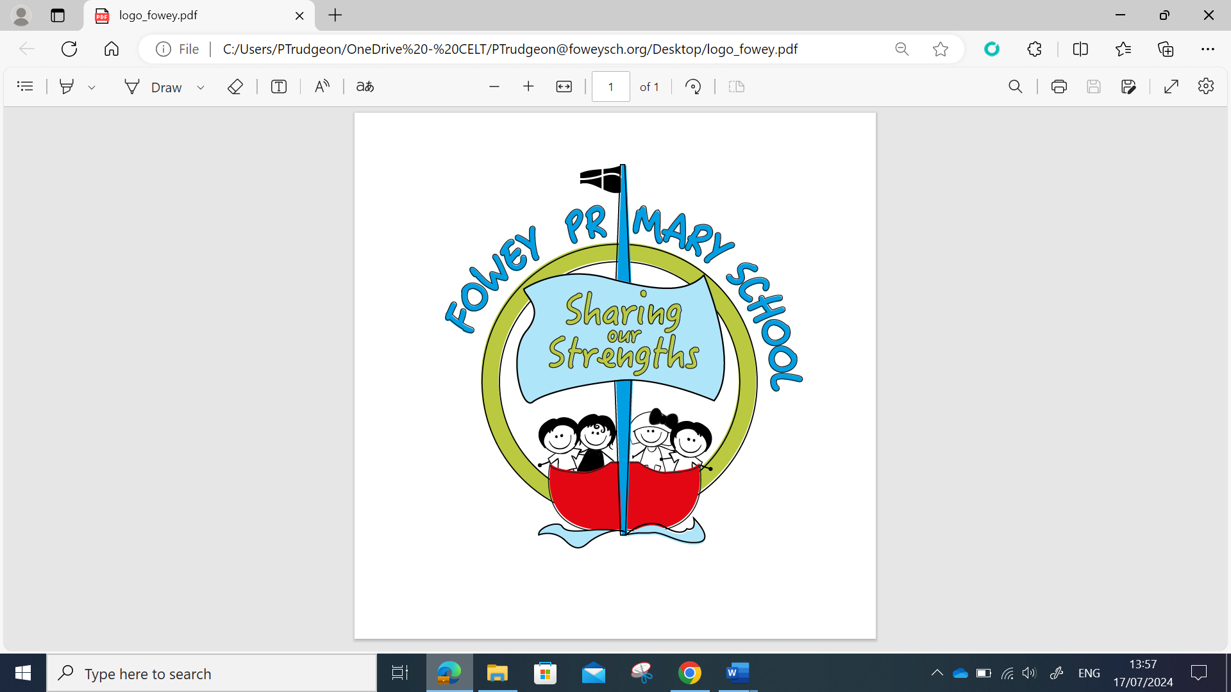 | Year 6 Autumn MTP
 | Wk 1 | Wk 2 | Wk 3 | Wk 4 | Wk 5 | Wk 6 | Wk 7 | Wk 8 | Wk 9 | Wk 10 | Wk 11 | Wk 12
Grammar and Punctuation | Ready to Write  Relative Clauses | Modal Verbs | Adverbs | Parenthesis  Expanded Noun Phrases | Commas | Present tense  Past tense | Synonyms and Antonyms | Word Classes | Word Classes | Word Classes | Subjunctive form  Assessment | Subjunctive form
Alan Peat  Sentences | Revisit sentence types  Tell: 3 examples sentences De:de sentences Tell: show three examples; sentences |  |  |  |  |  |  | Some; others sentence
Spelling  Spelling Shed | Week 1: Challenge Words  Week 2: Challenge Words  Week 3: Challenge Words |  |  | Week 4: Challenge Words  Week 5: Challenge Words  Week 6: Challenge Words |  |  | Week 7: Challenge Words  Week 8: Challenge Words  Week 9: Challenge Words |  |  | Week 10: Challenge Words  Week 11: Words with the short vowel sound  /i/ spelled ‘y’  Week 12: Words with the long vowel sound  /igh/ spelled ‘y’
Handwriting | The Ladder family |  |  |  |  |  | Assess and Review | The One Armed Robot Family |  |  |  | Practice and Review
Reading text  VIPERS Foci | Goodnight Mr Tom | Goodnight Mr Tom | Goodnight Mr Tom | Goodnight Mr Tom | Goodnight Mr Tom | Goodnight Mr Tom | Pig Heart Boy | Pig Heart Boy | Pig Heart Boy | Pig Heart Boy | Pig Heart Boy | Pig Heart Boy
Writing Sequence | Eye of the Storm  (Skills based unit)  (Narrative setting)  Flashback - Dialogue |  |  |  | Piano/Beyond the lines  (Letter writing) |  |  |  |  | The Christmas Truce (Lit Shed- John Lewis)  (Narrative Flashback)
Writing Outcomes | Can I understand the rules of spelling in Year 6?  Can I identify and define word classes within a passage?  Can I use expanded noun phrases?  Can I create a character description?  Can I use semicolons to mark the boundaries between independent clauses?  Can I use a wide range of devices to build cohesion within and across paragraphs?  Can I create a ship’s log of events?  Can I understand and use figurative language?  Can I use personification and pathetic fallacy within a setting description?  Can I plan by noting and developing initial ideas?  Can I create a sci-fi/fantasy narrative?  Can I edit my writing for commas splices?  Can I review and provide feedback on my own and others work?  Can I redraft my edited work? |  |  |  | Can I identify key vocabulary?  Can I identify figurative language?  Can I create expanded noun phrases?  Can I use ing/ed and emotion word sentences?  Can I use De:De and verb person sentences?  Can I expand sentences using relative pronouns and parenthesis?  Can I write using amplification?  Can I develop trigger sentences?  Can I write a flashback using a trigger sentence?  Can I build imagery?  Can I understand the use of 2nd person?  Can I identify the key features of a letter?  Can I plan a short recount?  Can I write a short recount letter?  Can I edit my writing? |  |  |  |  | Can I identify key vocabulary for characters?  Can I identify key vocabulary for a setting?  Can I use drama to summarise key events?  Can I understand a character’s thoughts and feelings?  Can I write a character monologue?  Can I write a character monologue?  Can I correctly use commas?  Can I use 2AD and De:De sentences?  Can I write effective the more, the more and O(I) sentences?  Can I write effective similes and metaphors?  Can I use Pathetic Fallacy to improve my description?  Can I write a setting description?  Can I write a character description?  Can I write an introduction?  Can I build cohesion between paragraphs?  Can I plan a narrative?  Can I write a narrative?  Can I edit my writing?  Can I re-draft my writing?

