Humanities Six: Why do the people of Camborne celebrate Trevithick Day?

What should I already know?  Study of Stone Age, Iron Age and Bronze Age  Mary Seacole and changes to nursing  Maya and Indus Valley Civilisations  Romans and the British invasion, Ancient Greece and Greek civilisation  The Great Fire of London  Cracking Contraptions whole class reading  British Monarchy and key monarchs |  | Key Experiences  Visit to Heartlands site and East Pool Mine in Pool, Redruth  Visit to Geevor Mine  Making the Modern World exhibit including Trevithick’s engine and steam pump models in the Science Museum- as part of London residential.  Make a cynotype and photographs without a camera
Luddite |  | Timeline  1764 James Hargreaves invented the spinning jenny, making spinning thread much quicker and more efficient.  1765 The steam engine was invented by James Watt. They used steam energy to power factories, mills, canals and waterworks.  1785 Edmund Cartwright invented the power loom, which, after 1800 was powered by new steam engines. Replaced the flying shuttle.  1790 Arkwright changes his huge factories over from water power to steam engines.  1799 Combination Acts make it illegal in England for workers to unionise in order to bargain for higher pay or better working conditions.  1801 Richard Trevithick drives the Cornish “puffer” steam powered locomotive down the street of Camborne, England.  1804 Trevithick invents his steam railway locomotive.  1825 George Stevenson invented the first passenger steam locomotive. The first passenger railway was built.  1832 The Tolpuddle Martyrs were transported to Australia  1833 The Factory Act was passed, making two hours of education a day compulsory for children working in factories.  1834 Fox Talbot captures the first photographic image without a camera, by placing objects onto paper brushed with light-sensitive silver chloride, which he then exposed to sunlight.  1840 The first postage stamp The Penny Black was created  1844 The Ragged Schools Union was set up to give the poorest children an education  1849 10,000 people die in three months in London from Cholera epidemic.  1851 The Great Exhibition opened in London and ran from May to October  1863 The first route on the London Underground began carrying passengers using steam locomotives  1876 The telephone was invented by Alexander Graham Bell  1878 Joseph Wilson Swan invented the electric lamp  1880 The Education Act was passed, making school compulsory for all children between the ages of five and ten  1885 Karl Bentz invented the automobile.
steam engine
condenser
inventor
unions/ unionise
industrial
revolution
cottage industries
produce
livestock | farm animals
agricultural | land that is used for farming
migrating | moving to a different area to find work or better living conditions
automobile
locomotive
factory
Cholera
Ragged School
Workhouse/ Poor house
transported

The Industrial Revolution

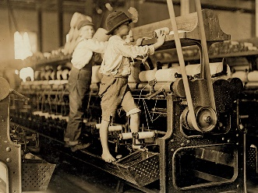
The Industrial Revolution was a period of tremendous change in Britain, which lasted from around 1750 until around 1900. In this period of 150 years, almost every aspect of life in Britain changed.

It was the birth of the modern world and Britain changed from a rural country with small industries to a highly industrialised and wealthy nation.

In 1750, before the Industrial Revolution, Britain was an agricultural country. Most people lived on their farms, growing their own produce and raising their own livestock. The fastest transport for most people was by horse and cart. Most industry, like pottery and weaving was done at home. Only 15% of the population lived in large towns. The total population of Great Britain was less than 10 million people.

After the Industrial Revolution, Britain had changed hugely. Industry had been transformed by key inventions such as the steam engine, which led to the establishment of factories all over the UK. Most people now lived in large towns, near to where they work. Transporting goods had become much faster thanks to canals, roads and railways. The population of Britain had trebled to around 30 million people and 85% of these people lived in large towns or cities.

Working conditions in Factories

New weaving processes in the late 1700s allowed for the mass production of the cheap and light cloth that was highly sought after in Britain and her colonies.

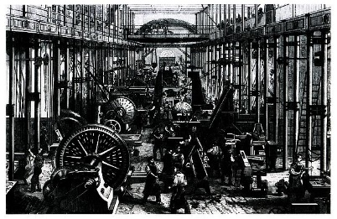
New factories employed hundreds of people, including many small children, whose nimble hands made light-work of spinning. Many factories were dismal and highly dangerous, often likened to prisons, where workers encountered harsh discipline enforced by factory owners.

Numerous children were sent there from workhouses or orphanages to work long hours in hot, dusty conditions, and were forced to crawl through narrow spaces between fast-moving machinery. A working day of twelve hours was not uncommon, and accidents happened frequently.

Poverty and The Workhouse

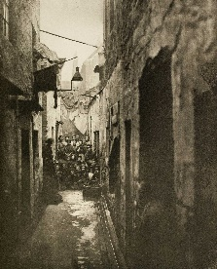
Poverty rates throughout the 1700s were high. Many families struggled to pay for their daily bread, and lived below the ‘breadline’ in abject conditions. Illnesses, accidents and old-age also prevented people from working, again resulting in poverty and often destitution.
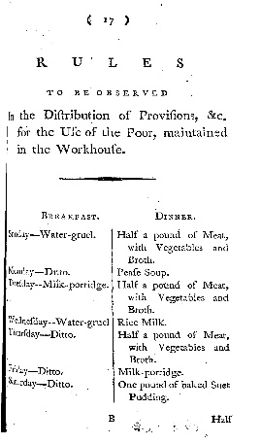
From the 1720s, workhouses were set up by local parishes to house the poor. Men, women and children lodged in single sex ‘wards’ where the able-bodied were set to menial tasks: breaking stones, spinning thread or sewing clothes, for example. Inmates were ordered to follow strict rules of behaviour and to conform to daily routines.

This document is from the rulebook of a London workhouse, and lists the food on offer to inmates. Some workhouses were clean and comfortable havens for the poor. Many provided education, rudimentary health care and clean clothing. Others were hopelessly overcrowded, prison-like institutions in which disease and even death were common as were accidents and exhaustion from strict work regimes.

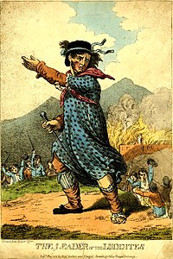
The Luddites

The Luddites were a secret oath-based organisation of English textile workers in the 19th century, a radical faction which destroyed textile machinery as a form of protest. The group was protesting against manufacturers who used machines in what they called “a fraudulent and deceitful manner” to get around standard labour practices. Luddites feared that the time spent learning the skills of their craft would go to waste, as machines would replace their role in the industry. Over time, the term has come to mean one opposed to industrialisation, automation, computerisation, or new technologies in general.

The Luddite movement began in Nottingham in England and culminated in a region-wide rebellion that lasted from 1811 to 1816. Mill and factory owners took to shooting protesters and eventually the movement was suppressed with legal and military force.

Richard Trevithick

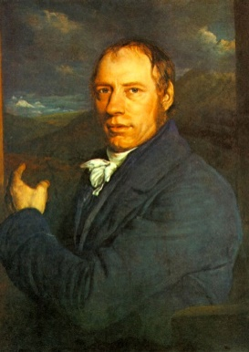
Richard Trevithick was born on April 13, 1771 in Tregajorran, Cornwall. He was a British inventor who was most famous for inventing the first high pressured steam engine. His passion for steam engines developed as a child when he would witness the engines pumping water from the copper and tin mines in Tregajorran.

From 1797-1798, Richard Trevithick lived next door to a famous Scottish inventor and engineer who inspired his thoughts with his steam powered road locomotion experiments. His name was William Murdoch and one of his most famous inventions was the oscillating cylinder steam engine.

His first job was at the East Stray Park Mine where the miners knew his father. Richard Trevithick was 19 when he began working at the mine and he progressed quickly to a consultant's position - a very good job for a man of his age. Richard Trevithick quickly earned the respect of his fellow workers.

Richard Trevithick started working at Ding Dong Mine as an engineer in 1797. His friend, Edward Bull, who later created the Bull Engine, also worked at the mine. Together, the two engineers pioneered and developed the use of high pressure steam.

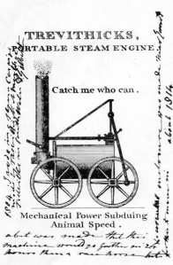
One of his early developments was a high pressure steam engine model. The first one that Richard Trevithick built was stationary and a later model could be attached to a road carriage. Richard Trevithick created a design using a double acting cylinder which distributed steam by a four way valve. A four way valve can be described as a fluid control valve with four equally spaced ports surrounding the valve chamber. A chimney vented exhaust steam into the atmosphere; a development which eliminated the need for a condenser.

Richard Trevithick built the Puffing Devil in 1801 close to Fore Street at Camborne. The Puffing Devil was a full scale, fully working steam road locomotive. It was successfully demonstrated on December 24, 1801 when it carried 6 passengers from Camborne to Beacon.

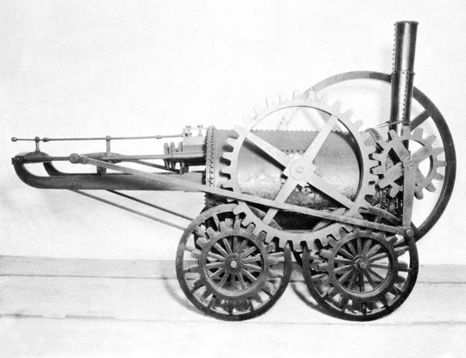
He then invented the first steam rail locomotive in 1804. The Pen-y-darren ironworks in Merthyr Tydfil, Wales, had used some of his high pressure stationary engines. They mounted one of his engines on wheels and it became the first steam railway locomotive. The ‘unnamed locomotive’ successfully transported 10 tons of iron almost 10 miles (16 km) along Pen-y-darren’s ironworks own tramway to Abercynon.

His invention of the first steam powered rail locomotive incorporated the ‘blastpipe’. The blastpipe is a device which uses the pressure of steam to draw fire. The system functions by exhausting spent steam through an upturned nozzle in the chimney.

