Discovering Two: Why do things grow?

EYFS and Y1 (Lower KS1 Science Project Two)
Combined focus elements with RSE- naming body parts, how people grow and changes that happen as we get older.
What should I already know? Year One Children  - Living things and their habitats (key terms vertebrate and invertebrate, carnivore, omnivore, herbivore and animal classification- fish, amphibians, reptiles, mammals and birds).  - Basic needs of humans and animals (food, shelter, warmth)  - Water cycle and food chains  - Differences between things that are alive, dead and have never been alive | Key Knowledge  Label the basic parts of the body associated with each of the five senses  Understand that animals produce offspring which grow and change over time  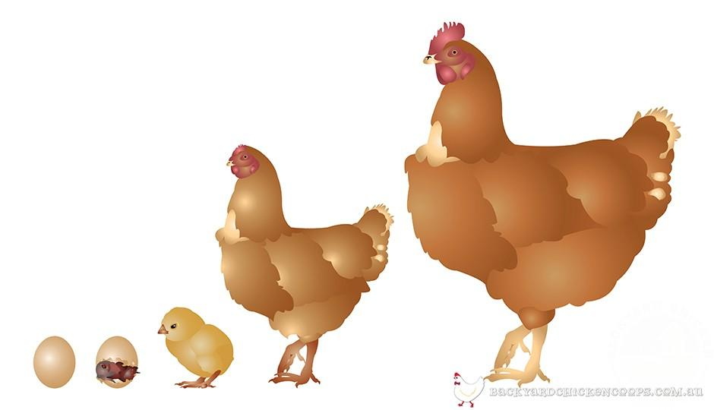  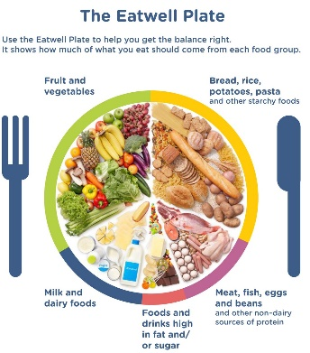  Animals, including people, need different things to survive. Humans need food, water, shelter and love. Exercise and eating a healthy diet are also important.  describe the importance for humans of exercise, eating the right amounts of different types of food, and hygiene.  growth and development of plants  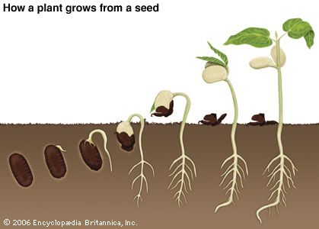  observe and describe how seeds and bulbs grow into mature plants  find out and describe how to help a plant thrive, including knowledge of how plants need water, light and a suitable temperature to grow and stay healthy.  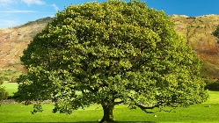  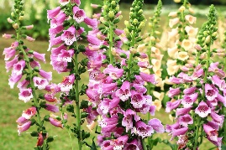  identify and name four different common British trees (beech, oak, silver birch, hazel), six common Cornish flowers (daffodil, cow parsley, bluebells, gorse, lily of the valley, foxgloves) and more than a dozen vegetables which can be grown in the UK.  Scientific Processes  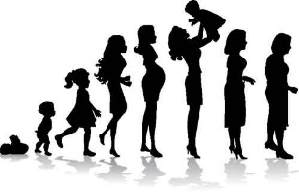  Describe how animals (including humans) grow through different stages- baby, toddler, child, teenager, adult.  Describe how a plant produces a seed which then grows into another plant and the stages in this development.  Label simple different parts of a flower and understand the role of bees in pollination.  Describe the changes that occur over the year in deciduous trees and how these differ to evergreen trees.
Key Vocabulary
Key Term | Definition
pupa | an insect in its inactive form between larvae and adult
spawn | the eggs of fish or frogs
tadpole | the tailed larvae of an amphibian
reproduction | the production of offspring
offspring | children or young
seed | the unit of reproduction of a flowering plant which can grow into another of the same plant
sapling | a young tree
pollination | the transfer of pollen from one plant to another
petal | the coloured leaves that make up a flower
anther | the part of a stamen that contains the pollen
stamen | the pollen producing part of a flower
pollen | tiny yellow grains made by the stamen
roots | the part of the plant which attaches it to the ground and passes water/nutrients to the rest of the plant
deciduous | a tree which sheds its leaves annually
evergreen | a tree which keeps its leaves all year round

Scientific Skills

- Test how different conditions (e.g. lack of light, too much water, no soil) affect growth of plants.

- Identify own factors which may affect growth and conduct own experiment using a control plant as a comparator.

- Suggest ways to find answers to their own questions

- Record observations, noting changes in development over time in the growth of a plant and an animal

Key Experiences

Visit to local farm
Baby and grown animals visit to school (lambs and sheep, calf and cow)
Hatching chicks from eggs, watching tadpoles change into frogs, raising a caterpillar into a butterfly
Meeting a baby and a pregnant mum
Grow your own fruits and vegetables to eat!

