Year 1/2
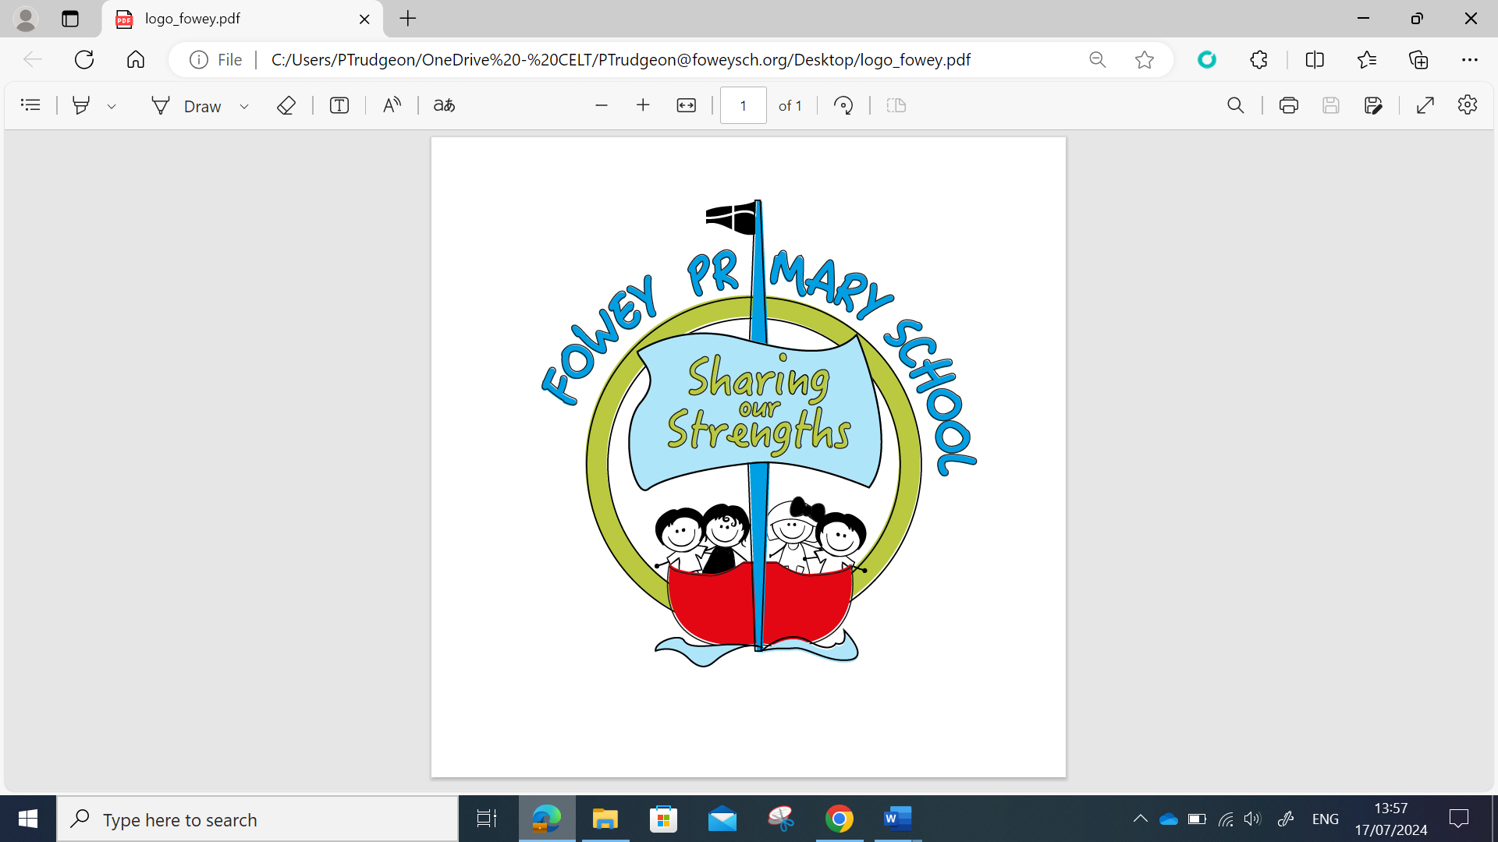 | Year 1/2 Autumn MTP
 | Week 1 | Week 2 | Week 3 | Week 4 | Week 5 | Week 6 | Week 7 | Week 8 | Week 9 | Week 10 | Week 11 | Week 12
Grammar and Punctuation | Ready to write  Leaving space between words | Introducing capital letters, full stops  Capital letters for names of people, places, days of the week and I  Full stops, capital letters, exclamation marks and question marks | Alphabetical order | Letter formation in the correct direction/starting and finishing in the correct place  Word classes | Combining words to make sentences  Joining words and clauses using and | Commas in a list  Using expanded noun phrases | Combining words to make sentences  Capital letters for people, places, days of the week and I | Forming the digits 0-9 | Conjunctions – When, if, that, because | Grammatical structures of questions and commands | Assess  Week | Review miscon Week
Alan Peat  Sentences |  |  |  |  |  |  |  |  |  | 2 A sentences (if and when ready for MA)
RWI Phonics Y1 | Read Purple Storybooks Read Set 2 sounds |  |  |  |  |  | Read Pink Storybooks Read first 5 Set 3 sounds
RWI Phonics Y2 | Read Blue Storybooks with increasing fluency and comprehension |  |  |  |  |  | Read Grey Storybooks
Handwriting | The Ladder family  (l, I, u, t, y and j) |  |  |  |  |  | Assess and Review | The One Armed Robot Family  (n, m and h) |  |  |  | Practice and Review
Reading text | RWI Phonics for the Autumn term- Year 1/2
Writing Sequence (Outcomes) | Traditional Tales  Rapunzel  (Write own traditional tale)  Can I predict characters and events, justifying answers?  Can I sequence events in a story?  Can I retell a story using actions?  Can I describe a setting?  Can I describe a character?  Can I describe how a character feels?  Can I write the beginning of a story?  Can I write the middle of a story?  Can I write the end of a story?  Can I edit and improve my writing? |  |  | The Three Little Pigs  (Write own tale with an alternative ending)  Can I learn a story orally?  Can I identify nouns and verbs?  Can I write a sentence?  Can I sequence events in a story?  Can I use question marks?  Can I write the beginning of a story?  Can I write the middle of a story?  Can I write the end of a story?  Can I edit and improve my writing?  Can I identify nouns and verbs? |  |  | Alternative fairytales  The three little wolves and the big bad pig.  (Write alternative fairytale)  Can I predict events in a story?  Can I use capital letters for names and days of the week?  Can I combine words to make sentences?  Can I join words and clauses?  Can I use question marks?  Can I compare the traditional and alternative versions of the stories?  Can I plan my own alternative fairytale?  Can I write my own alternative fairytale?  Can I write my own alternative fairytale?  Can I edit and improve my writing? |  |  | Little Red  (Continue the story)  Can I share my opinion on a book?  Can I use because to give a reason?  Can I learn about the features of a newspaper report?  Can I write a newspaper report?  Can I use similes to describe a setting?  Can I write a diary as a character?  Can I imagine what characters might say?  Can I sort words according to their types?  Can I learn about the suffix -ed and how it changes words?  Can I use my imagination to continue a story?

