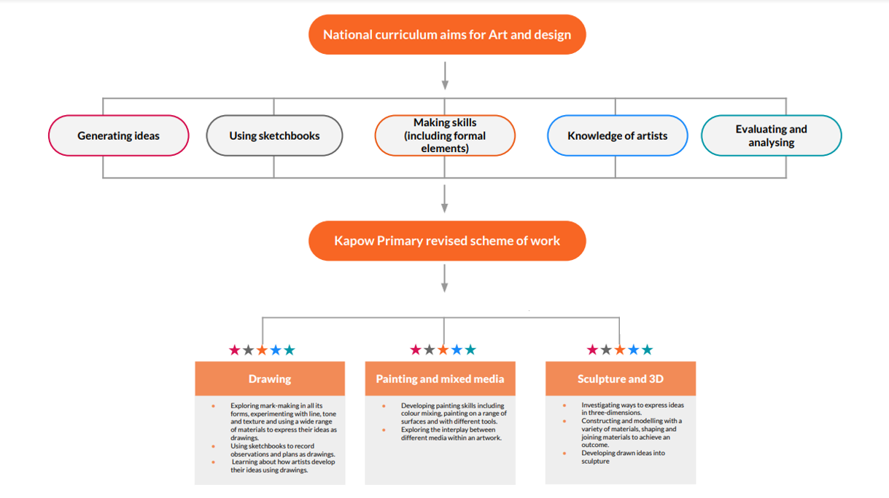
Key skills and progression

 | Year 1/2 | Year 3 | Year 4 | Year 5 | Year 6
Drawing | How different marks can be used to represent  words and sounds.  ●That a combination of materials can achieve  the desired effect.  ● That charcoal is made from burning wood.  How to:  ● Use different materials and marks to replicate texture.  ● Manipulate materials and surfaces to create  textures. Eg scratching with tools or blending  with fingers.  ● Use marks and lines to show expression on  faces.  ● Make a concertina book.  ● Use drawing to tell a story.  ● Use charcoal to avoid snapping and to achieve  different types of lines.  ● Use drawing pens. | How to:  ● Use shapes identified within in  objects as a method to draw.  ● Create tone by shading.  ● Achieve even tones when  shading.  ● Make texture rubbings.  ● Create art from textured paper.  ● Hold and use a pencil to shade.  ● Tear and shape paper.  ● Use paper shapes to create a  drawing.  ● Use drawing tools to take a  rubbing.  ● Make careful observations to  accurately draw an object.  ● Create abstract compositions  to draw more expressively. | Use pencils of different grades to shade  and add tone.  ● Hold a pencil with varying pressure to  create different marks.  ● Use observation and sketch objects  quickly.  ● Draw objects in proportion to each  other.  ● Use charcoal and a rubber to draw tone.  ● Use scissors and paper as a method to  ‘draw’.  ● Make choices about arranging cut  elements to create a composition.  ● Create a wax resist background.  ● Use different tools to scratch into a  painted surface to add contrast and  pattern.  ● Choose a section of a drawing to  recreate as a print.  ● Create a monoprint. | ● What print effects different  materials make.  How to:  ● Analyse an image that  considers impact, audience  and purpose.  ● Draw the same image in  different ways with different  materials and techniques.  ● Make a collagraph plate.  ● Make a collagraph print.  ● Develop drawn ideas for a  print.  ● Combine techniques to  create a final composition.  ● Decide what materials and  tools to use based on  experience and knowledge. | Gesstural and expressive  ways to make marks.  ● Effects different materials  make.  ● The effects created when  drawing into different  surfaces  How to:  ● Use symbolism as a way to  create imagery.  ● Combine imagery into  unique compositions.  ● Achieve the tonal  technique called  chiaroscuro.  ● Make handmade tools to  draw with.  ● Use charcoal to create  chiaroscuro effects.
Painting and mixed media | Mix a variety of shades of a secondary  colour.  ● Make choices about amounts of paint to  use when mixing a particular colour.  ● Match colours seen around them.  ● Create texture using different painting  tools.  ● Make textured paper to use in a collage.  ● Choose and shape collage materials eg  cutting, tearing.  ● Compose a collage, arranging and  overlapping pieces for contrast and effect.  ● Add painted detail to a collage to  enhance/improve it. | Use simple shapes to scale up a  drawing to make it bigger.  ● Make a cave wall surface.  ● Paint on a rough surface.  ● Make a negative and positive image.  ● Create a textured background using charcoal and chalk.  ● Use natural objects to make tools to paint with.  ● Make natural paints using natural materials.  ● Create different textures using  different parts of a brush.  ● Use colour mixing to make natural colours. | Mix a tint and a shade by adding black or white.  ● Use tints and shades of a colour to create a 3D effect when painting.  ● Apply paint using different techniques eg. stippling, dabbing, washing.  ● Choose suitable painting tools.  ● Arrange objects to create a still life composition.  ● Plan a painting by drawing first.  ● Organise painting equipment independently, making choices about tools and materials. | Develop a drawing into a  painting.  ● Create a drawing using text as lines and tone.  ● Experiment with materials and create different backgrounds to draw onto.  ● Use a photograph as a starting point for a mixed-media artwork.  ● Take an interesting portrait  photograph, exploring different angles.  ● Adapt an image to create a new one.  ● Combine materials to create an effect.  ● Choose colours to represent an idea or atmosphere.  ● Develop a final composition. | Use sketchbooks to research  and present information.  ● Develop ideas into a plan for a final piece.  ● Make a personal response to the artwork of another artist.  ● Use different methods to  analyse artwork such as drama, discussion and questioning.
Sculpture and 3D | Smooth and flatten clay.  ● Roll clay into a cylinder or ball.  ● Make different surface marks in clay.  ● Make a clay pinch pot.  ● Mix clay slip using clay and water.  ● Join two clay pieces using slip.  ● Make a relief clay sculpture.  ● Use hands in different ways as a tool to  manipulate clay.  ● Use clay tools to score clay. | How to:  ● Join 2D shapes to make a 3D  form.  ● Join larger pieces of  materials, exploring what  gives 3D shapes stability.  ● Shape card in different ways eg. rolling, folding and choose the best way to recreate a  drawn idea.  ● Identify and draw negative spaces.  ● Plan a sculpture by drawing.  ● Choose materials to scale up an idea.  ● Create different joins in card eg. slot, tabs, wrapping.  ● Add surface detail to a  sculpture using colour or  texture.  ● Display sculpture. | How different tools can be used to create different sculptural effects and  add details and are suited for different purposes, eg. spoon, paper clips for soap, pliers for wire.  How to:  ● Use their arm to draw 3D objects on a large scale.  ● Sculpt soap from a drawn design.  ● Smooth the surface of soap using water when carving.  ● Join wire to make shapes by twisting  and looping pieces together.  ● Create a neat line in wire by cutting and  twisting the end onto the main piece.  ● Use a range of materials to make 3D artwork eg. manipulate light to make  shadow sculpture, use recycled materials to make 3D artwork.  ● Try out different ways to display a 3D  piece and choose the most effective | How to:  ● Make an explosion drawing in  the style of Cai Guo-Qiang,  exploring the effect of  different materials.  ● Try out ideas on a small scale to assess their effect.  ● Use everyday objects to form a sculpture.  ● Transform and manipulate  ordinary objects into  sculpture by wrapping,  colouring, covering and  joining them.  ● Try out ideas for making a  sculpture interactive.  ● Plan an installation proposal, making choices about light, sound and display. | How to:  ● Translate a 2D image into a  3D form.  ● Manipulate cardboard to  create 3D forms (tearing,  cutting, folding, bending,  ripping).  ● Manipulate cardboard to  create different textures.  ● Make a cardboard relief  sculpture.  ● Make visual notes to generate  ideas for a final piece.  ● Translate ideas into sculptural forms.

