Humanities Five: Ancient Greece

What should I already know?  The UK as a democracy  Study of Stone Age, Iron Age and Bronze Age  Maya and Indus Valley Civilisations  Romans and the British invasion  Notable people including Boudicca, explorers, Mary Seacole and Professor Stephen Hawkins  British Monarchy and key monarchs  Geography- countries, continents, seas and oceans as well as human and physical geographical features of Europe |  | Key Experiences  British Museum Mini Site http://www.ancientgreece.co.uk/  Visit to Truro Museum and Ancient Greece workshop  Visit to The Box museum in Plymouth- Greece workshop (combine with visit to mosque as part of RE studies https://piety.org.uk/index.php/portfolio-items/visiting/)
acropolis | the citadel of an ancient Greek city | Timeline  776 BC The first Olympic games take place  c. 750 BC Early Greek culture thrives. Homer writes The Iliad and The Odyssey  570 BC Pythagorus is born. He made major breakthroughs in Science and Maths  508 BC Democracy begins in Athens, giving greater power to the people.  c. 450 BC Athens becomes a powerful city and controls an empire.  432 BC The Parthenon, the most famous building in Athens is completed.  336 BC Alexander the Great is King and helps the Greek empire expand further  146 BC Rome conquers Greece, making it part of the Roman Empire.
architecture | the art of planning, designing and constructing buildings
chronology | the order of events in time
circa | Latin meaning ‘around’. c. 800 BC means around 800 BC.
citadel | a strong building in or near a city, where people could shelter for safety
civilisation | a human society with its own social organisation and culture.
climate | the general weather conditions that are typical of a place
continent | a very large area of land that consists of many countries. Europe is a continent.
culture | activities such as the arts and philosophy, which are considered to be important for the development of civilisation
deity | a god or goddess
democracy | a fair political system where all adults vote for an elected government. This government then makes decisions on how to run the country.
empire | a number of individual nations that are all controlled by the government or ruler of one particular country
fertile | rich in nutrients to support the growth of many plants
invasion | to try and take over a place by force
merchant | a person who buys or sells goods in large quantities
military | relating to or belonging to the army
mythology | a group of myths, especially all the myths from a particular country, religion, or culture.
philosophy | the study or creation of theories about basic things such as the nature of existence, knowledge, and thought, or about how people should live
polis | an ancient Greek city-state
polytheists | the worship of or belief in more than one god
seafaring | working as a sailor or travelling regularly on the sea
society | people in general, thought of as a large organized group
trade | the activity of buying, selling, or exchanging goods or services
urban | belonging to, or relating to, a town or city  warfare the activity of fighting a war
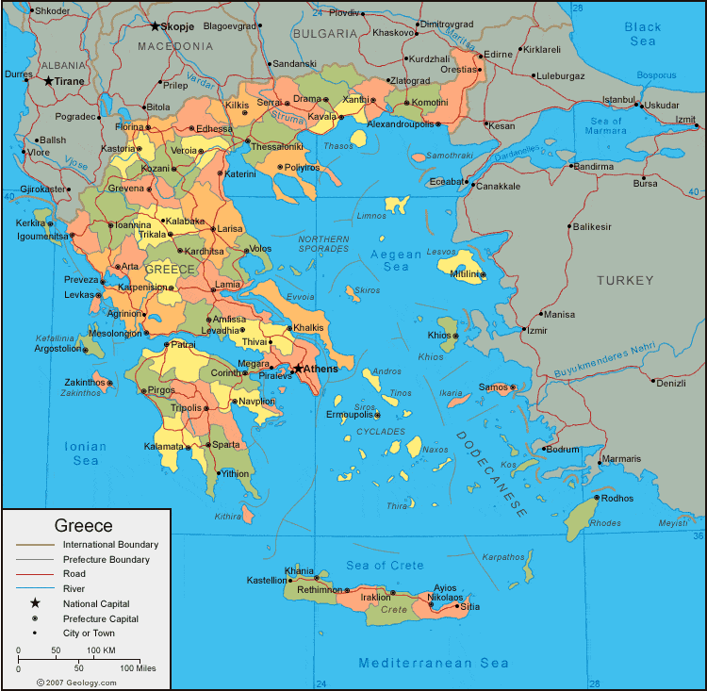
Greece

Mainland Greece is a mountainous land almost completely surrounded by the Mediterranean Sea. Greece has more than 1400 islands. The country has mild winters and long, hot and dry summers.

The ancient Greeks were a seafaring people. They traded with other countries around the Mediterranean. Many cities created settlements overseas known as colonies. Greek cities were founded around the Black Sea, North Africa, Italy, Sicily, France and Spain.
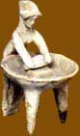
Daily Life
Life in ancient Greece was quite different for men and women. Whilst men were expected to take an active part in the public life of their city, women were expected to lead a private life as wives and mothers. Their lives were centred on the home.

Slavery was a central feature of life in Greece. Families of reasonable wealth would have slaves to carry out the household chores, to go shopping at the market and even to help bring up children.

However, daily life in Sparta was rather different from most other city-states. Here women led more active lives, as this would improve their physical strength and their ability to have healthy babies. Sparta also had slaves but these belonged to the city as a whole, rather than to individual families.

Athens and Sparta
Greece was divided into citystates (polis) that each had their own laws and way of life, but that all spoke the same language.

Two of the most well-known city states are Athens and Sparta.

In Athens, Greek styles of art, architecture, philosophy and theatre were developed - these helped shaped our modern society along with science, language and maths. Athens had a democratic government – this means that the people who lived there made decisions by voting, like we do in Britain. Perikles, the great statesman of Classical Athens, said that Athenians thought of 'a man who takes no interest in public affairs not as apathetic, but as completely useless.'

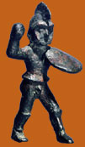
Male citizens in Athens could vote on all the decisions that affected the city and serve on juries. However, democracy was not open to everyone. Citizen women and children were not allowed to vote. Slaves and foreigners living in Athens (known as metics) were banned from participating in government.

In Sparta, life was very different. The state was ruled by two kings and a Council of Elders. There was an assembly of Citizens, but it did not have the power of the citizen assembly in democratic Athens. Sparta had a great army which made it a very powerful State. The focus in Sparta was on producing good soldiers and all male citizens were part of the army.

Greek Gods
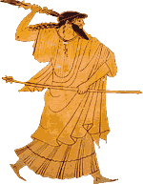
Religion was very important in ancient Greece. They were polytheists - they believed in different gods and goddesses that were in charge of different parts of their lives, such as a god of the sea and a goddess of wisdom. Temples were built in their honour and they featured heavily in the stories of Greek mythology.

The ancient Greeks believed there were a great number of gods and goddesses. These gods had control over many different aspects of life on earth. King of all the gods and goddesses was Zeus. He could control the weather and was often called 'the thunderer' or 'the cloud-gatherer'. He lived with the other gods on Mount Olympus, a high mountain in northern Greece.

Festivals and Games
Festivals were a very important part of life in ancient Greece, and were a central part of worshipping the gods. They usually included a procession and a sacrifice.

Festivals also included various competitions, which were seen as another way to honour a god. There were competitions in music, poetry, drama and also athletics. Some of the most important festivals of ancient Greece involved athletic competition, such as the Olympic Games, which were held in honour of Zeus, and the Pythian Games, held at Delphi in honour of Apollo.

One festival in Athens, held to honour Dionysos, involved a competition between playwrights. This led to the creation of some of the best known plays from Ancient Greece, written by people such as Sophokles, Euripides and Aristophanes.

