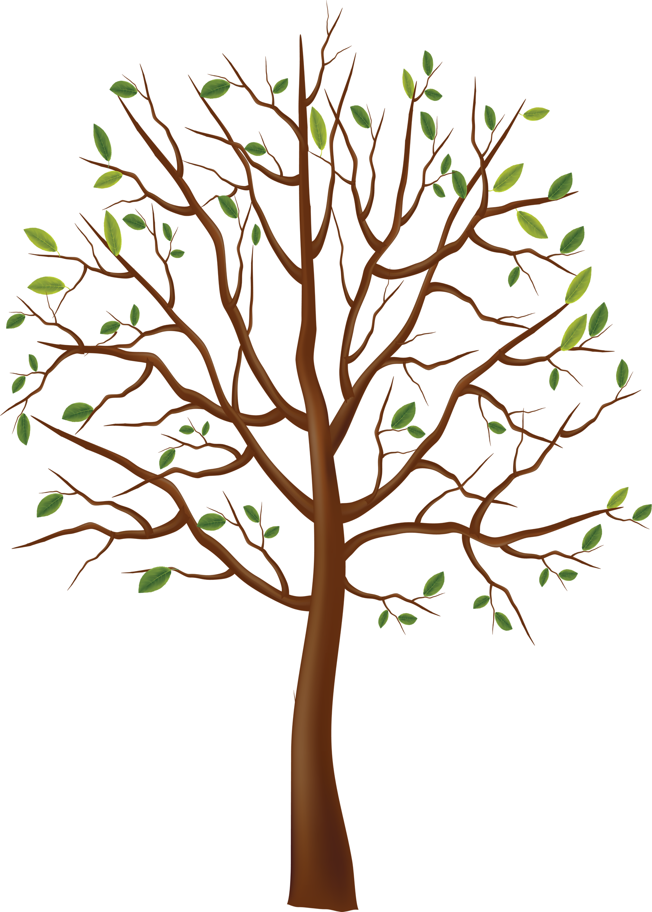

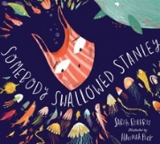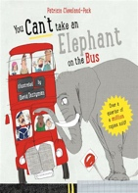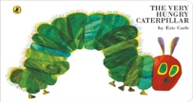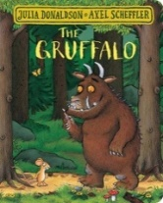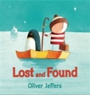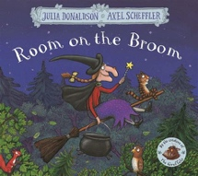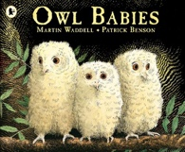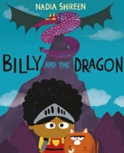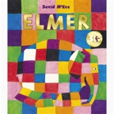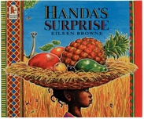

Fowey Foundation Stage

Reading Spine