EYFS Autumn 1/2 English MTP
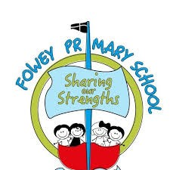

All About Me

Fowey Reception Class Medium Term Plan
Autumn 1 2024

 | Week 1 | Week 2  Baseline | Week 3  Baseline | Week 4 | Week 5 | Week 6 | Week 7 | Adaptations
Key texts:  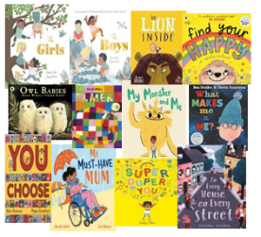  Additional texts:  Story times  Book vote  Play-based learning enhancements | The Hugasaurus  Starting School  The Day you begin  When a Dragon goes to School  Lulu’s First Day | Super Duper You  Different: A Great Thing to Be!  What makes me me?  Zog | Super Duper You  Different: A Great Thing to Be!  What makes me me?  Little Red Riding Hood | My Magic Family  Owl Babies  Love  You Choose  Stickman  My Daddies  Pirate Mums  The Tiger Who Came To Tea | My Magic Family  Owl Babies  Love  You Choose  In Every House on Every Street  Stickman  My Daddies  Pirate Mums  The Gingerbread Man | Tree  Leaf Man  The Leaf Thief  Hello Autumn  Room on the broom | Find your happy  Love  The Lion Inside  My Monster and Me  The River  Mr Big  The Leaf Thief  Three Billy Goats Gruff
Literacy | RWI sound card pictures  Fred games | RWI Set 1 speed sounds  m,a,s,d,t  Fred games  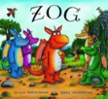  Key story time text –  Zog | RWI Set 1 speed sounds (first 16)  i,n,p,g,o  Word time 1.1  Fred games  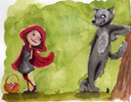  Key story time text –  Little Red Riding Hood | RWI Set 1 speed sounds (first 16)  c,k,u,b  Word time 1.2  Fred games  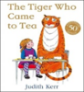  Key story time text – The Tiger Who Came To Tea | RWI Set 1 speed sounds (first 16)  f,e,l,h  Word time 1.3  Fred games  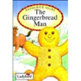  Key story time text - The Gingerbread Man | RWI (Group by progress)  Set 1 speed sounds  r,j,v,y,w  Word time 1.4  Fred games  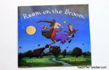  Key story time text – Room on the broom | RWI (Group by progress)  Set 1 speed sounds  z,x  Word time 1.1-1.4  Fred games  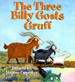  Key story time text –Three Billy Goats Gruff | Pinny time  Keep up group - from week 3  Reteach some sounds if significant gaps across class in first 16 before grouping by progress in week 6

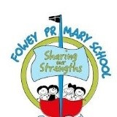
Food and Celebrations

Fowey Reception Class Medium Term Plan
Autumn 2 2024

 | Week 1 | Week 2 | Week 3 | Week 4 | Week 5 | Week 6 | Week 7 | Adaptations
Key texts: | Diwali non-fiction texts  The Best Diwali Ever  Owl Babies  Little Glow  Zim Zam Zoom | You choose  Ketchup on your cornflakes  Marcus Rashford Which food will you choose?  Off to the market  Pumpkin Soup  Goldilocks and the Three Bears | Welcome to Our table  Everyone cooks rice  Faruq and the Wiri Wiri  The BFG  Dumpling Day  Teatime around the world | Hansel and Gretel  Oliver’s Fruit Salad  Eco Girl  The Neighbourhood Surprise  Bea’s Bad Day  Joke/poetry book | Bear Snores On  Winter Sleep: a hibernation story  We’re going on a bear hunt  Percy the Park Keeper  A bear in the woods | Stick Man  Festivals!  The boy who brought the snow  If Winter comes, tell it I’m not here  Time to move south for winter  Hello Winter | The Night Before Christmas  One Snowy Night  Robin’s Winter Song  Grandpa Christmas  Cookie’s Christmas Invention  The Christmas Pine
Literacy | RWI (grouped by progress)  I, the  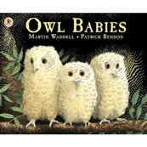  Drawing Club– Owl babies | RWI (grouped by progress)  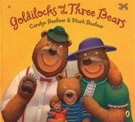I, the  Drawing Club– Goldilocks and the Three Bears | RWI (grouped by progress)  My, to  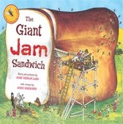  Drawing Club– The Giant Jam Sandwich | RWI (grouped by progress)  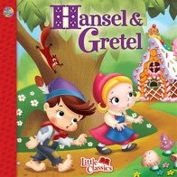My, to  Drawing Club– Hansel and Gretel | RWI (grouped by progress)  Of, no  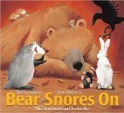  Drawing Club– Bear Snores On | RWI (grouped by progress)  Of, no  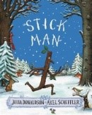  Drawing Club –Stick Man | RWI (grouped by progress)  Expected – 1 C  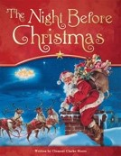  Drawing Club– The Night Before Christmas

