Rationale for PSHE at Fowey Primary School

At Fowey Primary School our curriculum aims to give children the knowledge, skills and understanding to achieve their full potential academically, socially and emotionally. We aim to give the children the necessary skills to prepare them for life in modern British society. Our curriculum reflects both the context of the school and the experiences of the children. This encourages the children to be aspirational, to fulfil their potential and reach the highest of expectations that we have of them.

Personal, social, health and economic (PSHE) education helps pupils to develop the knowledge, skills and attributes they need to manage many of the critical opportunities, challenges and responsibilities they will face as they grow up and in adulthood.

CURRICULUM INTENT

At Fowey Primary School our intention is to enable children to become independent, confident healthy and responsible members of society, as well as developing the “whole child” intellectually, morally, socially and spiritually. As a school, we believe that children are all individuals and therefore, we aim to encourage mutual respect, responsibility and foster self-esteem in a happy and caring atmosphere.

Our PSHE curriculum aims to send all our pupils into their adult life with strong foundations in their mental health, physical health and emotional wellbeing and to develop pupils who are passionate about leading happy lives. We believe this is vital for a successful and happy future for them all. We ensure that our PSHE provision is completely inclusive and accessible for all pupils regardless of their academic ability. An important part of our PSHE curriculum is ensuring that pupils have the knowledge to seek help; the understanding of themselves and others to know what is right and wrong for them and the vocabulary and skills of communication to express their thoughts and feelings. Our PSHE curriculum aims to model and explicitly teach the behaviours pupils need to learn to be successful socially as they grow. It aims to provide them with experiences they may meet in their future which could pose challenges, in a safe space where they can explore their thoughts and feelings with support. Through these opportunities they are encouraged to reflect and think critically.

The aims for our pupils in PSHE are:
- Develop confidence in opening up and talking about how they feel, their thoughts and opinions.
- Develop a range of skills and attributes that keep themselves safe.
- Develop an understanding of how to lead a healthy lifestyle.
- Develop a positive attitude towards being a global citizen and member of a local community and learn how to contribute in a positive way.
- To show tolerance and understanding of others’ beliefs, religions and life choices.
- To build positive relationships made through their choices and challenge what they are uncomfortable with.

We strongly believe that their spiritual, moral, social and cultural (SMSC) development should be greatly emphasised and celebrated and provide opportunities for this through our PSHE curriculum. Jigsaw PSHE is a comprehensive Scheme of Work for the whole primary school from Reception through to Year 6. It brings together PSHE Education, emotional literacy, social skills and spiritual development in a comprehensive scheme of learning. SMSC (Spiritual, Moral, Social and Cultural) development opportunities are mapped throughout. With an ever-changing society, we are able to provide our children with a strong understanding of the diverse world and support them to reach their potential as individuals, and within the local and global community.

CURRICULUM IMPLEMENTATION

Although teaching the entire scope of PSHE is not a statutory requirement for Primary Schools in England, we feel deeply passionate about this being an extremely important subject to consistently cover across all year groups through teaching, discussion and questioning.

The Department for Education (DfE) has stated:
“Personal, social, health and economic (PSHE) education is an important and necessary part of all pupils’ education. All schools should teach PSHE, drawing on good practice, and this expectation is outlined in the introduction to the proposed new national curriculum.”

With this in mind, we follow the whole school approach through the JIGSAW scheme, which offers a comprehensive programme including statutory Relationships and Health Education, in a progressive, sequential spiral through a fully planned scheme of work.

Jigsaw states that:
“Jigsaw holds children at its heart, and its cohesive vision helps children understand and value how they fit into and contribute to the world.
With strong emphasis on emotional literacy, building resilience and nurturing mental and physical health, Jigsaw 3-11 properly equips schools to deliver engaging and relevant PSHE within a whole-school approach. Jigsaw lessons also include mindfulness allowing children to advance their emotional awareness, concentration and focus.”

We deliver this through six lessons (known as pieces) per half-term, through six topics (known as puzzles) which are:
Every year group works on the same theme each half term; this enables the learning message to be reinforced through whole school activities, such as assemblies, allowing for themes to be shared and celebrated. All of these pieces of learning are brought together to form a cohesive picture, helping children to know and value who they are and understand how they relate to other people of the world.

Each lesson is designed to enhance collaborative learning, encourage a peaceful and positive environment, engage and stimulate the mind, consolidate and apply learning and allow the teacher to praise the positive attitudes throughout the learning. This is done through a clear structure in each lesson:
- Connect us
- Calm me
- Open my mind
- Tell me/Show me
- Help me reflect
- Closure

Mindfulness activities are key components of the Jigsaw PSHE lessons. The children reflect on their experiences and understand how they are developing personally and socially, tackling issues that are part of growing up. The Jigsaw PSHE lessons help the children develop their self-belief, realise their value and encourages them to become increasingly responsible for their own learning. In addition, the children develop an understanding of their place within the wider community, and are taught how to resolve conflicts, develop collaboration skills and respect for others.

Beyond the planning from Jigsaw, teachers have the freedom to plan PSHE work outside of the scheme according to the needs of the class. Additional resources are available from the curriculum provided by Cornwall and Isle of Scilly scheme of work and the RSE resources from the Christopher Winter Project. These are readily available to teachers to access to support their planning and lessons.

CURRICULUM IMPACT

Children will be able to demonstrate and apply the British Values of Democracy, Tolerance, Mutual Respect, Rule of Law and Liberty. They will also demonstrate a healthy outlook towards school and this is evident in the good behaviour seen across the school, both in the school and the playground.
Pupil's voice is used to measure children’s understanding. The enhancements mean that Jigsaw, the mindful approach to PSHE, will enable our children to have an understanding of the world, communicate their feelings, understand and have the skills to cope with issues like internet safety and body image. The children at Pondhu school experience and develop an understanding of British values that are necessary if they are to make sense of their experiences, value themselves, respect other, appreciate differences and feel confident and informed as a British citizen. Furthermore, the impact of our PSHE provision can be seen in the children’s social interactions, after-school club attendance and school parliament.
Further information about how the school approaches the teaching of PSHE through the Jigsaw programme can be found within the documents listed below:

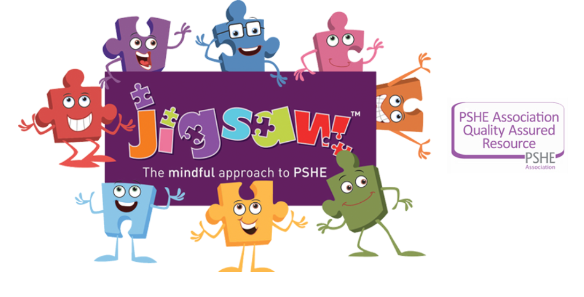

Relationships & Sex Education

An important part of the Jigsaw PSHE programme is delivered through the 'Relationships' and 'Changing Me' puzzle pieces which are covered in the summer term.
There are four main aims of teaching RSE:
- To enable children to understand and respect their bodies
- To help children develop positive and healthy relationships appropriate to their age and development
- To support children to have positive self-esteem and body image
- To empower them to be safe and safeguarded.
Each year group will be taught appropriate to their age and developmental stage. At no point will a child be taught something that is inappropriate; and if a question from a child arises and the teacher feels it would be inappropriate to answer, (for example, because of its mature or explicit nature), this information with be shared with you by your child’s class teacher. The question will not be answered to the child or class if it is outside the remit of that year group’s programme.

Below is a summary of RSE coverage within the Jigsaw scheme for each year group:
Foundation Stage - Growing up: how we have changed since we were babies
Year 1 - Boys’ and girls’ bodies; naming body parts
Year 2 - Boys’ and girls’ bodies; body parts and respecting privacy (which parts of the body are private and why this is).
Year 3 - How babies grow and how boys’ and girls’ bodies change as they grow older.
Year 4 - Internal and external reproductive body parts, body changes in girls and menstruation.
Year 5 - Puberty for boys and girls, and conception.
Year 6 - Puberty for boys and girls and understanding conception to birth of a baby

Further information about how the school approaches the teaching of Relationships and Sex Education through the Jigsaw programme can be found within the documents listed below:

Parent Consultation RSE

At Pondhu Primary School, puberty is taught as a statutory requirement of Health Education and is covered by our Jigsaw PSHE Programme in the ‘Changing Me’ Puzzle (unit). This is taught in the summer term. We conclude that sex education refers to Human Reproduction. In order to teach this in a scientific context and knowing that National Curriculum Science requires children to know how mammals reproduce, we have opted to teach this within our Science curriculum, not within PSHE or Relationships and Sex Education as we believe this is most appropriate for our children.

Parents have a right to withdraw their children from all or any part of Sex Education aspect of RSE if they wish to do so, but not from the biological aspects of human growth and reproduction provided under the National Curriculum for science. Parents do not have to give reasons for withdrawing their child but must inform the head teacher. Requests for withdrawal should be put in writing, making it clear which aspects of the programme they do not wish their child to participate in. The lessons that your child can be withdrawn from are:

• Year 4, Lesson 2 (Having a baby): The children will learn to identify and label the internal and external parts of male and female bodies that are necessary for making a baby. They will also learn that having a baby is a personal choice.
• Year 5, Lesson 4 (Conception): The children will learn that sexual intercourse can lead to conception and that is how babies are usually made. They will also learn that sometimes people need IVF to help them have a baby.
• Year 6, Lesson 3 (Conception, birth): The children will learn how a baby develops from conception through the nine months of pregnancy, and how it is born.

Below, you will find our RSE and PSHE policy and the curriculum content covered in each year group. Also, you will find government guidance for RSE.

Documents
What does Jigsaw teach about LGBTQ relationships?

Jigsaw is a complete scheme of work for Personal, Social, Health Education (PSHE) covering the entire PSHE curriculum. Only a very small number of these lessons in the entire scheme have any focus upon LGBTQ issues. Jigsaw’s philosophy is about inclusion and valuing all children. Relationships lessons focus on respect and regard between people e.g. friendships and families. Any reference to adult relationships, whether LGBTQ or heterosexual people is NOT describing sexual activity as this would be inappropriate.

See the leaflet below for more information on how Jigsaw supports the teaching of LGBTQ issues in an age appropriate manner and how you can support this at home.

LEAFLET

