 | FOWEY SCHOOL EYFS LONG TERM CURRICULUM MAP |  |  |  |  |  |  |  |  | 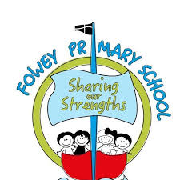
Reading spine  Drawing Club | Autumn 1  All about me  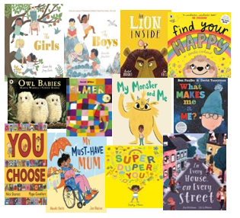  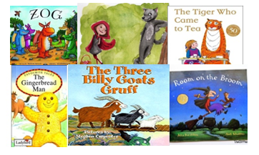 |  | Autumn 2  Food and Celebrations  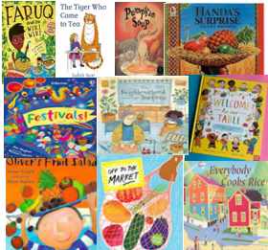  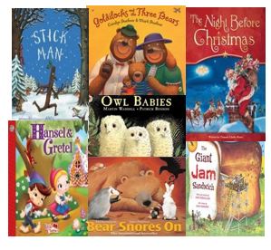 | Spring 1  People Who  Help Us  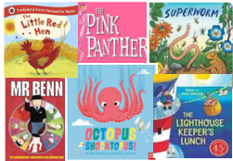  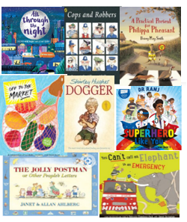 |  |  | Spring 2  Journeys and  Adventures  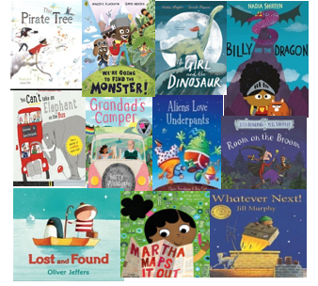  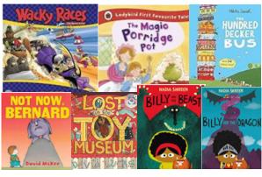 | Summer 1  Looking  After Our  Planet  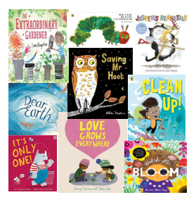  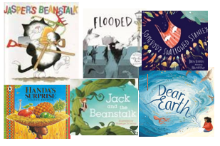 |  | Summer 2  Seaside and  Water  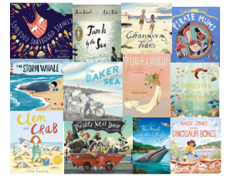  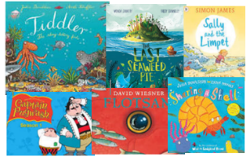
Communication and Language  ELGs | Can listen to a story and ask a relevant question and answer appropriately when asked.  - Ask questions about what I have heard.  - Respond with questions, actions and comments.  - Can listen to and answer questions about a story.  Have a 2-way conversation and express their ideas and feelings confidently .  - Is able to demonstrate understanding in their conversations by responding appropriately.  - Can talk about their thinking, ideas, feelings and events.  - Can talk about what they are doing and things they remember.  Create their own stories using a growing range of story language  - Understand the different elements of stories including character, setting, problem and solution.  - Listen to and acquire vocabulary from stories.  Make up their own stories.
Listening | I can listen to others in one-to-one or small groups when the conversation interests me.  I can listen to familiar stories with increasing attention and recall.  I can join in with repeated refrains and anticipate key events and phrases in rhymes and stories. | I am beginning to focus my attention and actively listen.  I can follow simple directions, if not already intently focused on a self-chosen task. |  |  | I can listen to instructions and carry them out in my play.  I can share instructions with others. | I can indicate two-channelled attention, e.g. paying attention to something of interest for short or long periods; can both listen and do for short span. |  |  | I can listen for extended periods of time, paying attention to the speaker.  I am beginning to ask questions about what I have heard.  I am starting to take turns in a conversation with others. | I can listen attentively and respond to what they hear with relevant questions, comments and actions when being read to and during whole class discussions and small group interactions.
Understanding | I can understand the use of objects (e.g. Which one do we cut with?)  I am beginning to understand prepositions such as under, on top, behind by carrying out an action or selecting correct picture. I can respond to instructions with more elements, e.g. Give the big ball to me; collect up all the blocks and put them in the box.  I am beginning to understand why and how questions. | I can understand a range of complex sentence structures including negatives, plurals and tense markers.  I am beginning to understand humour, e.g. nonsense rhymes, jokes. |  |  | I can follow a story without pictures or props.  I can listen and responds to ideas expressed by others in conversation or discussion. | I can understand questions such as who; why; when; where and how. |  |  | I can make comments about what they have heard.  I can hold a conversation when engaged in back-and-forth exchanges with their teacher and peers. | I can make comments about what they have heard and ask questions to clarify their understanding.  I can show an understanding of what has been read to me by retelling stories and narratives using my own words and new vocabulary.  I can predict key events in stories.  I can use and understand recently introduced vocabulary during discussions.
Speaking | I am beginning to use more complex sentences to link thoughts (e.g. using and, because).  I can use language in recalling past experiences.  I can retell a simple past event in correct order (e.g. went down slide, hurt finger).  I can use talk in pretending that objects stand for something else in play, e.g. This box is my castle. | I can use talk to explain what is happening and anticipate what might happen next.  I can question why things happen and give an explanation.  I can use a range of tenses e.g play, playing, played. |  |  | I can extend vocabulary, by grouping and naming, exploring the meaning and sounds of new words.  I can use language to imagine and recreate roles and experiences in play situations. | I can link statements and stick to a main theme or intention.  I can use talk to organise, sequence and clarify thinking, ideas, feelings and events.  I can introduce a storyline or narrative into my play. |  |  | I can participate in small group, class and one-to-one discussions, offering my own ideas, using recently introduced vocabulary.  I can offer explanations for why things might happen, making use of recently introduced vocabulary from stories, non-fiction, rhymes and poems when appropriate. | I can express my ideas and feelings about my experiences using full sentences, including use of past, present and future tenses and making use of conjunctions, with modelling and support from my teacher.
PSED  ELGs | Develop friendships with other children, showing cooperation and resolving any conflicts.  - Can take turns when playing with others, listening to their ideas.  - Can play with one or more children, extending and elaborating on play ideas.  - Can play cooperatively with others.  Show empathy to others.  - Understands the feelings of others and how to respond thoughtfully.  - Can talk about their own feelings and feelings of others.  - Can identify and express their own feelings.  Show resilience and perseverance in the face of challenges.  - Show confidence in choosing resources and perseverance when carrying out an activity.  - Be confident in the familiar school environment.  - Be confident to have a go and try new things.  Know how and why to look after their bodies and can manage own self-care.  - Show an understanding of healthy foods.  - Toilet independently and manage hygiene e.g. hand washing  Make healthy choices about food, drink, activity and toothbrushing.
Self-regulation | I can talk about feelings (happy, sad, angry)  I can choose what I need to complete a goal (short term)  I am starting to follow instructions | I can identify a range of different feelings  I can keep on trying when I find something difficult  I am starting to sit and listen more consistently during adult focus time |  |  | I can explore feelings  I can follow simple instructions | I can say how others are feeling based on their expressions and actions  I can say what I am good at and what I would like to improve  I can sit and listen during adult focus time |  |  | I can say how I and others are feeling  I can set myself goals  I can follow instructions with two or more parts | I can show my understanding of feelings by changing my behaviour  I can wait for my requests and needs to be met  I can listen to and respond to adults  I can follow instructions accurately (several ideas/ actions)
Managing Self | I am starting to become more confident when things are new (dealing with the transition) | Enjoys a sense of belonging through being involved in daily tasks |  |  | I can work independently when I am set a task. | I am starting to become more confident when things are new |  |  | Can describe their competences, what they can do well and are getting better at. Shows confidence in choosing resources and perseverance in carrying out a chose activity. | Describing themselves in a positive but realistic terms. Has a clear idea about what they want to do in their play and how they go about it.
 | I am showing an awareness of rules and how to behave in the classroom | Is more able to recognised the impact of their choices and behaviours/actions on others. |  |  | Knows some actions and words can hurt others feelings | I can follow the rules and know how to behave in the classroom |  |  | Attempt to repair a relationship or situation where they have cause upsets | I can explain the rules of the classroom and beave accordingly. Understand how their action impact others
Self-Care | I can tell an adult I need the toilet | I can toilet myself |  |  | I can explain good dental hygiene practices | I can get dressed for outdoor learning, swimming or PE independently |  |  | I can remember to wash my hands after the toilet and before eating | Understand healthy food choices and explain what healthy food is
Building relationships | To learn to play purposefully with equipment.  I can play with one or more children cooperatively. I can seek out companionship.  I can start to talk about the way I feel | I can play with a small group of children, sharing ideas  I am starting to form good relationships with the familiar adults in my class  I show empathy and concern for other people |  |  | Looks to a supportive adult for help in resolving conflict with others  I can express my basic needs to familiar adults e.g. ask to go to the toilet, etc.  I can express and identify my feelings | I can work well with others listening and sharing ideas  I am developing friendships with lots of different people  I can use words to help solve conflicts with others  I can show friendly behaviour in the classroom and around school  I can identify how others feel and respond to them appropriately |  |  | Is increasingly social skilled and takes steps to resolve conflict. Is proactive in seeking out adult support and is able to articulate their wants and needs.  Develop particular friendships with other children which helps me to identify other points of view  I show some consideration of other peoples needs and have become less impulsive. | I can work with others in a group  I can play with others, take turns and share.  I can form good relationships with the adults in the classroom and around school  I have lots of friends and positive friendships  I know what my own needs are and can share them.  I am sensitive to the needs of others
Physical Development  ELGs | Shows good control, coordination and balance in gross motor movements.  - Develop fluency in movements and posture.  - Revise and refine fundamental movement skills.  - Shows strength, balance and coordination to move in a range of ways.  Is proficient in handling equipment and tools effectively including cutlery, craft tools and pencils for writing and drawing.  - Apply fine motor skills to a range of tools including one handed tools and begin to demonstrate good pencil control.  - Shows a preference for dominant hand.  - Manipulates a range of tools and equipment using one hand e.g.  scissors, paintbrushes, hairbrushes, toothbrushes, ribbons, scarves.
Gross Motor | To be able to build spatial awareness, positional awareness negotiating space and obstacles safely.  To revise the fundamental movement skills they have already acquired: rolling, crawling, walking, jumping, running, hopping, skipping, climbing.  To develop their core muscle strength to support them holding a good posture when sitting at a table or sitting on the floor.  To be able to implement skills needed during daily routines, such as lining up and queuing.  To be able to use strength, co-ordination, and balance, through play movement with objects and adults. | To have refined the fundamental movement skills they have already acquired: rolling, crawling, walking, jumping, running, hopping, skipping, climbing.  To move energetically using the fundamental movement skills.  To use their core muscle strength to achieve and maintain a good posture when sitting at a table or sitting on the floor. |  |  | To be developing a more fluent style of moving, working towards movements with control and grace.  To be able to use static and dynamic balances.  To begin to develop ball skills individually and in small groups. | To use a fluent style of moving, with developing control and grace.  To confidently and safely use a range of large and small apparatus indoors and outside, alone and in a group.  To develop overall body-strength, balance, co-ordination and agility through a range of activities and resources available. |  |  | To be able to combine different movements together, with ease and fluency.  To develop a range of ball skills including: throwing, catching, sending, receiving, kicking, passing, batting, and aiming.  To develop competence when engaging in activities that involve a ball. | To be able to refine a range of ball skills including: throwing, catching, kicking, passing, batting, and aiming.  To develop confidence, precision and accuracy when engaging in activities that involve a ball.  To develop the overall body strength, co-ordination, balance and agility needed to engage successfully with future physical education sessions and other physical disciplines including dance, gymnastics, sport and swimming.
Fine Motor | To develop their small motor skills so that they can use a range of tools safely.  To begin to use pencils for drawing and writing, focusing on holding a pencil.  To be able to mark make using a paintbrush, fingers and other mark making tools.  To be able to practice fine motor skills using tweezers, threading, and playdough.  To be able to interact with small world activities, puzzles, arts and crafts using their hands to develop control and confidence with fine motor movements. | To be able to  develop the skills they need to manage the school day successfully, including using appropriate tools at mealtimes.  To be able to manipulate different materials using their hands.  To develop scissor skills including holding scissors, being safe and making snips.  To be able to interact with small tools to develop control and confidence with fine motor movements.  To refine fine motor skills using tweezers, playdough and threading activities.  To hold a pencil effectively in preparation for fluent writing, using the tripod grip in almost all cases. |  |  | To develop their small motor skills so that they can use a range of tools competently, safely and confidently, including pencils for drawing and writing, control and grip.  To be able to manipulate different materials to make things for a desired effect or outcome using your hands.  To use scissors confidently using the correct grip and movement and begin to use them safely, confidently and effectively. | To use their small motor skills with a range of tools competently, safely and confidently. Use pencils for drawing and writing, control and grip and accurate letter formation.  To begin to show accuracy and care when drawing.  To use the skills they need to manage mealtimes successfully using the appropriate tools. |  |  | To develop their small motor skills so that they can use a range of tools competently, safely and confidently, using pencils effectively to write.  To revisit showing accuracy and care when drawing. | To develop the foundations of a handwriting style which is fast, accurate and efficient.  To revisit manipulating different materials to make things for a desired effect or outcome using your hands.
Literacy  ELGs | Can describe what they have read, making inferences and predictions about what might happen next.  - Can recall and discuss what has happened in stories.  - Anticipate key events in stories.  - Know a repertoire of stories and rhymes.  Read simple sentences and books containing phase 2 and 3 sounds independently.  - Read captions and sentences applying their phonics skills.  - Begin to segment the sounds in simple CVC words and blend them together.  - Recognises familiar words and signs such as own name and advertising logos and screen logos.  Write simple sentences with independence.  - Start to write simple sequenced sentences with support.  - Begin to write CVC words.  Mark make with confidence, using some letters accurately.
Word Reading | RWI progress expectations: Read single-letter Set 1 sounds  (first 16)  Notice some print, such as the first letter of their name, a bus or door number or logo.  Read individual letters by saying the sounds for them. | RWI progress expectations: Read all Set 1 single- letter sounds  Blend sounds into words orally  Recognise words with the same initial sound.  Understand that print has meaning and that we read English text from left to right, top to bottom.  Blend sounds into words. |  |  | RWI progress expectations: Blend sounds to read words  Read short Ditty stories  Identifies alliteration.  Includes everyday literacy artefacts in play such as labels, instructions, signs, envelopes. | RWI progress expectations: Read Red Storybooks  Read Set 1 Special Friends  Read some letter groups that each represent one sound.  Read a few common exception words.  Read simple phrases and sentences. |  |  | RWI progress expectations: Read Green Storybooks  Read 4 double consonants  Count or clap syllables in a word | RWI progress expectations: Read Green Storybooks  Read first 6 Set 2 sounds  Read aloud simple sentences and books that are consistent with their phonics knowledge, including some common exception words.
Comprehension | Enjoy sharing a book with an adult.  Ask questions about the book. Make comments and share their ideas.  Develop play around favourite stories using props.  Join in with songs and rhymes. | To have a favourite book/non-fiction text/poem and seek them out to share with an adult, another child or to read alone.  Repeat words and phrases from familiar stories. |  |  | Engage in extended conversations about stories, using story vocabulary.  Anticipate key events in stories.  Continues a rhyming string.  Re-enact and reinvent stories in play. | Understand that print can have different purposes.  Re-read stories to build fluency and understanding. |  |  | Describe main story setting, events and principal characters in increasing detail.  Retell stories and narratives using their own words and story vocabulary. | Know the names of different parts of a book.  Is able to recall and discuss stories or information that has ben read to them or they have read themselves
Writing transcription | Make marks on their picture to stand for their name.  Add some marks to their drawings which they give meaning to.  Imitate adults writing by making continuous lines and shapes. | Give meaning to the marks they make in writing, painting, printing and drawing.  Write some or all of their name, including a capital letter at the start.  Write some letters accurately. |  |  | Use some of their print and letter knowledge in their early writing. | Use their developing phonic knowledge to write labels and captions. |  |  | Write recognisable letters, most of which are correctly formed.  To explore the use capital letters as they are introduced incidentally. | Spell words by identifying the sounds and representing the sound with a letter or letters.
Writing composition | Enjoy drawing freely. | Enjoys creating texts which communicate meaning for a variety of purposes such as greeting cards and lists. |  |  | I can say what I want to write before writing it down. |  |  |  | Re-read what they have written to check that it makes sense. | Write simple phrases and sentences that can be read by others.
Mathematics  ELGs | To understand in depth numbers to 10, including number bonds.  - Recall and use number bonds to 5 and 10.  - Subitise to 5.  - Count, order, recognise and use numbers to 10 and beyond.  - Counts to and links numbers to amounts to 5 and subitise to 3.  To recognise, compare and explore mathematical patterns.  - Share equally.  - Count verbally beyond 20.  - Identify odds and evens.  - Find one more and one less.  - Continue, copy and recreate repeated patterns.  Tackles problems involving prediction, discussion of properties of shape, spatial awareness and comparison of different measures.  - Select, rotate and manipulate shapes to develop spatial reasoning skills.  - Compose and decompose shapes so that children recognize a shape can have other shapes within it,  - Order 3 or more objects by measures.  - Name 2D and 3D shapes and talk about the properties.  Begin to talk about and explore the properties of shape and position and make comparisons of different objects.
 | I can recognise up to 3 objects, without having to count them individually.  I can recite numbers to 5.  I can say one number for each item in order: 1,2,3,4,5  I can match, sort objects and compare amounts. | I can talk about and explore 2D shapes using mathematical language.  I can begin to compare quantities using the language of ‘more than’, ‘fewer than’.  I can experiment with representing my own symbols and marks as well as numerals.  I can recite numbers to 5.  I can say one number for each item in order: 1,2,3,4,5. I can explore quantities up to 5. |  |  | I can talk about and explore mass and capacity.  I can compare objects relating to size, length, weight and capacity.  I understand the ‘one more than/one less than’ relationship between consecutive numbers.  I can explore quantities up to 8. | I can explore composition of numbers to 10.  I can count beyond ten.  I can extend and create ABAB patterns.  I can link the number symbol (numeral) with its cardinal number value up to ten.  I can talk about and explore 3D shapes using mathematical language/ |  |  | I can recall number bonds for numbers 0–5 and some to 10.  I can copy and create repeating patterns including ABBC patterns.  I can compare length, weight and capacity.  I can add more and take away using practical resources.  I can verbally count to 20 and beyond.  I can explore rotation, manipulation composition and decomposition of shape. | I can count beyond 20.  I am familiar with number patterns up to 10, including evens and odds, double facts and sharing and grouping.  I can subitise up to 5. Compare quantities up to 10 in different contexts, recognising when one quantity is greater than, less than or the same as the other quantity.  I can explore pattern rules and mapping.
Understanding the World  ELGs | Understands similarities and differences between the past and now.  - Compare and contrast characters from stories, including figures from the past  - Comment of images of familiar situations from the past  - Can talk about some of my own and my family’s history (grandparents,  parents, etc.)  Understand some important processes and changes in the natural world around them.  - Explore the natural world around them, talking about changes and explaining why things occur.  - Recognise some environments are different to the one in which they live in- comment on and discuss similarities and differences.  - Can describe what they see, hear and feel when outside.  Appreciate and accept different religious and cultural communities in their hometown, and around the world.  - Recognise that people have different beliefs and celebrate special times in different ways.  - Recognise some similarities between life in this country and others.  Talks about the differences I have seen in people, countries and communities.
Past and Present | I can share information about myself, my experiences and family | I can begin to identify some similarities and differences between themselves and others |  |  | I can use my senses to explore objects from the past and comment on familiar situations in the past | I can share information about figures from the past (people from the community and wider world) and what life was like in the past |  |  | I can share information about the past learned through settings, characters and events encountered in books read in class and story telling | I can explain some similarities and differences between things in the past and now, drawing on experiences and what has been read in class
People, culture and communities | I know where I live and where I go to school  I can share information about myself and my family structures | I can identify features in my immediate environment  I can share things I celebrate and how I celebrate them |  |  | I can describe my immediate environment and be able to draw information from a simple map  I can begin to describe different celebrations and how and where they are celebrated | To identify features of other environments  I can describe different celebrations and how and where they are celebrated |  |  | To describe other environments  I can begin to explain some similarities and differences between religious and cultural communities in this country | To be able to explain similarities between life in this country and life in other countries  I can explain some similarities and differences between religious and cultural communities in this country
The Natural World | I can explore my immediate environment  I can express some signs of Autumn | I can describe what they can see, hear and feel whilst outside  I can express some signs of Autumn/Winter |  |  | I can make observations and ask questions about what I can see, hear and feel in my own environment  I can express some signs of Winter/Spring | I can identify features of other environments and begin to compare to my own  I can express some signs of Spring |  |  | I can record observations of animals and plants through drawings  I can express some signs of Spring/Summer | I can describe some similarities and differences between the natural world around them and contrasting environments  I can express some signs of Summer and start to compare the different Seasons
Expressive art and design  ELGs | Select materials to work on processes that interest them. Explore, find out about and decide how materials, tools and techniques can be combined and changed.  - Develop own ideas through experimentation with diverse materials.  - Use increasing knowledge and understanding of tools and materials to explore interests and enquiries and develop their thinking.  - Uses a range of art materials, joining and colour mixing purposefully and freely.  Perform a story, song, poem or rhyme to an audience.  - Develop storylines in pretend play.  - Sing in a group or alone.  - Create your own dance, music or song to a piece of music or a  story.
 | I can explore what I see and hear.  I can notice, look, wonder and talk what I see and hear. | I can explore and play with a range of materials to make sound and marks.  I am developing an understanding of how things are used and the effects they give.  I can sing in a group or on my own. |  |  | I can express my ideas using a range of art forms, effects on my own and in collaboration. | I can revisit and use key materials.  Respond to different experiences, watching, talking and expressing feelings. |  |  | I can reflect and respond to art in my own way. I can develop story lines in my pretend play.  I can talk about what I see and share my likes and dislikes. | I can join materials and work in 2D and 3D to represent my ideas.  To select different roles to play with support if necessary.  To engage in music making and dance, performing solo or in groups.

Many of the Early Learning Goals in PSED, CL, PD and EAD will be present throughout the day in lots of different contexts. Use ELG breakdowns to see how they can be supported/ enhanced in the provision. The themes are subject to change dependent on children’s interests.

