Year 4
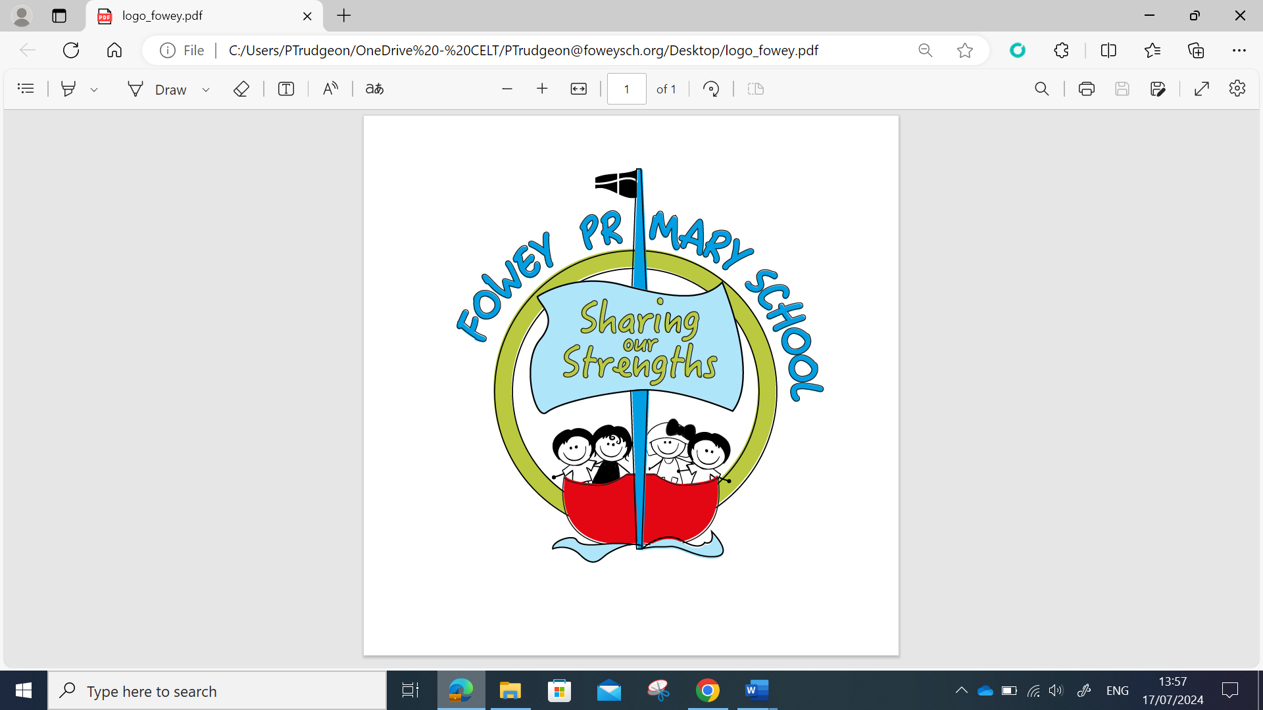 | Year 4 Autumn MTP
 | Week 1 | Week 2 | Week 3 | Week 4 | Week 5 | Week 6 | Week 7 | Week 8 | Week 9 | Week 10 | Week 11 | Week 12
Grammar and Punctuation | Ready to Write  Using Determiners | Clauses  Expanding sentences using conjunctions | Expanding sentences using adverbs  Expanding sentences using prepositions | Direct speech | Past tense  Present Tense  Present perfect and simple past | Using Paragraphs | Pronouns | Fronted Adverbials | Fronted Adverbials | Using commas after fronted adverbials |  | Assess and review
Alan Peat  Sentences | Revisit previous sentences e.g. 2A, 3ED  Emotion word, comma  The more, the more
Spelling  Spelling Shed | 1.Words that are homophones  2.Words with the prefix ’in-’  3.Words with the prefixes ’il-’, ‘im-’ and ‘ir-’ |  |  | 4.Words with the prefix ’sub-’  5.Words with the prefix ’inter-’  6.Challenge Words. |  |  | 7.Words ending in ’-ation’  8.Words ending in ’-ation’  9.Words ending ’-ly’ |  |  | 10.Words ending ’-lly’  11.Words where ‘ch’ makes a /sh/ sound  12.Challenge Words
Handwriting | The Ladder family  (l, I, u, t, y and j) |  |  |  |  |  | Assess and Review | The One Armed Robot Family  (n, m and h) |  |  |  | Practice and Review
Handwriting linked to common exception word foci | General assessment – ball shapes, straight lines, tunnel letters, hoops, loops and lines | c – accident  a – accidentally  d – calendar  - | o – occasion e – enough s – surprise i - important i – interest | l- library  t through  x - exercise | r – regular  v- various  w – weight  z - pizza | n – natural m – edicine h – height  b - believe | j -jelly  y-yacht  f- favourite  k - knowledge | ai – straight ch – church  ck – clock | er -answer sh – should th – though but – butter | ea-appear ed – knowledge ss-possess  jig - jigsaw  as -increase | igh – eight  ing - bring  sat - satin  be - believe  ie-experiment se - surprise her -therefore men - mention | oe – toe  re - pressure ve - arrive we - weight
Reading text  VIPERS Foci | Treasure Island |  |  |  |  |  | Demon Dentist
Writing Sequence | The Wind in the Willows |  |  |  | The Lion, the Witch and the Wardrobe |  | Granny Came here on the Windrush |  |  | Coming to England  Expanded Narrative
Writing Outcomes | SETTING DESCRIPTION  Can I gather key vocabulary after reading a setting description?  Can I identify and define adjectives, fronted adverbials and prepositions within a setting description?  Can I use powerful adjectives to describe a setting? (2A sentences)  Can I use prepositions to describe positions in a setting?  Can I use fronted adverbials as effective sentence starters?  Can I describe settings using ‘as a/like a’ sentences?  Can I identify and use coordinating and subordinating conjunctions to create compound and complex sentences?  Can I plan an effective setting description?  Can I draft an effective setting description using the senses?  Can I edit my writing for correct use of punctuation? (commas after fronted adverbials and correct use of possessive apostrophe)  Can I review and provide feedback on mine and others work?  Can I redraft my edited work?  Can I share my setting description with an audience? |  | Story opening |  |  |  | Non-chronological report on what happened during the Windrush. |  |  | Expanded narrative
 |  |  | Can I share my knowledge about a story and collect key vocabulary?  Can I identify the key skills in a story opening?  Can I build descriptive sequences featuring action?  Can I vary my sentence openers using action, verbs and adverbs? (DADWAVERS)  Can I vary my sentence openers using similes? (DADWAVERS)  Can I use the features of speech correctly? (DADWAVERS)  Can I plan a first-person story opener?  Can I write a story opener?  Can I edit my story opener?  Can I publish and share my story opener? |  |  |  | Can I identify key features in a non-chronological report?  Can I gather information about the Empire Windrush?  Can I successfully write using third person?  Can I write definitions for unfamiliar words?  Can I identify and write in present perfect tense?  Can I use subordinating conjunctions in my writing?  Can I use pronouns effectively?  Can I successfully identify and use expanded noun phrases in my writing?  Can I use relative clauses in my non-chronological report?  Can I plan my own non-chronological report?  Can I independently write a non-chronological report?  Can I edit and improve my independent write?  Can I publish and share my non-chronological report? |  |  | Can I gather and uplevel important words in a story?  Can I identify key features in an expanded narrative?  Can I understand how cohesion is created within writing?  Can I correctly use possessive apostrophes?  Can I write a double ly ending sentence?  Can I plan an expanded narrative?  Can I independently write an expanded narrative?  Can I edit and improve my expanded narrative?  Can I publish and share my expanded narrative?

