Fowey Primary School - Health & Safety Policy

Author: Carrie Freeman
Adopted by (body): Fowey School RIG
Approved date: January 2024
Review date: January 2025

On 26th January 2024 the Fowey Primary School adopted the following statement, organisation and responsibilities, and procedures for the provision of health, safety and welfare of pupils, visitors, employees, and contractors involved with activities at the academy.

Position | Name | Signature | Date
Chair of Local Governing Body or Rapid Improvement Group | Michele Taylor | 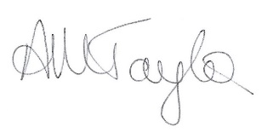 | Jan 24
Headteacher | Liz Measom |  | Jan 24
LGB/RIG Member responsible for Health and Safety | Tony Freshwater |  | Jan 24

Note:
All details are checked as correct at the time of publication
This policy mirrors exactly the CELT H&S Policy (published on the CELT website) for the ‘Statement of Intent’ and the ‘Organisation and Responsibilities’. The ‘Operations’ section is amended to set out how the school arranges for H&S management at the school level based on the instruction and guidance in the ‘Operations’ section of the main CELT H&S Policy but may also identify additional local hazards or procedures or remove sections irrelevant to their site.
Page no. | Contents
5 | Statement of Intent
6 | Organisation and Responsibilities
15 | School Operations
15 | 1) Arrangements for supervision of students
15 | 2) First Aid
18 | 3) Pupils and staff with medical needs
19 | 4) Medicines
20 | 5) Sun Safe and Temperature
21 | 6) Accidents/Incidents
23 | 7) In-House Catering Provision
24 | 8) Compliance and Mandatory Testing
24 | 9) Management of contractors
25 | 10) Vehicles and Driving for Work
26 | 11) Business Continuity
27 | 12) Training
28 | 13) Risk assessment
29 | 14) Educational Visits
30 | 15) Fire and Evacuation
32 | 16) Electricity
33 | 17) Control of hazardous substances
35 | 18) Personal Protective Equipment (PPE)
36 | 19) Display Screen Equipment
37 | 20) Work equipment
38 | 21) Lone Working
39 | 22) School Security
40 | 23) Violence & Abuse
42 | 24) Manual handling
43 | 25) Work at height
45 | 26) Shared Premises (where appropriate)
46 | 27) Hand Arm Vibration
46 | 28) Noise
47 | 29) Exposure Monitoring and Health Surveillance
47 | 30) Hot Works
48 | 31) Ionising Radiation
48 | 32) Infection Prevention Control (IPC)
49  50 | 33) Asbestos  34) Mental Health and Wellbeing
52 | Appendix 1 – Named individuals with responsibilities
54 | Appendix 2 - Fire evacuation procedure
55 | Appendix 3 - Emergency evacuation (critical incident)
56 | Appendix 4 - Emergency closure procedure
60 | Appendix 5 – Lockdown procedure
62 | History of Changes
Statement of Intent:

It is the policy of Cornwall Education Learning Trust (CELT) to conduct its operations in such a manner as to ensure the health, safety and welfare of all its employees, students, contractors, clients, general public and others while working and studying on any of its premises and outside the school on associated activities.

CELT will ensure, so far is reasonably practicable, that
- Its premises provide a healthy and safe working environment for all students, staff, clients temporary contractors and the general public
- There are safe systems of work for all employees and students
- Suitable and sufficient work equipment is provided
- There are adequate welfare arrangements
- Information, instruction, training and supervision is provided to employees to ensure their competency to perform their tasks.

CELT recognises its responsibility to provide adequate control of the health and safety risk arising from school and clients’ activities. An assessment of risks will be made where a significant risk has been identified. All reasonably practicable measures will be put in place to manage risks and ensure activities or tasks can be conducted in a safe manner.

Whilst day to day management of health and safety can be delegated to the individual schools, the ultimate and overall responsibility for ensuring a safe and healthy environment lies with the CELT Board of Trustees. Specific aspects of health and safety procedure at each CELT school must integrate into this Health and Safety Policy.

Employees have a legal duty to act in a safe manner and not to endanger themselves or others by their actions. Employees are encouraged to play a positive role in developing and maintaining a healthy and safe working environment and to report health and safety concerns as appropriate. CELT commits to implementing the Health and Safety at Work Act 1974 and UK statutory Instruments, as well as any future health and safety legislation. CELT’s competent health and safety representative will provide to the schools’ leadership regular information on updates, changes and arrangements, about any revisions to safety legislation.

CELT supports the view that a positive health and safety culture is of significant benefit to the good performance and safety of all schools. A positive and proactive approach for students will be encouraged, supported and developed through risk education and awareness. The organisation structure will ensure that sufficiently resources are available so that the policy and its arrangements can be implemented effectively.

Formal amendments to this policy will be conducted annually or, as necessary, to reflect changes in the Trusts strategy, UK or EU Law and any changes will be brought to the attention of staff.

Organisation and responsibilities:

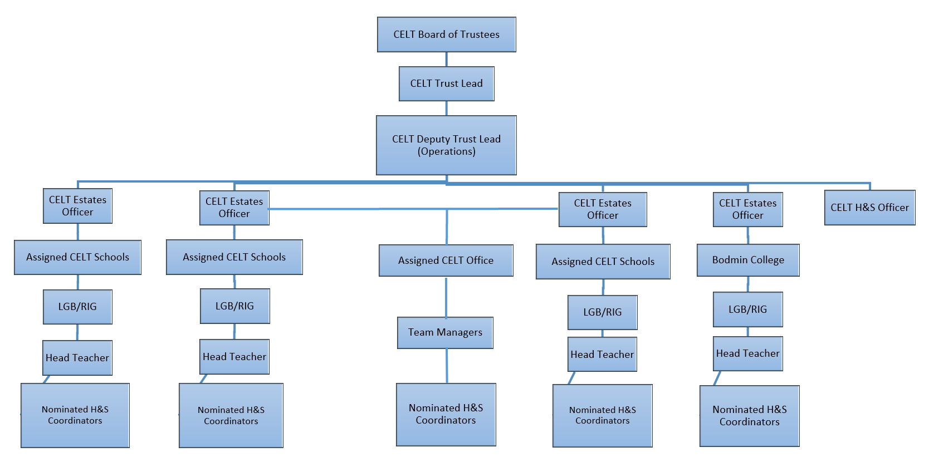

Introduction:

The Health and Safety at Work Act 1974 places ultimate and overall responsibility for health and safety with the CELT Board of Trustees and the Trust Lead (TL). However, each school, supported by the CELT central team, will manage its own health and safety procedures which fully integrate with this policy. Headteachers are responsible and accountable for the implementation and compliance of this policy within their school although health and safety roles and responsibilities can be delegated to other school staff. Management and monitoring mechanisms are in place to provide an overview of statutory compliance.

Board of Trustees:

The Board of Trustees, as a corporate body, has the responsibility to set the strategic direction and objectives of all health and safety matters across the Trust.

The Board of Trustees are responsible for ensuring that high standards of corporate governance are maintained. In the context of health, safety and welfare, it discharges these responsibilities by adopting an annual plan, monitoring CELT safety management systems and managing the Trust risk register. The overall aim is to ensure a positive health and safety culture is established and maintained across the Trust.

The Board of Trustees must ensure that all reasonable steps have been taken to reduce the possibility of accident or injury to staff, students and/or visitors.

The CELT Board of Trustees’ responsibilities are to:
- Ensure that each member of the Board of Trustees accepts their individual role in providing health and safety leadership for CELT.
- Ensure that it formally and publicly accepts its collective role and responsibility in providing health and safety leadership for CELT, by signing an agreeing to this policy.
- Ensure that its decisions reflect its health and safety intentions, as articulated in the CELT Health and Safety Policy Statement of Intent.
- Provide strategic direction in health and safety matters, by setting standards and expectations.
- Ensure that CELT suppliers and contractors have been appropriately vetted for health and safety standards.
- Ensure that the CELT TL is effectively discharging their responsibilities in terms of health and safety.
- Ensure that a proportionate and prioritised risk management system for the Trust is implemented and monitored.
- Ensure systems and processes are in place to ensure the Trust is compliant with its obligations in the management of fire risk, asbestos, legionella, electrical safety and other areas of health and safety.
- Ensure there are effective business continuity and emergency plans in place.
- Confirm that there have been no instances of material irregularity, impropriety, lack of integrity or negligence of health and safety statutory instruments. By taking part and receiving/acting on information from the H&S Committee.
- Ensure that adequate resources are committed to the management of health and safety.

Trust Lead (TL)

The TL must review, recommend to the Board and implement the Trust health and safety strategic plan; identify and manage risk at all levels of the Trust and keep the Board of Trustees informed on all health and safety matters.

The TL’s responsibilities are to:

- Inform and advise the Board of Trustees on:
  - Review of the health and safety policy
  - Risk mitigation
  - Recommendations from health and safety audits and compliance audits
  - Incidents reportable to the Health & Safety Executive under the ‘Reporting of Injuries Diseases and Dangerous Occurrences (RIDDOR)’ guidelines.
- Monitor and report to the Board of Trustees on the effectiveness of the Trust’s health and safety systems.
- Ensure that there are adequate communication and co-operation channels between all levels of the Trust and relevant third parties, in the context of this policy.
- Ensure that the health and safety policy and adequate health and safety management systems are in place within every school.
- Ensure that sufficient resources are allocated and authorised within the organisation’s budget to meet statutory procedures and standards for health and safety in the school

Deputy Trust Lead (Operations) and Estates Team

The CELT Estates Team is responsible for managing health and safety arrangements - including building works, contract management, maintenance, and compliance in such areas as fire protection, asbestos management, electrical inspections and control of legionella.

The CELT Estates Team must ensure that:
- Effective arrangements are in place for carrying out and recording compliance inspections, surveys and risk assessments, and recommending remedial action to the COO.
- When awarding contracts, health and safety is included in specifications & contract detail and contractors are provided with a copy of the Trust Health & Safety Policy.
- Ensure that any contracts awarded directly by the schools adhere to H&S requirements.
- Central Trust contracts are in place to ensure that premises, plant and equipment are maintained in a safe working condition.
- The correct procedures for awarding, checking competency, managing, monitoring and auditing all compliance contracts and maintenance service agreements on school premises are accurately carried out.
- School asbestos registers and asbestos management plans are maintained and readily available.
- Systems are established to ensure that all contractors engaged by the CELT meet health and safety requirements, including, relevant body registration, method statements, risk assessments, COSHH, accident records and safeguarding checks.
- Building projects comply with the Construction (Design and Management) Regulations 2015 (CDM 2015).
- Reasonable attempts to identify the hazards arising out of any contractors’ work are undertaken by requesting companies provide appropriate H&S documentation.
- Health and safety information is provided to contractors e.g., asbestos register, underground services, floor loading, safe working loads, school activities - ensuring safeguarding requirements are met – where necessary.
- There is a programme of servicing and inspection of workplace that is appropriately managed via a compliance contract.
- There is a programme to ensure that all safety systems are checked and serviced e.g., fire alarm, fire doors, firefighting equipment, smoke detectors etc.
- There is a programme to ensure that the use of showers and all water systems are checked and maintained to ensure the control of Legionella.
- Consider the impact of health and safety in all strategic and operational decision making.
- Monitor findings from Health and Safety audits, compliance audits, inspection audits, reporting of injuries, including undertaking annual inhouse H&S audits as necessary.
- Review Diseases and Dangerous Occurrences (RIDDOR) reports, and to implement changes to policy and procedures where required.
- Implement and monitor an informed, proportionate and prioritised risk management system for the Trust.
- Ensure there is an effective accident reporting and investigation procedure across the Trust.
- Lead on the investigation of incidents reportable under RIDDOR, where appropriate.
- Ensure that the Trust and its constituent schools have adequate business continuity plans in place, including emergency plans and procedures for the safe evacuation of the Trust’s premises.
- Ensuring all staff receive adequate health & safety training in line with the ‘Training skills matrix’.
- Be the point of contact with the Trust’s appointed Health & Safety consultant and ensure that the arrangement is fit for purpose and represents good value for money.

Local Governing Body (LGB)/Rapid Improvement Group (RIG):
Governors are responsible for monitoring compliance with statutory requirements and with the CELT H&S policy, and will:
- Ensure that H&S features as a regular agenda item at governor’s meetings.
- Appoint a nominated H&S Governor
- Review H&S reports (including the H&S Action Plan) submitted by the Headteacher
- Monitor, support and challenge the H&S performance of the school.
The LGB/RIG will monitor that so far as is reasonably practicable, the following is provided:
- Adequate allocation of resources, including time, for work and activities with implications for H&S to take place.
- A safe environment for staff, students, parents and visitors to go about their various activities.
- Adequate welfare facilities
- Necessary safety and protective equipment and clothing
- Safe plant, equipment and systems of work.
- Safe arrangements for the handling, storage and transport of articles and hazardous substances.
- Supervision, training and instruction so that all staff and students can perform their activities in a safe and healthy manner.
- The opportunity for all staff to receive H&S training appropriate to their duties and responsibilities. This should be given before an employee commences any relevant work. Whatever training is required by statute, or considered necessary for the safety of staff, students and others, the LGB/RIG will monitor that such training is provided. Students will receive such training as is considered appropriate to the school related activities that they carry out. Records will be kept of all training. Staff and students training will be regularly updated.
The LGB/RIG, so far as is reasonably practicable and in consultation with the Headteacher, will:
- Make itself familiar with the requirements of the Health and Safety at Work etc. Act 1974 and any other H&S legislation and codes of practice that are relevant to the work of the school, in particular the Management of Health and Safety Regulations 1999.
- Adopt and maintain an effective policy, organisation and arrangements for the provision of health and safety throughout the school.
- Identify and evaluate risk control measures in order to select the most appropriate means of minimising risks to staff, students, parents and visitors.
- Set standards and ensure responsibility is assigned (as a minimum) for:
  - Day to day operational H&S – via a nominated onsite H&S Coordinator
  - Reporting, recording and investigation accidents
  - Establishing and participating in the school Health and Safety committee (including LGB/RIG representation).
  - Providing and managing First Aid.
Headteacher

Each Headteacher is responsible and accountable for the implementation and compliance of this policy within their school, ensuring that a positive health and safety culture is encouraged and developed within the school, and that all staff and students understand their responsibilities and adhere to the CELT Health and Safety Policy.

The Headteacher is responsible for:
- Ensuring that there are effective arrangements in place for business continuity along with an emergency plan and/or relevant emergency procedures. Communicating the policy and other appropriate health and safety information to all relevant people within the school, including occasional contractors not appointed by the CELT Estates Team.
- Appointing/nominating a School H&S Coordinator.
- Ensuring that an investigation is carried out by a competent person, following an accident or incident and deciding on the level of investigation needed.
- Liaising with appropriate authorities and third parties as necessary e.g., Auditors, HSE, Inspectors, local authority officers, Ofsted.
- Ensuring that a school Health and Safety Committee is established.
- Reporting to the CELT COO any hazards which cannot be rectified within the establishment’s budget.
- Ensure that risk assessments are undertaken for any activity that has significant associated hazards and that a written record of these assessments is kept and reviewed regularly.
- Ensuring that the school appoints a named Educational Visits Coordinator, who has received relevant training to carry out the role (where educational visits are carried out by the school).
- Ensuring that there are effective health and safety management arrangements for educational visits.
- Appointing a named first aid coordinator for the school
- Ensuring that there is an adequate number of appropriately trained first aiders in the school, as per the first aid assessment of need.
- Ensuring that Health and Safety arrangements within the school are aligned to the CELT Health and Safety Policy.
- Ensuring that all reasonable steps have been taken to reduce the possibility of accident or injury to staff, students and visitors.
- Informing the CELT Estates Team of all RIDDOR reportable incidents within 24 hours of the incident occurring.
- Ensuring site security.
- Ensuring H&S is a standing agenda item on management and staff meetings.

School H&S Committee
Must meet a minimum of twice per year or following a serious incident or change. Where two or more schools share a site or site manager, a single committee can be established if there is representation from all schools.

The H&S Committee will review the following areas (where appropriate):
- statistics on accident records, ill health, sickness absence,
- accident investigations and subsequent action,
- inspections of the workplace by enforcing authorities, management or employee health and safety representatives,
- risk assessments,
- health and safety training,
- emergency procedures; and
- changes in the workplace affecting the health, safety and welfare of employees.

H&S Coordinators (to include, nominated H&S Coordinator, Heads of Departments (HoDs), Technicians, Curriculum Leads, Team Managers and other specifically nominated coordinators):

Although the Headteacher is responsible overall for health and safety in the school, H&S Coordinators have some specific responsibilities:

- Applying the CELT Health and Safety policy to their school or area of management.
- Developing, publishing and sharing with members of the team, specific Health and Safety procedures for high-risk activities within their department, such as Science, Design and Technology, PE and Art.
- Maintaining or having access to an up-to-date library of relevant published health and safety guidance from sources including CLEAPSS2, AfPE3 and ensure that all staff are aware of and make use of such guidance.
- Maintaining the risk assessment system, ensuring regular reviews following expiry and/or significant changes or incidents. To assist with risk assessments as and when required.
- Resolving any health and safety or welfare problems members of staff refer to them, informing the Headteacher or other Senior Manager of any problems to which they cannot achieve a satisfactory solution with the resources available to them.
- Checking that appropriate inspections are being carried out and recorded.
- Checking the adequacy of fire precautions and procedures in liaison with the Headteacher/Estates Team. Ensuring that a copy of the Fire Action Notices and assembly point(s) are prominently displayed in all rooms and areas for which they are responsible
- Ensuring, so far as is reasonably practicable, the provision of sufficient information, instruction, training and supervision to enable other employees and students to avoid hazards and contribute positively to their own health and safety.
- Establishing acceptable housekeeping and safe storage standards, in all areas of their responsibility/school.
- Developing a training plan, in line with the Trust training matrix, that includes specific job instructions and induction for new or transferred employees. Ensuring that the training needs of their staff are monitored and training opportunities made available.
- Ensuring that all accidents (including near misses) occurring within the school are promptly reported and investigated using the appropriate forms etc..

Other Employee Duties

Under the Health and Safety at Work Act etc. 1974 all employees have general health and safety responsibilities.
Staff must be aware that they are obliged to take care of their own health and safety whilst at work along with that of others who may be affected by their actions.

All employees have a responsibility to:

- Comply with the CELT Health and Safety Policy
- Report all accidents and incidents
- Report all defects in condition of premises or equipment and any health and safety concerns immediately to their line manager.
- Report immediately to their line manager any shortcomings in the schools’ arrangements for health and safety.
- Co-operate with the schools’ leadership and management on all matters relating to health and safety.
- Inform the schools management if something happens that might affect their ability to work safely, e.g., suffering an injury, taking prescribed medication, or becoming pregnant.
- Ensure that they only use equipment or machinery that they are competent / have been trained to use.
- Make use of all necessary control measures and personal protective equipment provided for safety or health reasons.

Volunteers

- Volunteers (such as parent-helpers, etc.) have a responsibility to act in accordance with the trust’s policies and procedures for health and safety and to report any incident or defective equipment to a member of staff immediately.
- Volunteers are also expected to act only under the supervision of a qualified teacher or other relevant paid member of staff.
- Volunteers are also expected to read and implement the code of practice supplied to them.

First Aid Coordinators

The First Aid Coordinator will be responsible for:
- Maintaining school and student records of first aid support given to staff and students.
- Maintaining first aid kit stocks and records. In conjunction with the school office, collecting data including administration of medication, Personal Health Plans, consent forms and medication retained, and keeping it up to date at all times.
- Checking that all medication held on the school site is stored and labelled appropriately and is within its use by date and informing the school office when any medications need renewing.
- Have oversight of the administration of medication.
- Arranging first aid cover for trips, visits and extra-curricular activities e.g., sports events, productions, after school clubs and academy fundraising events (where appropriate).

The School Administrators / Office Manager will be responsible for:

- Administering prescription medicines when parental consent has been obtained to do so, subject to appropriate training.
- In conjunction with the First Aid Coordinator, collecting data including administration of medication, Personal Health Plans, consent forms and medication retained, and keeping it up to date at all times.
- Requesting and collecting new or renewed medication from parents/guardians and passing this to the First Aid Coordinator for appropriate storage.
- Administering medication and liaising with the Health and Safety Team, Health Centre, School Nurses and parents as appropriate.
- Managing the input, maintenance and retrieval of all medical data in respect of pupils and staff at the school, ensuring that confidential information is held securely - this may be done by an appointed member of staff other than the Administrator.

Appointed Educational Visits Coordinator (EVC)

The Educational Visits Coordinator’s responsibilities are to:
- Coordinate off-site visits and ensure that effective health and safety management arrangements are in place for pupils, staff and volunteers.
- Ensure that suitable risk assessments have been recorded for the activity and suitable and sufficient actions and procedures have been implemented.
- Ensure that advice from the inclusion lead is sought if applicable for individual students.
- Communicate all relevant information and arrangements to providers of off-site visits, staff, pupils and parents / carers of pupils to ensure that the key learning objectives of the visit can safely be achieved.

Competent Health and Safety Advisor

CELT will seek competent Health and Safety advice to assist in discharging its health and safety responsibilities. Currently the service is provided by Cornwall Councils Health, Safety and Wellbeing Services Team.
A summary of the Service Level Agreement is as follows:
- Provide timely health and safety advice, support and training to the trust, schools and their staff.
- Support CELT in ensuring that all Members, Trustees, Governors and members of staff are aware of their duties and responsibilities in relation to health and safety, in line with UK legislation and any forthcoming legislation, and how to implement those duties to full effect.
- Undertake pro-active monitoring such as workplace inspections, audits and reviews.
- Explain and offer constructive feedback of the findings of the audits to senior managers in a style that achieves legal compliance and ‘buy in’. The findings of audits and inspections, in part, will feed into the strategic health and safety plan for the Trust.

Consultation with employees

Employees will be consulted, including any union-appointed safety representatives. Consultation with employees is provided by:

- Health & Safety Committee
- The Trust Lead
- The Estates Team
- Headteachers
- H&S Coordinators/Site Managers

School Operations:

Each school is required to establish and maintain a health and safety policy, mirroring exactly the Statement of Intent, and Organisation and Responsibilities of the CELT Health and Safety policy but setting out their own school operations and arrangements for health and safety, to implement the Trust’s policy.

The following sections provide a basic minimum standard of expectations for each school, details of which, are to be specified by the school, where relevant to its operations. There may be additional significant hazards at a specific school site for which further local arrangements should be added:

Additional CELT (and other recognised) guidance and safe working procedure for hazard areas can be found in the CELT Health and Safety Pack on the CELT HUB.

- Arrangements for supervision of students

Opening Times

On weekdays during term time:

The school will be open for Breakfast Club pupils from:- 7.45am

The school will open for all pupils from:- 8.35am

The main school day will finish at:- 3.05pm

All after school activities/clubs will finish by:- 5pm

Between these times supervision will be provided. Students will not be allowed on site outside of these times.

Supervision arrangements:
Risk assessment has been completed to determine the supervision needs for different parts of the day.
Staff members are on duty on a rota to cover; designated areas in the playground and lunch hal.
Breakfast and After school Clubs – the level of supervision is determined by the number, age of pupil’s booked to attend and the planned activities.

After School Lettings:
Unless specifically agreed in the Letting Agreement the School does not provide supervision for any groups using its facilities as part of a letting/hiring arrangement.

- First Aid

- A range of First aid boxes are located throughout the site and listed in Appendix 1

2. There are appointed first aiders. Details are listed in Appendix 1.
3. All significant accidents & cases of work-related ill-health must be recorded on forms and reported on AssessNET online. Minor first aid incidents for pupils are recorded in a first aid log or accident book. Location of books/forms and responsible persons are listed in Appendix 1.

4. The person responsible for reporting accidents to the enforcing authority/Cornwall Council (using AssessNET) is shown in Appendix 1. See section 6 of this policy for further information on incident reporting.

4. Health surveillance is required for identified employees, related to their specific tasks or daily duties.

The School has assessed the need for first aid provision.
Appointed persons and qualified first aiders holding a range of the following certificates (as identified by the assessment of needs); First Aid at Work, Emergency First Aid at Work, Paediatric First Aid, Emergency Paediatric First Aid, or Outdoor Education related First Aid certificates are available.
For EYFS, Paediatric First Aid trained personnel will always be available in school or out on trips/visits in accordance with section 3.25 and Annex A of ‘Statutory framework for the early years foundation stage’.
Provision to ensure cover for off-site, holiday activities, and staff absence has been considered.
Details listed in Appendix 1.
First aid coordinators
First aid coordinators (named in Appendix 1) are responsible for overseeing the arrangements for first aid within the academy. Their duties include ensuring: -
- that first aid equipment is available at strategic points in the academy as identified in Appendix 1.
- that the correct level of first aid equipment is maintained in each first aid box
- specific equipment e.g., eye rinses (tech rooms), are available where necessary
- that enough personnel are trained in first aid procedures (including for known pupil or staff medical conditions.)
- that first aid qualifications are, and remain, current (e.g. First Aid at Work Certificates are valid for 3 years)
- the school undertake an annual medical needs audit
This person will also regularly check first aid logs for indications of recurrent or frequently reported types of injury.
First Aiders
The first aiders listed will provide first aid treatment for anyone injured on site during the academy day. They will also provide, as appropriate, first aid cover for
- trips & visits
- extra-curricular activities organised by the academy (e.g. sports events, after school clubs, parents evenings, academy-organised fund raising events, etc.)
First aid cover is not provided for:-
- contractors
- events organised by third parties (fetes, evening clubs, etc.)
First aiders are responsible for ensuring that First Aid Logs are completed for all treatment given and that the necessary details are supplied for the reporting of accidents (see Reporting of Accidents section)

Those requiring emergency response for known medical conditions such as Allergies, Asthma, Diabetes or Epilepsy
All staff and children with known medical conditions requiring emergency response, will be recorded in the medical conditions annual audit with treatments specified. Emergency actions for severe cases will be available at the Main Reception Office. All staff are expected to be aware of this information and the response procedures. Relevant staff are trained to deal with medical emergencies. Employee’s and parent/carers of pupils will be requested to disclose relevant medical needs on joining, as they arise, or during annual audits. All food allergies are shared with the catering team on notification.
Treatment of Injuries
Each site will rely on the knowledge and experience of its trained first aiders to administer appropriate treatment to injured persons.
In emergency situations, the first aider will call (or will instruct another member of staff to call) 999 and request that an ambulance and paramedics attend.
Where there is any doubt about the appropriate course of action, the first aider will be expected to consult with the Health Service helpline: -
NHS Choices 111 (or other appropriate helpline service available)
and, in the case of pupil injuries, with the parents or legal guardians.

Suspected Head, Neck & Spinal Injuries to Pupils
In the event of a suspected head, neck or spinal injury to a pupil it is the policy of the School in addition to the normal first aid procedures, that the pupil’s parent/guardian is contacted and informed of the injury.
The attending first aider, in consultation with the parent/guardian, will decide the appropriate course of action in each case. The first aider will ensure that treatment is not delayed by difficulties in contacting the parent/guardian.
In any case where there is any doubt about the pupil’s wellbeing, the first aider is expected to contact NHS Choices for advice or phone for an ambulance as appropriate.
Other Significant Injuries
Any other serious injury will be notified to the parents/legal guardian by the quickest means possible (normally by phone).
In addition to the procedures above, the Academy will notify parents/legal guardians of any other significant injury by way of either:
- a telephone call
- or a note in a planner/ private message via appropriate school communication platforms
- follow-up letter to the above if necessary
Escorting Pupils to Hospital
When it is necessary for a pupil to be taken to hospital, they will be accompanied by a member of staff – unless the pupil’s parent or guardian is in attendance. Staff with appropriate business use insurance on their vehicle or other staff (covered by the CELT insurance for emergency journeys) may use their vehicle in an emergency to transport a child to hospital and best practice is to be accompanied by another supporting member of staff.
If an ambulance is used, then only one member of staff is required to attend.
The member of staff will stay with the pupil until a parent or guardian arrives and responsibility is “handed over”.
See CELT First Aid Guidance and Procedures (Appendix 6) for further information.

- Pupils and staff with medical needs

The school recognises that it has a responsibility to support pupils with medical conditions, so they can have ‘full access to education including school trips and physical education’. The school follows the CELT ‘Supporting pupils with medical conditions’ policy, which is in line with Department for Education’s statutory guidance.
When a significant medical condition is identified an Individual Healthcare Plan (IHP) will be written in accordance with the CELT Supporting Pupils with Medical Needs Policy
In addition to this, individual risk assessments will be completed where the students’ medical needs introduce new risks to an activity or increase existing risks. This may include (but may not be limited to) emergency response, off-site activities, sporting activities or practical lessons.
Individual healthcare plans are kept on the staffroom and in child’s classroom which all relevant staff should have access to and be aware of.

Staff with reported/known medical conditions will be supported through HR policy and processes (occupational health assessments, Employee Assistance Programme, wellness action plans, health surveillance etc) and locally by their line manager using risk assessment (where significant) to adapt, environment, equipment, or safe working procedures as relevant to their work role.

- Medicines

Medicines should only be administered at school when it would be detrimental to a child’s health or school attendance not to do so. The school will require parental written consent for a child under the age of 16 to be given prescription or non-prescription medicines. (See Appendix 3 of CELT Supporting pupils with medical conditions policy)

In exceptional circumstances, if pain relief medication is given, it must not contain aspirin unless prescribed by a doctor. Maximum dosages and when the previous dose was taken will be checked and parents will be informed.

The school will only accept prescribed medicines that are in-date, labelled, provided in the original container as dispensed by a pharmacist and include instructions for administration, dosage and storage. The exception to this is insulin which will be generally available inside an insulin pen or pump.

Staff should check that the medicine has been administered without adverse effect in the past and that parents have certified this is the case – a note to this effect should be recorded in the written parental agreement for the school/setting to administer medicine.

All storage facilities should be in an area which cannot be accessed by children without supervision. All emergency medication (not carried by a child themselves) e.g., asthma inhalers, adrenaline pens, dextrose tablets, blood glucose testing meters must be readily accessible (preferably in the same room as the child) but stored in a safe out of reach location known to the applicable child and relevant staff. At School medication is stored in the Main Reception Office. Paracetamol based or other prescribed medicines are kept with secure access at The Main Reception Office. Medication should be reviewed regularly to ensure it is in date.

At the end of a school term or when no longer required, the medicines will be returned to the parent/carer. Sharps boxes will be used for the disposal of needles and other sharps.

Administering medication, record keeping and storage

Medication will be administered in accordance with:

- Appendix 2 – Managing Medicines Guidance
- Appendix 3 - Receiving Medicine Record
- Appendix 4 – Administering Medication Record

of the CELT ‘Supporting pupils with medical conditions policy’.

This includes the procedure for the consent and administration of medication for off-site activities and visits, which should be managed and organised by the named activity lead.

Written records will be kept of all medicines administered to pupils for as long as these pupils are at the school. Parents will be informed if their pupil has been unwell at school.

Named staff approved to manage and dispense medicines are listed in Appendix 1.
Medication for personal use by members of staff must be kept in a secure location and must not be left in classrooms where pupils may be able to gain access.

- Sun Safe and Temperature

As part of CELT Healthy Schools work, we raise awareness of how to enjoy the sun safely. Statistics show increases in the cases of skin cancer in Cornwall driven in part by exceptionally high UV levels and the prevalence of outdoor activities and lifestyles. It is important to act early to prevent damage from a young age.
It is recognised that we all need some sun exposure; it’s our primary source of vitamin D, which helps us absorb calcium for stronger, healthier bones. However, it doesn’t take much time in the sun for most people to get the vitamin D they need. Unprotected exposure to the sun’s ultraviolet rays can cause skin damage, eye damage and even cancer.
As a Trust we will encourage all our staff, pupils, and students to be ‘Sun Safe’. Each academy will adopt their own practice in guiding everyone in being safe in the sun.
Staff will guide everyone including themselves to be safe in the sun. Children are reminded to wear hats during playtimes, lunchtimes, outdoor P.E. lessons and trips and visits. Parents will be advised and reminded that sunscreen should be applied before pupils come to school. Pupils will be encouraged to drink constantly, particularly in hot weather to prevent dehydration.
Sun safety, heat stress and temperature will be considered within activity and environment risk assessments for both pupils and staff, postposing, adapting, relocating, or adjusting the timing and content of trips and visits or activities to lower the risk of harm.
Especially in response to more frequent extremes of temperature.
Temperature, UV index, activity, time of day, clothing, duration in the sun, access to refreshments, access to shade, medical conditions, and ventilation will be considered as part of activity or environment risk assessments for both pupils and staff (including outdoor workers) to prevent sunburn, heat stress, heat exhaustion or heatstroke.
Further information on safe sun practice can be found at:
Sun Safe Schools
SunSmart: the UK’s national skin cancer prevention campaign
HSE – Outdoor workers and sun exposure
HSE – Heat stress
Risk Assessment will be made for employees who are exposed to lower temperatures due to activity i.e. working externally or with chilled and frozen goods and measures put in place (PPE, clothing and or time restrictions etc. ) to protect them.

- Accidents/Incidents

Students will report incidents to a member of staff.

First Aid treatment is recorded in local area ‘Accident Books’ or ‘First Aid Logs’. Accident books/First Aid Logs and incident reports are reviewed regularly by the First Aid/Health and Safety Coordinator for any possible patterns emerging.

In addition to the accident books or first aid logs, All staff are responsible to report significant incidents or near misses (see below) to the appropriate activity/area lead and the Reporting Officer using the appropriate form, for reporting onto AssessNET.

Forms for reporting incidents are available from:
- The Reporting Officers
- On staff shared drives in a Health and Safety area
- On AssessNET (Accident/incident reporting module – Printable module templates)
- In the CELT H&S Pack on the CELT HUB

Reporting Officer
The reporting officer (see Appendix 1) is responsible for the collection of information and the completion of the Accident Report onto AssessNET. In his/her absence, this role will be fulfilled by Deputy Reporting Officer (see Appendix 1).

All significant incidents (as specified below) must be reported as soon as is practicable (keeping in mind the RIDDOR reporting requirements within 10 days of the incident – see section on RIDDOR reporting below) on the Cornwall Council online incident reporting software AssessNET.

Minor Injuries
- Any ‘significant’ injury to anybody arising out of a work or school activity (structured or unstructured).
- Occur due to a defect in property of equipment
- Required first aid treatment (this does not include very minor play injuries such as bumps and scrapes, and bruises or paper cuts recorded in the red accident books’

Hospitalisation of Non-Employees
- Any injury incident to a person not at work (e.g., Pupil or visitor) taken from the scene of the incident to Hospital or other medical facility.

Over 7-day injuries (report within 15 days of the incident)
- Any injury to an employee, trainee or contractor which results in the injured party being unfit for normal duties for 7 or more consecutive days (excluding the day of the incident).

Specified Major Injuries (Employees)
- Any injury which meets the criteria for specified injuries as set out in RIDDOR (fractures (not fingers or toes), loss of consciousness, hypothermia, heat induced illness, eye damage leading to permanent partial or loss of vision, serious burns, crushing, amputation)

Violent Incidents
- Any instance of violence physical or verbal to an employee, trainee or contractor, or where another pupil was taken direct for medical attention.

Dangerous Occurrences (collapse of scaffold, explosion etc)

Specified Occupational Disease (Repetitive strain injuries, occupational asthma, hand-arm vibration etc)

Near Miss
- Any incident that, while not causing harm, had the potential to cause significant injury or ill health.

Incident Investigation
All incident reports will be seen by the Headteacher (supported by the Health and Safety Co-ordinator), who will decide if an investigation is necessary and review if appropriate remedial action has been taken to ensure similar cases are prevented in the future. The results of any investigation will be recorded on the online incident report.

Major incidents will be reported to the Local Governing Board and Board of Trustees.

Following an incident, the manager or activity lead for that area will review related risk assessments or safe working procedures to revise any necessary controls.

Incidents Reportable to the Health and Safety Executive (RIDDOR)
The council Health, Safety and Well-being team review all incidents reported on AssessNET and make relevant reports to HSE on behalf of CELT. They may make requests for further information, which should be provided as soon as possible to remain within statutory reporting requirements (within 10 days of the incident) and may make appropriate recommendations for remedial action to be taken to ensure similar cases are prevented in future.

CELT Guidance – Accident Incident Reporting and Investigation (available in the CELT H&S Pack on the CELT HUB) should be followed to guide reporting and investigation.

- In-House Catering Provision and Food Hygiene

Any in school food preparation will be overseen by a member of staff with at least a Level 2 Food Safety and hygiene certificate.

The school (this includes the provision of food provided during wraparound care) follows the guidance and practices outlined in the ‘Safer Food, Better Business – Caterers Pack’ issued by the Food Standards Agency, which includes guidance on:
- Cross-contamination
- Cleaning,
- Chilling
- Cooking
- Overall management

The school follows the guidance and practices outlined by the Food Standards Agency for:

Food Hygiene

Allergen guidance for food businesses

Prepacked for direct sale (PPDS) allergen labelling changes for schools, colleges and nurseries’ also known as ‘Natasha’s Law’.

Wraparound provision providing food will be registered as a food business.

The above may be achieved for wraparound food provision by working with the catering contractor on site.

Risk assessment will be made for key hazards and risks relevant to the catering environment such as, Fire (frying etc), burns, slips trips and falls, knives, manual handling, temperature, COSHH and use of specialised catering equipment.

For DT Food curriculum, the activity lead will risk assess the activity. CELT has membership to CLEAPSS (details in the CELT Health and Safety Pack) which has model risk assessments and guidance to assist this process.

The school contracts its main catering provision to Chartwells

- Compliance and Mandatory Testing

The school procures its compliance and mandatory testing as part of the tender package sent out via the Trusts Estates team.

Those services not procured in this way are done so in-line with the requirements set out in legislation.

All records of compliance and mandatory testing are stored in the following way.
- Hard copies of key compliance information are located on site at the school for the past 2 years in particular Fire and Asbestos Folders are kept up to date with a full set of paper documentation.
- Electronic copies are stored on the trusts compliance platform My Compliance and or shared folders for all previous years.

- Control of Contractors:

The Site Manager/s (Appendix 1), or the Headteacher is responsible for overseeing the management of all contractors on site.
They are also responsible for ensuring all contractors have received H&S information and been inducted, such as may be needed to minimise the risk from the contractor’s activities on School site.
Centrally appointed contractors are pre-vetted, and their key information is held centrally and available (through My Compliance) to school reception and site staff.

Where the school appoints a contractor who is not on the central appointed list, the school is responsible for the following pre-work checks and contractor management.

Selection of Contractors
The school will only select contractors to carry out work who meet/have the following criteria: -
- Competence to carry out the work required (by way of training, knowledge and experience)
- Assessment of the risks associated with the work
- A safe scheme of work
- Appropriate management of the work
- Appropriate vetting procedures for their employees where appropriate
- Appropriate employers and public insurance

Management of Contractors
Supervision of contractors will, to an extent, depend on the type of work being carried out: -
- New contractors or contractors visiting the site on a one-off basis will be directly supervised by a member of school staff.
- Term-time contractors or regular contractors to the site will only be allowed unsupervised access following appropriate checks and assurances from the employer.
Where contractors are engaged to work with the fabric of the building or the site, the nominated CELT Estates and Facilities Officer/Site Manager should be consulted during project planning to ensure Health and Safety information (in particular the Asbestos Management Plan and register of known Asbestos Containing materials) has been checked, shared and signed where appropriate, or additional surveys have been requested, so that the works will be compliant with relevant building and health and safety legislation.

All contractors likely to enter service areas (lifting ceiling tiles, roof spaces, service cupboards, ducts etc) or disturb the fabric of the building must view and sign the Asbestos Management Plan and register on site before starting work.
All contractors will be required to sign-in and out and carry visible identification which should include a school visitors’ badge/lanyard unless they are in a separated work area.
All contractors will be issued with the CELT Code of Conduct, as part of their site induction and will be monitored against its requirements.
Direct supervision will not be necessary where the area of work is physically separate from the school (for example: where there is a separated construction compound on site) as agreed with the Site Manager.

Construction Works
For all construction works (other than minor maintenance works) the area under construction will be physically separated from the rest of the school and will be out-of-bounds to all non-construction workers except for the purposes of contract management.
The school will follow the CELT guidance on use of contractors available in the CELT H&S Pack on the CELT Hub.

- Vehicles and Driving for Work

Driving for work can be defined as any driving carried out by an employee for work (separate to their commute between home and their usual place of work – i.e. any CELT site) whether in their own or a work vehicle.

The school will follow the CELT Vehicle Policy and Procedures (available in the CELT H&S Pack on the CELT Hub) and ensure the following legal requirements are checked and recorded for vehicles used for work purposes.
Legal Requirements - The law requires that a vehicle must:
- Be insured for business use (fully comprehensive for CELT owned vehicles).
- Be well maintained.
- Have a valid MOT certificate where required.
- The vehicle needs to be taxed.
- Have the correct seating with correctly fitted seat belts.

The school will ensure the drivers of vehicles have a valid licence and training where appropriate (such as for minibus driving) that entitles them to drive the class of vehicle they use for work as well as any equipment towed.

Employees who regularly drive their own vehicle for work should add ‘business use’ to their insurance policy, which is often free on renewal.

The CELT insurance policy covers employees for ‘occasional business use’ in the case of an emergency where an employee is required to drive for work unexpectedly.

Following changes to legislation on 25 March 2022, motorists are breaking the law if they use a handheld mobile phone behind the wheel for any use, this includes when stopped at lights, in traffic, or in a start/stop vehicle. Hands free devices may be used but must not restrict view and must not be interacted with by hand at all, whilst driving. It is acknowledged that even when using hands-free whilst driving, attention and response to hazards is reduced and so should be minimised, where possible.

To drive safely, drivers should, observe the Highway Code, be physically fit to drive, not be under the influence of any drugs or drink, take regular breaks and have sufficient separate support to supervise pupils in the vehicle.

Risk assessments will be completed for driving at work, particularly for any activities involving the transport of pupils prior to that activity taking place.

Any driving for work purposes, including the transportation of pupils, will be authorised by Headteacher.

- Business Continuity and Critical Incident

Critical incident
In the case of site wide critical incidents e.g., a major fire or other significant risk affecting the health and safety of users, the relevant emergency/critical incident procedure will be implemented in accordance with the school’s critical incident plan.
Procedures are unique to each site and the specific arrangements detailed in the school’s Critical incident/Emergency Plan (a CELT Emergency Plan template is available in the CELT H&S Pack on the CELT Hub) informs the following Appendices:

- Appendix 2 – Fire Evacuation
- Appendix 3 – Emergency Evacuation
  - Emergency off-site evacuation procedures will be reviewed once per year in the case of a site wide critical incident. This will likely be a partial practice of key staff meeting, or walking through the process, checking routes, access to and safety of their proposed off-site location.

- Appendix 4 – Emergency Closure Procedure
- Appendix 5 – Lockdown Procedure
  - To be rehearsed at intervals no less than 12 monthly, preferably in the first term of the school year.

- Training

Induction

All employees will be given health and safety induction by an appropriate person at each site when they start work, which will cover basic site instructions such as first aid and fire safety.
- Induction training will be organised by site specific CPD Coordinators.
- There will also be appropriate ‘On the job’/job specific health and safety induction, arranged and provided by line managers/departmental heads as appropriate.
- The ‘master’ induction pack is overseen and updated by the site CPD Coordinator.
- The CELT Induction Training Checklist will be used to guide this process.

Training for specific roles

Specific jobs/roles requiring specialist training are identified as part of the staff appointment
process, using the CELT training matrix and/or annual staff review process.

- All staff members are required to continually review their personal CPD with their line manager and bring all training and development requests to for consideration prior to submission to the relevant CPD Co-ordinator.
- All line mangers will review the balance of H&S training within their team group, maintain a competent workforce.

Other training

- On-line H&S training is available through iHasco (Interactive Health and Safety Company), through which all CELT employees will be assigned mandatory training modules to complete including Health and Safety Awareness and Fire Safety in Education. Other modules will be assigned dependent on job role.

- Training will be identified, arranged, and monitored by line managers/departmental heads and the relevant CPD Coordinator.

- In addition, training will be provided if risks change, and refresher training when skills are not frequently used.

- Training records are kept by the CPD Coordinators and held on personnel files. The school/CPD Coordinator shall keep an overall view of those trained on site to ensure sufficient staff are trained in key roles such as First Aid or Team Teach and that is training is refreshed as required.

- Further training and guidance is available through the CELT H&S Officer and or Cornwall Council’s Health Safety and Wellbeing Team.

- Risk assessment

The school will seek to identify all activities and situations where there is a likelihood of significant risk. Significant risks will be assessed, and controls will be introduced to remove or reduce those risks (in most cases) to a ‘reasonably practicable’ level.

Risk assessments will be undertaken by all staff as appropriate to their areas of responsibility or activities that they lead. Staff are responsible for managing the risk assessment process within their classrooms, work area, the academy, or all other activities, to consider the risks to pupils, themselves, staff, or any others that may be affected.

Senior leaders, department/faculty heads, curriculum, area, or activity leads are responsible for ensuring risk assessments are completed for activities where there is a significant risk.

Site Managers with support from the CELT Estates Team are responsible for assessing risks associated with the grounds and building.

Risk assessments will be completed using the Cornwall Council online risk assessment system AssessNET, for which access and training can be organised through your H&S Coordinator (see Appendix1)

Risk assessments in specialised areas must be based on guidance provided by external advisory bodies such as:
- CLEAPSS – Science, DT and Art;
- Association for Physical Education (AFPE) – PE;
- Outdoor Education Advisors Panel (OEAP)
- Food Standards Agency Safer Food, Better Business – In-house Catering provisions
- Lantra – Grounds Staff
- Health and Safety Executive (HSE) – Site Team/All
Safe Working Procedures – The risk assessments will be used to develop safe working procedures which must be shared in a timely way, with those who have responsibility for or are involved in that activity and followed by all staff. Safe working procedures form the basis of operating procedures and copies should be made easily available to all, either printed or online in appropriate class, departmental or team areas.

- The findings of the risk assessments will be reported to line managers/departmental heads.

- Action required to remove/control risks will be approved by line managers/departmental heads and approved staff as appropriate.

- The persons responsible for ensuring the action required is implemented are line managers/departmental heads other approved staff as appropriate.

- Line managers/departmental heads and other approved staff as appropriate are responsible for checking that the implemented actions have moved/reduced the risk/s to an acceptable level.

- Assessments will be reviewed annually, when the activity or needs of an individual change or if additional risks are identified (such as after an incident), whichever is the soonest.

- Documented Risk assessments will be held by relevant sites and departments.

- The Health and Safety co-ordinator is responsible for producing relevant reports for the CEO, Estates team, Headteachers and Trustees.

See CELT Risk Assessment Policy and Procedures (CELT website and H&S Pack on the CELT Hub) for further information.
14) Educational Visits
The Education Visits Coordinator (EVC) is responsible for over-seeing and co-signing (with the Head) the safety of Educational Visits out of schools. Individual teachers in charge/visit leads will write and clear their risk assessments for a visit and associated activities with the Head/EVC.
Educational visits documentation (including risk assessments) for visits that meet the following criteria will be submitted (in appropriate time for endorsement) to the Cornwall Council Educational Visits Service for additional hazard and risk control checking.
Visit type | Submission to CC EVC database for approval
50 miles from base (unless residential or foreign) | 1 month
Adventurous activities (sailing, climbing, surfing, etc | 1 month
Residential visits | 3 months
Foreign visits/Expedition to a remote area | 3months/12 months

The school will follow the guidance of the Outdoor Education Advisory Panel (OEAP) and CELT Educational Visits Policy, Guidance and Procedures available in the CELT H&S Pack on the CELT HUB.

15) Fire Safety
Fire and Evacuation procedures
Procedures are unique to each site. Specific arrangements for this site are detailed in Appendices 2 and 3.
All Staff
All staff are responsible for ensure that
- they understand their possible escape routes and that pupils and visitors evacuate in an orderly and timely fashion in the event of the alarm sounding. That
- fire escape routes are not blocked and remain clear of combustible materials
- combustible materials, flammable and explosive substances are stored appropriately away from heat and ignition sources
- flammable substances are stored in flam cupboards away from heat sources
- that fire alarm call points remain accessible
- that firefighting equipment remains in position and accessible
- they do not leave fire-doors wedged open in unoccupied spaces
- they report any fire hazard or fire safety equipment defect.

Fire Officer
The fire officers (see Appendix 1) are responsible for:
- Arranging fire evacuation drills (see below)
- Reviewing and recording the significant results of the fire evacuation drills
- Through the Site Managers ensuring that the Fire Log is kept up-to-date (arranging for alarm tests every week, emergency lighting every month, fire extinguisher checks, etc.)
Fire Wardens
Fire Wardens (Appendix 1) may assist in the monitoring fire safety of the premises or during and evacuation by:

- Assisting with the operation of the fire panel
- Checking assigned area have been evacuated
- Supervising and directing students and staff to areas of safety
- Assisting with the roll call.
- Monitoring fire safety in their work area.

Fire Officers and Wardens will complete Fire Warden in (Education) training (iHasco), any training specific to their site procedures and may (if relevant) receive Fire Extinguisher training.
Site Manager

1. The Site Manager is responsible for ensuring fire risk assessments are undertaken, implemented and actioned.

2. Escape routes are checked on a regular basis by Site Managers and their teams (where appropriate) as part of daily routines.

3. Fire extinguishers are maintained and checked by Site Managers and their teams (where appropriate) on a visual basis within daily routines, with full annual maintenance inspections and remedial work undertaken by an approved contractor within organised property compliance arrangements.

4. Alarms are tested by Site Managers as a weekly inspection, with full annual maintenance inspections and remedial work undertaken by an approved contractor within organised property compliance arrangements.
PEEPS – Personal Emergency Evacuation Plan

A PEEP will be agreed for anyone who may require additional assistance (i.e. cannot evacuate themselves along with others to the usual assembly points without assistance) to evacuate the premises in the event of an emergency. E.g. those with limited mobility, visual or hearing impairment or other special educational needs.
Fire Drills/Evacuation Practice

Fire Drills will take place termly as a minimum and at the start of the Autumn Term specifically to provide training for all staff and students. There will be at least one planned drill per term and often there are unplanned evacuations, but dependent on the complexity of the site, it may be necessary for the Fire Officer to implement the following to ensure safe evacuation.

Drill 1 - All staff and students are to be aware of this and be prepared to move out. Details of the procedure are:

- Form Tutors have explained the procedures to their forms.

- Staff teaching students at the prescribed period remind students of the procedures.

- In each classroom there should be a fire notice outlining the action to be taken. If there is not one in a room Form Tutor should inform the site manager.

- The assembly areas are prepared with indicators for each form group showing where they should line up.

Drill 2 - Will take place and ONLY THE STAFF will know when it will be.

Drill 3 - Will take place unannounced to anyone except SLT

The above may take place in the first term (if required, usually at larger sites) or can be spread across the Spring and Summer Term drills.

Whole site evacuation information moved up into the Critical incident section 11

16) Electricity
The school will undertake to inspect and test all portable electrical appliances by a competent person and according to the level of risk posed by individual items. Between 1 and 3 years as best practice guidance recommends.
These tests are to be arranged or carried out by trained staff as identified in Appendix 1.
Coordinator
Persons named (see Appendix 1) are responsible for keeping up-to-date inventories of all relevant electrical appliances and for ensuring that all equipment is available for testing.
Persons named in Appendix 1 is responsible for liaising with contractors to arrange fixed wiring inspections (every 5 years), although these can be undertaken on a phased basis.
Persons named in Appendix 1 will organise any electrical works through competent contractors. No electrical works shall take place by employees unless assessed as suitably competent for specific activities as risk assessed and agreed with their manager.
Personal Items of Equipment
Personal items of electrical equipment should not be brought into academy for use by staff or pupils.
Where possible rechargeable battery type pieces of electrical equipment should be used, that do not require electrical supply.
All Staff
Staff will always visually inspect electrical equipment before use for obvious defects such as cracked housing or defective/damaged cables or plugs.
Defective equipment will not be used.
Any problems found with plant/equipment should be reported to one or more of the relevant people listed above. However:
Dangerous faults must be reported immediately, and all equipment removed immediately from active use (locked away and or clearly marked as defective).
Other equipment may be reported later and if considered not fit for purpose removed from active use (locked away and or clearly marked as defective).
Only electrical equipment suitable for its purpose or environment will be used, i.e. for internal/external use etc.

- Control of hazardous substances

Chemicals can cause you and others harm - cause skin allergies, asthma or skin burns and eye damage.

Some substances are easily identifiable as hazardous to health such as cleaning or site chemicals, others are not so clearly identifiable and may become hazardous through an activity such as dust from sanding wood or using clay, or vapours from heating plastics or solder.

When carrying out a COSHH risk assessment, consider those with by-products of a process or activity.

The most hazardous substances are given Workplace Exposure Limits (WEL’s), listed in the Health and Safety Executive (HSE) document EH40.

Hazardous products are often labelled with hazard symbols; white diamond with a red surround and black symbol, or list hazard phrases such as ‘Health Hazard’, ‘Corrosive’, ‘Toxic’, ‘Irritant’ or ‘Harmful’.
All Staff
All staff must ensure that they do not use any potentially hazardous substance without first familiarising themselves with the requirements of the COSHH assessment or requesting one from the COSHH Coordinator.
Hazardous substances should:
- be used as recommended in the COSHH assessment and/or by the product safety labelling and information
- Always be securely locked away from access to pupils
- Stored in clean, cool, and dry conditions, away from heat sources and in dedicated flammable storage if they have flammable properties (unless used in controlled and small amounts i.e. hand sanitiser)
- never be decanted into unmarked containers or bottles
- not be mixed
- not be used if you are not trained to use them safely
- not be left unattended
- be considered in risk assessments for work activities or lesson schemes of work where hazardous substances could be created through a process (dust, vapours, aerosols).

CELT follows the Hierarchy of Control for hazardous substances.
- Elimination (if possible don’t use a hazardous product,
- Substitution (for a less hazardous product),
- Engineering controls (mechanical ways of reducing the risk for all, such as LEV)
- Administrative controls (organisational controls or safe working procedures for a substance)
- Personal protective equipment (last resort because it only protects the wearer).
As such for general surface cleaning and sanitation, each site has been provided with a (COSHH free) Tersano unit that produces, ozone aqueous solution (used in spray bottles with a sanitising lifetime of 48 hours and cleaning lifetime of 5 days. This should always be the first product used for these purposes (rather than ant-bacterial products that have hazardous properties). Tersano solution can be obtained in spray bottles from your site team.

The school will assess the risks from all substances hazardous to health. These are known as COSHH assessments and the arrangements for completing these are detailed below.
All substances which may be considered hazardous to health will be assessed prior to use, (except those used in secondary level Science – these are covered by the CLEAPSS HazCard system).
In addition, any hazardous substances / materials being used by artists, crafters, etc. must have appropriate COSHH assessments before being used in the academy.
COSHH Coordinators
Coordinators (Appendix 1) are responsible for:
- Identifying substances and ensuring a COSHH assessment has been obtained for any new substance prior to its use.
- Undertaking/requesting COSHH assessments
- Maintaining the schools COSHH register including timely review of assessments

COSHH assessments are obtained through the Cornwall Council Sypol Database by COSHH Coordinators at Schools.
See the COSHH Guidance for schools and COSHH Procedure within the CELT H&S Pack available on the CELT HUB.
- reviewing the risk ratings and suggested controls in the COSHH assessment

- ensuring that all actions to lower risk identified in the assessments are implemented or identifying a lower hazard product
- ensuring that all relevant employees exposed to a product/substance are informed of the COSHH assessment and its recommendations to lower risk
- that the COSHH file (physical and/or electronic) is kept up-to-date and available in case of emergency. -

Documented COSHH assessments are usually physically held at office areas related to each of the listed functions or shared file areas.
- Assessments will be reviewed on a cycle as advised by the assessment, when the work activity or users change, or when accidents or incidents occur, whichever is soonest.

- ensuring that COSHH assessments are in place and accessible for contractors on site (both regular contractors such as cleaners and through the Risk Assessments and Method statements (RAMS) for specific projects from builders, decorators, flooring specialists, etc.), where persons may be affected by their use on site, or the storage of such substances / materials may need to be controlled.

- Personal Protective Equipment (PPE)

Personal protective equipment will be supplied to control hazards as a last resort, where the hazard cannot be removed or reduced to an acceptable level of risk by other means.
The need for PPE will be determined through the risk or COSHH assessment process and where identified as necessary PPE will be provided without cost to the user. Where issued the user must use it and wear it correctly, storing and maintain it properly if required.
Specialist Technical Staff, Site Managers, H&S Co-ordinators as appropriate will be responsible for the purchase of PPE ensuring that it is of the correct type, is suitable for the purpose, the correct size to ensure that the fit is comfortable, provides the correct safety protection for the wearer and that staff are given appropriate instruction on its correct use. This includes provision of PPE for CELT employees or temporary workers.
Where specialist PPE is required, staff may wish to refer to the CELT Health and Safety Officer, Health and Safety Team at Cornwall Council for advice or the Health and Safety Executive for guidance.
In addition, responsible staff will ensure that suitable arrangements are in place for the storage, cleaning, disposal and replacement of PPE. (Replacement PPE must be always readily available).

- Display Screen Equipment

The School acknowledges that health and safety hazards (such as repetitive strain or musculoskeletal injuries) may arise from the use of display screen equipment (DSE). It is the intention of the school to ensure that any risks are removed or reduced to a minimum.
Whilst it is generally recognised that the use of DSE can be undertaken without undue risks to health, it is appreciated that inappropriate work practices or poorly set up workstations may encourage the onset of ill health. The school will seek to give information and training to enable a fuller understanding of these issues.
This policy applies where DSE is used by people at work including agency and temporary employees and to all workstations including shared areas.
DSE users are defined as:-
- employees who use display screen equipment as a significant part of their normal work; and
- use DSE for continuous or near continuous spells of an hour or more at a time; and
- use it in this way more or less daily; and
- have to transfer information quickly to or from the display screen equipment; and
- a requirement to apply high levels of attention and concentration;
- or are highly dependent on DSE or have little or no alternative means of completing the work/task.
The school will, in consultation with employees and their representatives:
a) ensure suitable assessments of workstations are carried out regardless of who provides them, taking account of the DSE used, furniture, equipment, working environment and the employee;
b) reduce the risks identified in consequence of any assessments to the lowest extent reasonably practicable;
c) plan activities of users to ensure DSE work is periodically interrupted by breaks or changes of activity;
d) on request, arrange for the provision of eyesight tests for DSE users;
e) arrange for the free supply of special corrective glasses where required specifically for working with DSE;
f) provide information, instruction and training to ensure that DSE users are aware of the potential risks to health and how these can be avoided.
Staff will complete individual self-assessment and iHasco DSE training as set out in the Guidance and Procedures in the CELT H&S Pack, available on the CELT HUB.
Qualified DSE Assessors named in Appendix 1 will undertake to review DSE arrangements and the self-assessments.

- Work equipment

Budget holders will be responsible for overseeing the purchase of work equipment.
All work equipment must be purchased from a reputable supplier for the type of equipment that is required.
Before purchase consideration must be given to
- the installation requirements,
- the suitability for purpose,
- the positioning and or the storage of the equipment,
- maintenance requirements (contracts & repairs);
- training and use of the equipment
- second-hand plant and equipment meets health and safety standards before purchase
Staff must not use new items of work equipment unless appropriate training has been given.
Persons responsible for following this are departmental heads, budget holders, technical support staff, Site Managers. This will include:
- identifying all equipment/plant needing maintenance;
- ensuring effective maintenance procedures are drawn up;
- ensuring that all identified maintenance is implemented;
- check that new plant and equipment meets health and safety standards before it is purchased.

Use the CELT Work Equipment Form available in the CELT H&S Pack on the CELT HUB to plan/record the above prior to installing any new equipment.

Any problems found with plant/equipment should be reported to one or more of the relevant people listed above. However:
Dangerous faults must be reported immediately, and all equipment removed immediately from active use.
Other equipment may be reported later and if considered not fit for purpose removed from active use.
Checks should always be undertaken prior to use.
All test certificates will be retained by Site Managers or other approved managers for the duration of the life of the appliance.

- Lone Working

Ideally staff should not work alone at school as there are risks involved, such as assault, accident or sudden illness. However, it is recognised for operational effectiveness, staff will want to work outside of normal hours or in the case of other staff e.g. members of the site team, may be required to work within pre-defined shift arrangements and other ad-hoc cover arrangements for activities such as evening and weekend lettings, or maintenance duties etc.
Risk Assessment
Lone working will be risk assessed and suitable controls put in place to minimise the risks.
Regular or routine instances (such as members of the site team working within pre-defined shift patterns) of lone working must be risk assessed.
For occasional or un-planned periods of lone working staff must carry out a dynamic assessment of the risks (i.e. consider the factors relating to the situation at the time), use common sense and follow the requirements of this policy.
Prior to working alone
Any member of staff (except for Site Staff) wishing to work outside of normal hours or during school holidays, must ensure that
- They have the prior agreement/permission of the Headteacher or Site/Premises manager.
- Organise (if possible) that at least one other colleague is on site, – ideally within ‘hailing distance’, or with both parties having mobile phones programmed with each other’s numbers, or close and easy access to an internal telephone handset that can dial internal and external numbers, or two-way radio.

At the time

When working alone (or are working during a holiday period) on site, or you are part of the team where your shift pattern and contract of employment necessitates lone working, you must take the following precautions: -
- Complete the visitors’ log (both on arrival and leaving) in case of fire or other emergency to provide a reference for other staff/emergency services to trace and verify staff safety.
- Carry a mobile phone with you.
- ensure that at least one other person knows you are on site, when you are expected to arrive home and that they have contact details of appropriate school staff, to raise the alarm if required.
Contacting the Site Team
Details listed in Appendix 1 under Site Managers.
Limitations on work to be carried out when working alone
- Do not work at heights on a ladder or steps
- Do not go into lofts or any other space in which you might become trapped
- Do not do any tasks involving hazardous tools or materials
- Assess your own physical ability to undertake the task
- Avoid working outside of the site complex
- Lock the doors and close the windows to prevent potential intruder access
- Know the location of your nearest fire exit and how to open it in an emergency
- Know the location of the nearest first aid kit
- If working after dark, always carry a torch when accessing un-lit areas
- When leaving, limit the amount you are carrying to have one hand free
- If you arrive at school or during the period of attendance, and find any sign of intruders, do not enter the building and avoid potentially dangerous confrontation. Instead, call the Police in the first instance followed by the on-site Site staff, or other management personnel.
- Do not work alone if you know you have a medical condition that might cause you to become incapacitated or unconscious.
- When working alone, do not attempt any tasks which have been identified as medium or high risk (including a change in the environmental conditions that may affect the level of risk), or which common sense and/or a dynamic risk assessment tells you are potentially hazardous given your own level of expertise and the nature of the task.
Summary
It is established that staff may want on occasions or be required for operational/contractual reasons to work on-site at times outside of the normal hours or in holiday periods. Ideally staff should not find themselves in a lone working situation, however where this is unavoidable, all staff must use practical common sense and undertake a dynamic risk assessment, using the guidance above (although this should not be considered exhaustive), to ensure that the risks are adequately controlled).

- School Security

Jonathan Warnham the appointed person responsible for the security of the site.

Persons responsible for closing the site are: Churchills cleaning staff

Please assist them, by closing windows and doors and locking them from inside and closing blinds and turning off lights, equipment and carrying out any other closing checks before you leave your work area.

Staff who visit the school site out of hours are responsible for checking with the Site Manager prior to the time, regarding security of the school as they leave and setting the alarm.

The school is monitored for security by PJI security who monitor the site and alarm activations.

Responding to Call-outs

Staff nominated as out-of-hours key holders are sometimes required to attend site following the activation of the alarm.

The name of those who will respond in an out of hours call-out are shown in Appendix 1

It is considered that it is foreseeable that when attending a call out there is a potential for injury due to assault (which is rare) or as the consequence of an accident.
The school will assess the risks to these individuals and introduce suitable control measures to ensure that all risks are minimised.
The following call out arrangements may be used:

- Attendance with nominated security firm (as named in Appendix 1) to check the site.
- Attendance with Police (if situation indicates necessary). Either meeting them offsite first or at the site entrance.
- Lone person attends (Least favoured option).
Where this happens procedures must be in place so that the individual on site keeps in contact with someone or someone will take steps to contact the police should the individual not return at a given time.
Person attending should normally contact Liz Measom – The Headteacher on arrival at site, at regular intervals whilst on site, when leaving the site and when arriving safely home.
A member of staff should not enter a building alone unless there is an urgent and important need to do so before assistance arrives.
No member of staff is expected to enter a building where it is believed that there is a significant risk.

- Violence & Abuse

The school has a Zero Tolerance policy to verbal, physical and written (including online) violence - all incidents will be recorded using the online accident reporting system as detailed below.

The headteacher will implement measures to minimise the risk of violence to staff, based on risk assessment and ensure staff are aware of the procedures and trained (where relevant) on deescalating, dealing with and reporting violent incidents, including support available to victims of violence at work including the Employee Assistance Programme.
Team Teach
Team teach is a training package for staff utilising de-escalation and positive handling strategies to support a child when they are in a crisis situation. Within this academy the relevant staff are trained in team teach techniques. Specific policies, aimed at the safeguarding and behaviour of pupils, have been adopted and are available to staff.

Reporting

- Violence towards staff from other members of staff, visitors or members of the public will be reported to the police.

- Violence towards staff from students will be dealt with using the school’s internal disciplinary procedures (which may include police involvement where appropriate).

- Violence towards visitors will be reported to the police.

- Violence between students will normally be dealt with using the school’s internal disciplinary procedures (which may include police involvement where appropriate).

- Violence towards students from staff, visitors or members of the public will be reported to the police.

All incidents of significant verbal and physical abuse are to be recorded using the on-line accident/incident reporting system. This should include
- Any instance of significant physical or verbal abuse towards an employee or other that affects their personal health and safety.
- Any significant physical injury to a pupil, employee or other, caused by another – particularly indicated by the need to seek first aid or direct medical care.
- Any violent or abusive situation that could have resulted in a significant physical injury to a pupil or employee (i.e., a near miss)
- Significant numbers of incidents against employees caused by pupils (through dysregulation) that may have an accumulative affect on the H&S of those supporting them. This is different to reporting on CPOMs that records the outcomes for a pupil.

- Manual handling

- Avoidance of risk
The School will eliminate, as far as is reasonably, practicable, the need for its employees to carry out any manual handling tasks that involve a risk of injury.

- Assessment of risk
Staff should ensure that the manual handling risk has been assessed and documented where manual handling operations cannot be avoided. The risk assessments for regular tasks are available on AssessNet or from Site Manager. Further information on risk assessment and safe working practice for manual handling is available in the CELT H&S Pack.

- Reduction of risk
The risk assessment will document any remedial action to reduce the risk to the lowest possible level and will say when and by whom this should be implemented. The risk assessment will be reviewed annually or sooner if any significant changes have occurred to ensure effective control and monitoring of the risk.

- Responsibility for assessment
Site Managers, department/faculty head, managers and activity or curriculum leaders have the responsibility to ensure that there are suitable and sufficient assessments of manual handling tasks within the school which are regularly reviewed.

A risk assessment for manual handling will consider the Task, Individual (a form to assess the individual capability of a person is available in the CELT H&S Pack on the CELT HUB), Load and the Environment in which it takes place.

A safe working environment will be provided that allows manual handling procedures to be carried out with minimal risks to employees “as is reasonably practicable”.

Manual handling issues will be considered at the design stage of every refurbishment or new building. Ergonomics advice will be sought if necessary.

Equipment will be provided to prevent manual handling wherever possible. Where manual handling cannot be prevented, equipment will be provided to reduce the risk.

All employees receive information and training in manual handling as part of iHasco H&S Awareness, or as part of a specific Manual Handling Awareness module where their role has higher risk of manual handling injury.

Where an employee has a specific manual handling responsibility that requires further training, such as the moving and handling of pupils, the school will organise this in accordance with their role and the CELT Training Matrix to:

- Inform employees of legislation, policies, and procedures they must follow to reduce the
risk of injury.
- Inform employees of their responsibility to look after their health and safety and
that of those who may be affected by their actions.
- Provide practical advice, access to competent advisors and training on best practice in manual handling for specific situations.

- Work at height

Follow the working at height hierarchy of control:
Working at height should be avoided.
Where this is not possible an existing place of safety such as a non-fragile roof with guard rails or using work equipment to prevent falls should be used.
If the risk of falling remains sufficient measures to minimise the distance or consequences should be used.
When working at height the correct equipment should be always used to mitigate the potential risk to health and safety prioritising collective measures over personal protection.
No working at height should be undertaken when working alone, where there would be no-one on site, to assist or raise the alarm should an incident occur.
Risk assessments should be completed for all regular (can be generic) or one-off (specific) working at height activities.
For any work at height task other than of routine, short duration on a step up or step ladder, a risk assessment and safe working procedure must be agreed with a competent assessor (usually the site manager) before the work at height task is carried out.

Portable Ladders
The law says that ladders can be used for work at height when an assessment of the risk for carrying out a task has shown that using equipment offering a higher level of fall protection is not justified because of the low risk and short duration of use.
Any new portable steps/ladder purchase should meet the latest EN131 Professional standard with a 150kg maximum total load (total weight of the user, their clothing, protective equipment, tools and materials).
Any portable steps/ladders equipment meeting the previous Class 1 (BS 1129/BS 1027 Industrial) or Class 2 (EN 131 Trade/Industrial) standard can remain in use if it is regularly checked and remains in good condition.
EN 131 Non-professional or the previous standard Class 3 Domestic (BS 1129/BS 2037) should not be used in the workplace and be removed or replaced.
Each ladder must clearly display an up to date safe to use ladder inspection tag and staff must only use ladders that have an in-date tag.
Even with a tag in place it is imperative for users to satisfy themselves that the equipment remains in good order before active use. Any un-safe equipment or concerns about equipment should be reported to the appropriate Site Manager as soon as possible, and where equipment is damaged taken out of use immediately.
Further to the working at height risk assessment, staff should use a dynamic risk assessment of the work to be undertaken as they carry it out and suspend the activity until any further risks (such as a change in duration or the environment are sufficiently controlled. If staff are unsure of what is the right equipment to use, advice should be sought from a member of staff (usually the Site Manager) who has completed the iHasco on-line training on slips, trips and falls or completed working at height training.
The HSE and Ladder Association Brief guide to safe use of ladders and stepladders and the Ladder Association Code of Practice will be followed – copy available in the CELT H&S Pack on the CELT HUB.

Work the safe way on Stepladders:

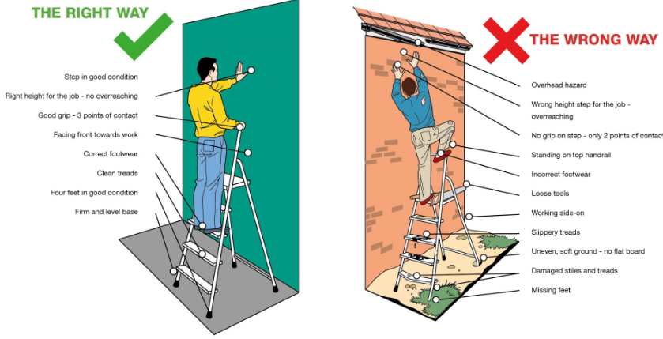
Work the safe way on ladders: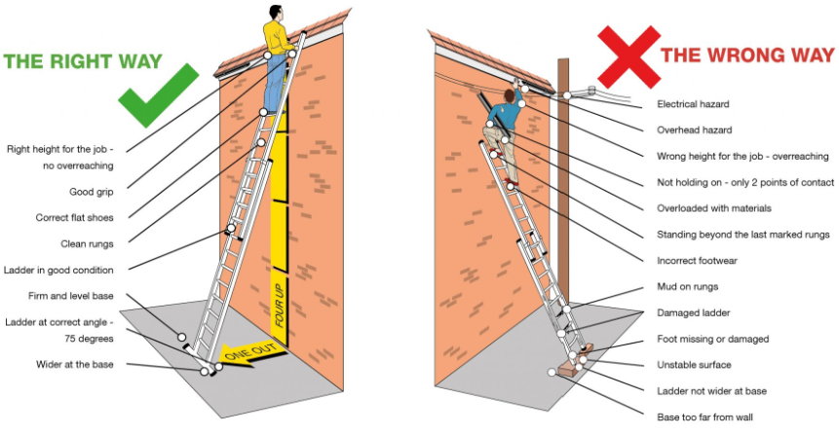
Mobile Work Platforms (Towers)
Standard mobile towers are only to be used by staff who have completed PASMA ‘Towers for Users’ Training making them competent in the assembly, use, alteration, dismantling and inspection of the equipment.
The PASMA Code of Practice will be followed - copy available in the CELT H&S Pack on the CELT HUB.
Only mobile towers that have all the necessary parts to the current standard should be used and only if the full instructions are available for its use.
If towers for stairs, with cantilevers, bridges, linked or large decks are required other equipment and a competent contractor will be required.
Other access equipment (Scaffold/Mobile Elevated Work Platforms etc)
All other access equipment may only be used once its use has been specifically risk assessed for regular or one-off activities and users have been sufficiently trained in its use and deemed competent to use it by their manager.

- Shared Premises – Not relevant to Fowey Primary School

The school shares it site with the following organisations

We conduct a yearly meeting with each organisation to discuss emergency arrangements, first aid, fire safety and health, safety and welfare matters. Both parties will also share any risks within the working environment and safe systems of work for both parties. We will also arrange regular inspections of the organisation premises.

If any information discussed at this meeting changes during the year both parties should share this information with one another and cooperate on relevant health and safety arrangements.

- Hand Arm Vibration

The school will put in place measures to protect (and monitor) employees from the risks of Hand Arm Vibration Syndrome (HAVS) and Whole Body Vibration.
These measures will include:
- Assessing the risks from vibration exposure;
- Taking steps to reduce vibration exposure;
- Taking into account vibration risks when purchasing or hiring equipment;
- Providing training and information for employees on the risks from vibration and the measures in place to reduce these;
- Providing health surveillance where the risk assessment shows that this is appropriate.
- Monitoring exposure

Before staff begin work with equipment where HAV has been identified as a hazard, normally by their risk assessment, they will be entered into health surveillance.

Staff who use the equipment identified as having HAV as a hazard must also complete a ‘HAV CELT log’ which details when the equipment was used and for how long. Using the ‘HAV Grid’ the exposure can be calculated and recorded. This must be then passed onto their line manager/Head of department to be kept on file for future reference.

The above risks will largely but possibly not exclusively affect site and grounds staff.

Information about HAVs and documents for recording exposure can be found in the CELT H&S Pack.

- Noise

The school will put in place measures to protect employees from the risks of noise induced hearing loss (and tinnitus), which can be caused by exposure to excessive noise (as defined by upper and lower work exposure limits). These measures will include:

- Assessing the risks from noise exposure (which may require monitoring to do so)
- Taking measures to reduce noise exposure where a risk assessment shows that this is necessary
- Ensuring the level of noise generated is considered when a new piece of equipment is purchased or hired
- Providing hearing protection where necessary if risks cannot be adequately reduced by other means.
- Providing training and information for employees on the risks from noise and the measures in place to reduce these
- Providing health surveillance where the risk assessment shows that this is appropriate.

The above risks will largely but possibly not exclusively affect music, site, DT and grounds staff.

- Exposure Monitoring and Health Surveillance

Where required (as the outcome of an appropriate risk or COSHH assessment) exposure monitoring will take place and the school will undertake and record health surveillance on staff regularly exposed to the following hazards:

- Noise
- Vibration
- Solvents
- Fumes
- Dust
- Biological agents
- Other substances hazardous to health

Staff in the following departments are subject to annual health surveillance. Others, as risk assessment identifies. New starters or those moving into new departments will be subject to baseline assessments. The above risks will largely but possibly not exclusively affect:

- Design and Technology staff
- Grounds staff
- Estates/site staff
- Music staff

Most monitoring and surveillance will be organised through the Estates/HR Teams with our nominated Occupational Health Contractor or other BOHS registered Exposure Monitoring Contractors.

- Hot Works

A formal Hot Works Permit/Permit to Work system is in place and must be always adhered to.
Hot Works cannot take place unless a permit has been issued which can only be authorised through the Site Manager (Appendix 1) and according to the procedure for small or project works as set out in the CELT H&S Pack found on the CELT HUB.
Copies of all Hot Works Permits/Permits to Work, will be shared with the Estates and Facilities Manager of the site.

- Ionising Radiation
The school is registered with the HSE for the use of Ionising Radiation. Files are kept in the radiation log folder.
The school subscribes to the CLEAPSS SLA through Cornwall Council Health and Wellbeing Team provide us with the Radiation Protection Advisor (RPA) Service.
The school follows CLEAPSS L093 Managing Ionising Radiations and Radioactive Substances in Schools and Colleges and will have a risk assessment and safe working procedures for use of radioactive sources in place.
The school has appointed a Radioactive Protection Supervisor (RPS) listed in Appendix 1 whose responsibility it is to risk assess storage, use of sources and ensure the above guidance is implemented and followed.
For further assistance and information contact:
HandS@cornwall.gov.uk or the CLEAPSS Helpline on 01895251496

- Infection Prevention Control (IPC)
The school will control the spread of infection (including Acute Respiratory Infections ARI’s) using local risk assessment, outbreak management plans and the incorporation and promotion of key IPC baseline measures into school procedure, working practice and teaching.

This will be guided by national Public Health messaging and in particular the government guidance on ‘Health protection in education and childcare settings – A practical guide for staff on managing cases of infectious diseases’ and ‘Reducing the spread of respiratory infections, including COVID-19, in the workplace’

The key baseline measures of infection prevention control include:

- Hand hygiene
- Respiratory hygiene (Catch it, Kill it, Bin it)
- Cleaning
- Ventilation
- Vaccination
- Exclusion (isolation whilst infectious as opposed to educational exclusion)
- Communication

In the event of an outbreak, the school will check and reinforce the robustness of their baseline IPC controls, stepping measures up and down as experience has shown works in their setting. The aim being to control infection but to minimise educational disruption with measures to affect the least number of people for the least amount of time.

Education and childcare settings may consider seeking specialist advice from the relevant UKHSA HPT if they are concerned and have seen:

- a higher than previously experienced and/or rapidly increasing number of staff or student absences due to acute respiratory infection or diarrhoea and vomiting
- evidence of severe disease due to an infection, for example if a pupil, student, child or staff member is admitted to hospital
- more than one infection circulating in the same group of students and staff for example chicken pox and scarlet fever

Education and childcare settings are also asked to contact their UKHSA HPT as soon as possible to report any outbreak or serious or unusual illness for example:

- E.coli 0157 or E coli STEC infection
- food poisoning
- hepatitis
- measles, mumps, rubella (rubella is also called German measles)
- meningococcal meningitis or septicaemia
- scarlet fever (if an outbreak or co-circulating chicken pox)
- tuberculosis (TB)
- typhoid
- whooping cough (also called pertussis)

UK Health Security Agency (UKHSA) – South West Health Protection Team:
Email swhpt@phe.gov.uk Tel 0300 303 8162 (option 1, then option 1)

Public Health Team for Cornwall and the Isles of Scilly:
Email phnotifications@cornwall.gov.uk Tel: 018972 322027

- Asbestos

CELT acknowledges the health hazards associated with exposure to asbestos and will protect those persons potentially exposed to asbestos as far as is reasonably practicable by minimising exposure through the use of proper control measures and work methods.

Asbestos was used regularly in buildings up until the year 2000 and it is true that most buildings (this is known to be the case across CELT Estate), constructed up until this date will contain Asbestos unless it has been removed. It should always be assumed that Asbestos could be present, as it takes many forms, from roof tiles to floor and ceiling tiles, to lagging and board.

Asbestos remains low hazard unless it is sawn, drilled, broken up or dust is disturbed to release fibres which can be inhaled. Exposure to Asbestos fibres in this way can cause life limiting disease.

There is known/suspected Asbestos at Fowey Primary School and all are advised to assume it is always present.

No invasive works drilling, fixing to surfaces, lifting ceiling tiles or access to service areas is allowed without first following the procedures below.

Fowey Primary School has an Asbestos Management Plan (AMP) and register available in the Main Reception Office detailing the locations of known/suspected asbestos, which should be bought to the attention of any contractors or CELT employees (a signature should be obtained to show they have seen it and countersigned by the site manager) that are carrying out either invasive works or works (including for IT or communications) that may disturb the fabric of the building.

The AMP is formed from a comprehensive management survey however, in the case of invasive works or disturbing the fabric of the building not already surveyed, the nominated Estates and Facilities Officer/Site Manager should be consulted to obtain a refurbishment/demolition survey for the work area prior to its start and to receive a permit to work.

CELTs full Asbestos Management Policy and Procedures can be found in the CELT H&S Pack available on the CELT Hub or from the CELT Health and Safety Officer or Estates Team.

If you suspect Asbestos is present or think you may have disturbed (released fibres), stop what you are doing, evacuate the area, restrict access, and immediately contact the Estates and Facilities Manager/Site Manager (Appendix 1) for further instruction, who will risk assess next steps by consulting our contracted competent advisors.

34 Mental Health and Wellbeing

CELT recognises the importance of the wellbeing of its pupils and its employee’s so that they able to carry out and not be adversely affected by their job role.

For pupil mental health and wellbeing, the CELT safeguarding policy for Mental Health and Wellbeing should be followed.

Employee Assistance Programme

For employees CELT has an Employee Assistance Programme (EAP) provided by Health Assured. The EAP is a confidential support network for practical advice and counselling. The free service is accessible 24 hours a day, 365 day7s a year by phone: 0800 028 0199 or online https:healthassuredeap.co.uk/ To access the wellbeing portal you will require the log in below:

USERNAME: Wellbeing
PASSWORD: BulbKiteDeal

Health Assured also have an app that can be downloaded for both android and iOS systems.
Managing wellbeing at work

Stress affects people differently – what stresses one person may not affect another. Factors like skills and experience, age or disability may all affect when a worker can cope.

Providing planning, training and support can reduce pressure and bring stress levels down. Demands should be matched to workers’ skills and knowledge.

There are six main areas of work design which can affect stress levels; demands, control, support, relationships, role and change.

These areas of work design should be considered by CELT managers in any personal or team risk assessments where required. This can be considered in a risk assessment for an activity or please see the CELT H&S Pack for template for a personal risk assessment.

CELT has an annual performance management cycle where issues can be raised but it operates an ‘open door’ policy for staff to raise issues with their manager at any time, or through HR support accessed either on site with the HR team member or through the main CELT Office HR Team based at Poltair.

Employee wellbeing should also be considered in respect of other relevant CELT HR Policies.

HSE – Work related stress and how to manage it

HSE – Advice for employees with mental health conditions

MIND – How to be mentally healthy at work

Appendix 1 – Named individuals with responsibilities

Responsibility | Fowey Primary School
Health & Safety Trustee | Tony Freshwater
Delegated responsibility  Supported by (H&S Coordinator) | Liz Measom – Headteacher  Jonathan Warnham – Site Manager  John Purshouse – Estates and Facilities Officer
Employee/Union representatives | Paul Trudgeon
The persons who will carry out regular inspections are  With the support of | Jonathan Warnham
 | John Purshouse
Educational Visit Coordinator (EVC) | Paul Trudgeon
CPD Coordinator | Liz Measom
CPD/Training records held by | Kirsti Spry
Accident book location/s | Every Classroom and dinner hall
Accident/incident investigator | Liz Measom  John Purshouse
Reporting Officer (Accidents and Near miss incidents)  Supported by | Kirsti Spry
 | Jonathan Warnham
Deputy Reporting Officer (Accidents and Near miss incidents) | Liz Measom
The persons responsible for liaising with contractors undertaking major works to ensure that the risk due to having contractors on site is monitored and controlled | Jonathan Warnham
 | John Purshouse
 | Liz Measom
The persons appointed with the authority of the CEO to request action from the Contractor where conditions are unsafe | John Purshouse
 | Jonathan Warnham
 | Carrie Freeman
First aid coordinators | Liz Measom

Nominated first aiders | See list
First Aid boxes are located | In all classrooms, Staff room, Medical room  (see First Aid Plan
Dispensing of medicines | Kirsti Spry
Health surveillance | HR team
Off-site First Aid Coordinators | Liz Measom  Paul Trudgeon
Fire Officer/s  And in case of absence | Liz Measom  Kirsti Spry  Paul Trudgeon
Fire Warden/s (if applicable) | Liz Measom  Kirsti Spry  Jonathan Warnham
COSHH Coordinators | Jonathan Warnham / John Purshouse
Portable Appliance Testing | Jonathan Warnham
Equipment Safety Coordinators | Jonathan Warnham
DSE Assessor | John Purshouse
PPE equipment | Jonathan Warnham
Minibuses | License holders:  Paul Trudgeon  Chloe Rawlings  Alfie Havenhand
Radiation Protection Supervisor | n/a
Estates and facilities Officer/Site Manager  Contact Number  Email  School Security (Keyholder service)  Contact Number  Email | Jonathan Warnham  jwarnham@fow.celtrust.org  07399 462678  PJI Security  01726 890318 or 01726 216377
Those nominated for out of hours call out (in order). | PJI Security  Jonathan Warnham  Liz Measom

Appendix 2 - Fire evacuation procedure – Diagrams in all rooms

To include:

- Procedure for evacuation of the building (may include a visual guide to evacuation routes and assembly points).
- Procedure for returning to the building

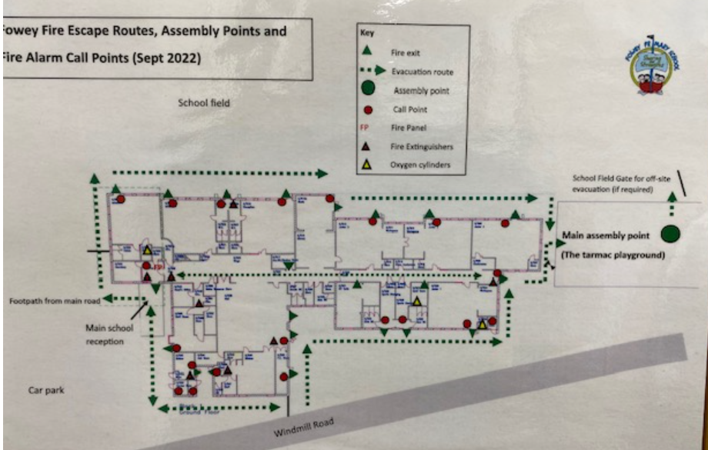
Appendix 3 - Emergency evacuation (critical incident)
Emergency Procedure for Evacuation OFF SITE whilst School is in session.
Add your procedure from your critical incident plan or use template below.
See guidance in CELT H&S Pack on CELT Hub

Evacuation Template (example)
If the threat is within the venue (eg fire, gas leak, structural failure etc but not bomb alerts (see Bomb Alert template) the responsible person should consider evacuation, but if the threat or incident is outside the venue it may be safer to stay inside.
Alarm or signal
Signal for whole building evacuation | Fire Alarm
Signal for stand down / all-clear | Public Address (PA) announcement –

Incident Control Officers & Response Team
Role | Name | Emergency Contact Number
Incident Control Officer | Liz Measom | 07899966254
Deputies | Paul Trudgeon  Jonathan Warnham | 07771 566527  07949 137599
Communications Officer | Kirsti Sry | 07800 882811

Other useful contacts:
Role | Name | Emergency Contact Number
Safeguarding Lead | Amy Daniels | 07736 573330
John Purshouse | Site manager | 07917 390062

Information for emergency services
Include a map and information such as location of gas shut off valves, storage of on-site chemicals, etc
Assembly points
1.Classes have designated areas on the playground
2.If necessary children will be moved to the field at Fowey River Academy
3.
Secondary (alternative) assembly point / place of safety
(for example, partner school / college / leisure centre) must be pre-arranged
Name of venue | Fowey River Academy
Type of venue | Secondary School
Contact name | Jon Rolls or Paul Smith
Contact telephone number | 01726 833484
Include useful info such as distance from school, directions, capacity, opening hours
Children will walk to venue as very close

Appendix 4 - Emergency closure procedure
Emergency Closure Procedure Whilst School is in Session –
The school will follow the Cornwall Council procedure:

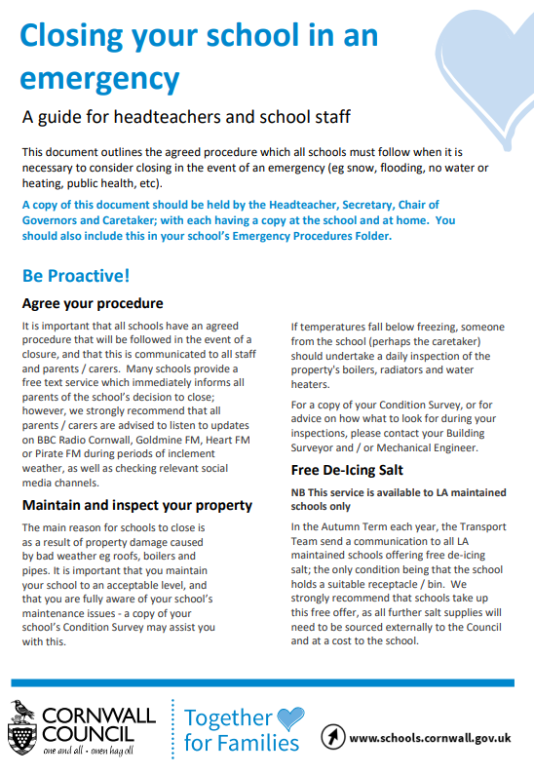

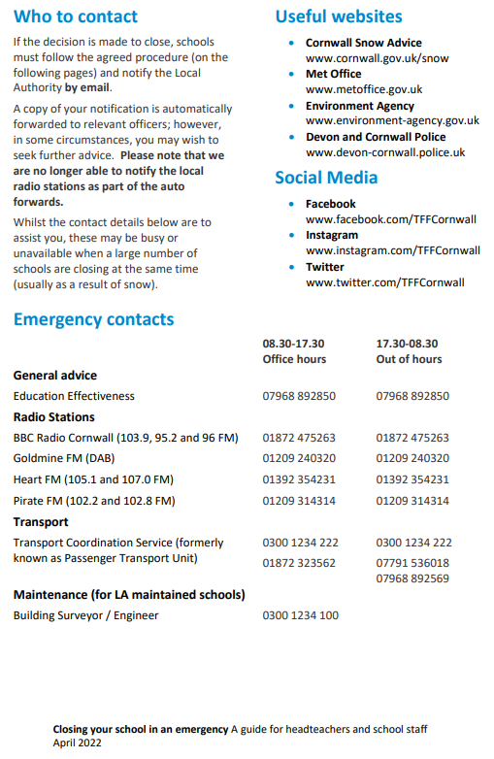

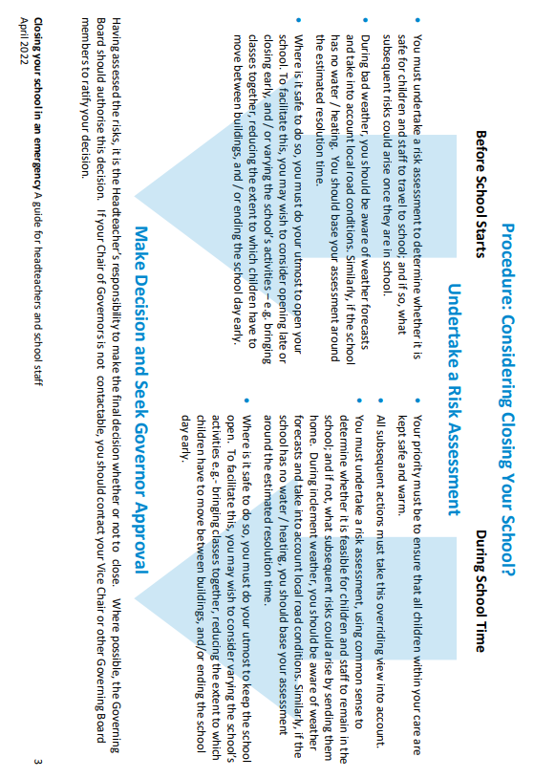

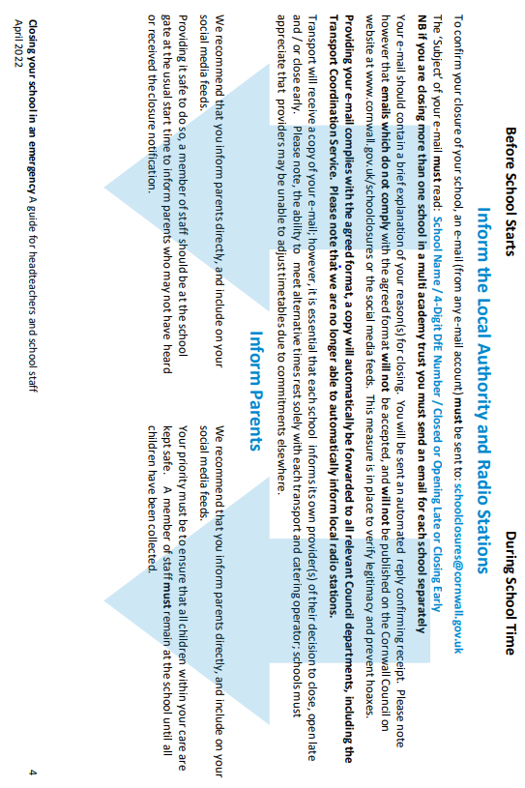

Appendix 5 Lock down procedure
Add your procedure from your critical incident plan or use template below.
See guidance in CELT H&S Pack on CELT Hub.

Lockdown Template (Example)

There are important differences between the lockdown and shelter arrangements. Lockdown is necessary when children and staff need to be locked within buildings for their own safety i.e. in an emergency situation such as a hostile intruder, terrorist attack or other criminal activity.

Signals
Alarm or signal for lockdown shelter | Personal ‘LOCKDOWN’ message form head or SLT  Radios to be used.
Signal for stand down / all-clear | ‘All Clear’ on Radios from Headteacher of SLT

Incident Control Officers & Response Team
Role | Name | Emergency Contact Number
Incident Control Officer | Liz Measom | 07899 966254
Deputies | Paul Trudgeon | 07771 566527
 | Jonathan Warnham | 07949 137599
Communications Officer | Kirsti Spry | 07800 882811

It is important to remember that it is very much the exception to evacuate a building in the event of a hostile intruder. Unless the location of the intruders is known, a "blind" evacuation may be putting people in more danger (e.g. from an intruder or device at one of the entrances/exits) than if they had remained within the building.

Rooms most suitable for lockdown
1 Classrooms
2 Hall
3 Sports hall
4 Offices

It is important to make sure that items that could be used as weapons (kitchen implements, sports equipment, tools, cleaning products) are securely locked away when not in use.

Communication arrangements
Wherever possible use silent communications and keep noise to a minimum especially if the intruders are close by. Make sure any communications devices are secure and cannot be intercepted.
Two-way radios
Classroom telephones
Mobile phones
Instant messaging / email
Other (TV’s / Whiteboards / etc)

Alternative place of safety in the event that it is considered necessary to leave site
(for example, partner school/college / leisure centre) must be pre-arranged.
Name of venue | Fowey Rover Academy
Type of venue | Secondary School
Contact name | Jon Rolls or Paul Smith
Contact telephone number | 01726 833484
Useful info such as distance from school, directions, capacity, opening hours
Can walk to the school

Other useful contacts:
Name | Emergency Contact Number
John Purshouse | 07917 390062
Amy Daniels | 07736 573330

Action Plan | Completed by (sign and time)
Sound Alert - Activate lock-down procedures immediately
Dial 999
Direct all children, staff, parents and signed in visitors to the nearest safe place (this may be dependent on what and where the risk is)
Secure rooms and take action to increase protection from attack - Lock and barricade doors and windows
Close windows / blinds
Turn off the lights, fans or mobile air conditioning units (this will reduce noise and the risk of exposure to any chemical/biological attack)
Hide, sit on the floor under desks, and away from windows
Stay as silent as possible - put any mobile devises to silent (consider writing / displaying instructions on whiteboards / TV's etc as long as it can’t be seen by the intruder)
Ensure that students, staff, and visitors are aware of an exit point in case the intruder does manage to gain access
If possible, check for missing / injured students, staff and visitors
Keep doors and windows locked shut and remain inside until an all-clear has been given, or unless told to evacuate by the emergency services

History of Changes:

Version | Date | Page | Change | Origin of Change
1.0 | 09.04.2020 | N/A | Original Draft | N/A
2.0 | 23.01.2023 | 2 | Signature page adjusted to add Chair of LGB/RIG and H&S Member | To show adoption by Local Governance
 | 23.01.2023 | 4 | Contents page adjusted | To match document sections
 | 23.01.2023 | 5 | Organisation chart adjusted to match job roles of Deputy Trust Lead and H&S Officer | Job changes
 | 23.01.2023 | 10 | Headteacher duties amended to add H&S standing agenda item | Deputy Trust Lead
 | 23.01.2023 | 13 | School Operations text amended | To reflect updated procedures and information.
 | 23.01.2023 | 13 | Supervision section – times added for Wraparound provision. | N/A
 | 23.01.2023 | 13 - 17 | First Aid sections re-written regarding provision and assessment, Paediatric First Aid requirements, Emergency response for those with known medical conditions and Escorting pupils to Hospital | To match the supporting pupils with Medical Conditions Policy and EYFS requirements for Paediatric First aid
 | 23.01.2023 | 17 | Pupils and staff with Medical Conditions section re-written. | To refer to DoE guidance and CELT policy for Supporting Pupils with Medical needs
 | 23.01.2023 | 17 | Medicines section re-written. | To reflect and refer to CELT policy for Supporting Pupils with Medical needs
 | 23.01.2023 | 19 | Sun safe and Heat Stress section re-written. | To reflect HSE guidance on Heat Stress and sun exposure for employees
 | 23.01.2023 | 20 | Accident/Incident section re-written to reflect current reporting practice. | AssessNET reporting system for incident and RIDDOR reporting.
 | 23.01.2023 | 22 | In-House Catering section re-written to reflect changes in Allergen management. | Natasha’s Law
 | 23.01.2023 | 23 | Management of contractor’s section addition to check contractor work with fabric of building for Asbestos safety. | Asbestos regulations 2012
 | 23.01.2023 | 24 | Vehicles section re-written to reference school driver checks that should be made, restriction of mobile phone use, and risk assessment of transport of pupils. | Mobile phone use whilst driving legislation 25 March 2022
 | 23.01.2023 | 25 | Business Continuity section additions of Appendices titles | N/A
 | 23.01.2023 | 26 | Training section addition of information of online iHasco training. | iHasco
 | 23.01.2023 | 27 | Risk Assessment section updated with information on external advisory bodies for high-risk areas. | N/A
 | 23.01.2023 | 27 | Educational Visits Section set out separately. | Change in Cornwall Council Educational Visits Service
 | 23.01.2023 | 29 – 30 | Fire Section re-written | Definition of roles and drill expectations.
 | 23.01.2023 | 31-33 | Control of Substances section re-written to ensure reference to hazardous substances arising from processes. | COSHH process.
 | 23.01.2023 | 33 | PPE section addition of PPE for temporary workers | Legislation
 | 23.01.2023 | 35 | DSE Section – added reference to CELT H&S Pack. | CELT H&S Pack
 | 23.01.2023 | 36 – 37 | Lone working section re-ordered to clarify procedures for safety. | H&S Audit
 | 23.01.2023 | 37 | School security section made separate. To clarify responsibilities and procedures for safety. | H&S Audit
 | 23.01.2023 | 39 | Violence and abuse section – additions on reporting of incidents | H&S Audit
 | 23.01.2023 | 40 | Manual handling section addition on manual handling training. | N/A
 | 23.01.2023 | 41- 43 | Working at Height section completely re-written. | Legislation
 | 23.01.2023 | 44 | Exposure monitoring and Health Surveillance, section addition of hazards. | N/A
 | 23.01.2023 | 45 | Hot Works section addition of CELT H&S Pack reference. | CELT H&S Pack.
 | 23.01.2023 | 45 | Infection Prevention Control Section added. | Significant Hazard/CELT H&S Policy
 | 23.01.2023 | 47 | Asbestos Section added. | Significant Hazard/CELT H&S Policy
 | 23.01.2023 | 49 | Appendix 1- Table section titles amended | N/A
 | 23.01.2023 | 52 | Appendix 3 Emergency Evacuation Template added | N/A
 | 23.01.2023 | 53 | CC Emergency closure procedure added | Update to CC procedure
 | 23.01.2023 | 57 | Appendix 5 Lockdown Template added | N/A
 | 23.01.2023 | 59 | Appendix 6 added to reference CELT First Aid Guidance location | DoE
 | 23.01.2023 | 60 | Appendix 7 added to reference CLET Risk Assessment Guidance and Procedures location | DoE
 | 23.01.2023 | 61 | History of Changes table added.
 | 28.03.2023 | 62 | Wording amended:  - To reference RIGSs as well as LGBs  - That the LGB/RIG responsibilities are to ‘monitor so far as is responsibility practical’ that the items listed are provided rather than ‘provide or allocate’ resources | n/a
3.0 | Aug 2023 | 1 | Revised content table | Annual Review
 | Aug 2023 | 6 | Revised roles and responsibilities graphic - School and staff additions | Annual Review
 | Aug 2023 | 6 | Letter ‘s’ added to ‘roles and responsibilities’ in the penultimate line of the ‘Introduction’ paragraph | Annual Review - Grammar
 | Aug 2023 | 9 | Addition of word ‘RIG’ to bullet point 12 of LGB/RIG responsibilities | Annual Review
 | Aug 2023 | 11 | Responsibilities of ‘School H&S Coordinators’ changed to ‘H&S Coordinators’ with description of roles added who are coordinators, such as Heads of Departments (HoDs), Technicians, Team Managers, or other nominated coordinators. | Annual Review
 | Aug 2023 | 19 to 20 | The title is amended, and two paragraphs added to section 5) ‘Sun Safe and Temperature’ To ensure the needs of pupils and staff are considered in respect of temperature (hot/heat stress or cold exposure) | Annual Review
 | Aug 2023 | 22 | Reference to CELT Guidance for Accident Incident Reporting and Investigation. | Annual Review New Guidance
 | Aug 2023 | 23 | Section 7) In house Catering  Requirement for registration of food business for wraparound provision. The word ‘temperature and COSHH’ as type of catering risk assessment considerations. | Annual Review To meet current food standards and compliance
 | Aug 2023 | 23 to 24 | Section 9) Contractors – Title amendment. Addition of reference to CELT Contractor Guidance in CELT H&S Pack. | Annual Review
 | Aug 2023 | 25 | Section 10) Vehicles and Driving for Work –Reference to the CELT Vehicle and Driving for Work Policy and Procedures and change to definition of ‘driving for work’ to include direct commute to ‘any CELT site’ | Annual Review Clarification of requirements
 | Aug 2023 | 26 | Section 11) Business Continuity and Critical Incident title amendment and reference to critical incident/emergency plan template in the CELT H&S Pack. Addition of annual check of off-site Emergency Evacuation instruction. | Annual Review Consistency
 | Aug 2023 | 28 | Section 13) Risk Assessment – Addition of LANTRA and HSE as Guidance for high-risk activities. Reference to CELT Risk Assessment Policy, Procedure and Guidance | Annual Review – updated references
 | Aug 2023 | 29 | Section 14) Educational Visits reference to OEAP. Competent guidance. | Annual Review
 | Aug 2023 | 31 | Section15) Fire Safety - Title amendment. Removal of off-site evacuation check instruction to Critical Incident section 11). Addition of reference to storage of flammable and explosive substances away from heat and ignition sources | Annual Review
 | Aug 2023 | 32 | Section 16) Electricity. Only suitably competent persons to undertake electrical works. | Annual Review
 | Aug 2023 | 35 | Section 18) PPE Addition that schools ensure staff understand how to use PPE appropriately before it is used and dispose of it. | Annual Review
 | Aug 2023 | 35 | Section 19) DSE – Descriptor of injuries added: RSI or musculoskeletal. | Annual Review
 | Aug 2023 | 37 | Section 20) Work Equipment Reference to the CELT Work Equipment Form - For work equipment purchase planning | Annual Review
 | Aug 2023 | 41 | Section 24) Manual Handling, ref to safe working practice information, Individual capability assessment form and CELT H&S Pack. | Annual Review
 | Aug 2023 | 42 | Section 25) Work at Height, amendment of first section to refer to working at height hierarchy of control | Annual Review
 | Aug 2023 | 46 | Section 29) Exposure Monitoring and Health Survielance – Reference to use of BOHS registered Exposure Monitoring Contractors. | HSE Recommendation
 | Aug 2023 | 49 | Section 34) Mental Health and Wellbeing | New Section
 | Aug 2023 | 51 | Appendix 1- H&S Coordinator added to delegated responsibility box | Previous omission.
 | Aug 2023 | 54 | Appendix 3 – Text added ‘Add your procedure from your critical incident plan or use template below’ | Instruction
 | Aug 2023 | 59 | Appendix 5 – Text added ‘Add your procedure from your critical incident plan or use template below’ | Instruction
 | Aug 2023 | 60 | Appendix 6 and 7 for Risk Assessment and First Aid guides removed. | Will now be standalone policy, not appendices.

The term Headteacher will be used to mean Headteacher and/or Principal throughout this document.

