Rationale for Maths
at Fowey Primary School
Intent
At Fowey Primary School, we aim to teach our children a rich, progressive and sequential maths curriculum which develops their ability to calculate, reason and solve problems, enabling them to make sense of the world around them and prepare them for life in modern British society. As an inclusive primary school, our curriculum reflects both the context of the school and the experiences of the children. This enables the children to be develop a passion and be aspirational, to fulfil their potential and reach the highest of expectations that we have of them.
We aim to provide high quality mathematical learning experiences in order to develop children’s mathematical skills and understanding. Children are encouraged to explore maths through practical experiences and investigative work, building a sense of enjoyment and curiosity about the subject.
We aim to give all our pupils, particularly the most disadvantaged, the knowledge, experiences and ‘cultural capital’ necessary to become educated citizens and to succeed in life.
Our aims of teaching Maths, as outlined in the National Curriculum, are to ensure that all pupils:
- Ensuring our children have access to a high-quality maths curriculum that is both challenging and enjoyable and quality-first teaching.
- Fluency in the fundamentals of mathematics, including through varied and frequent practice with increasingly complex problems over time is key, so that pupils develop conceptual understanding and the ability to recall and apply knowledge rapidly and accurately.
- Develop their ability to reason mathematically by following a line of enquiry, conjecturing relationships and generalisations, and developing an argument, justification or proof using mathematical language
- Fully develop independent learners, who can solve problems by applying their mathematics to a variety of routine and nonroutine problems with increasing sophistication. Using and developing the behaviours Mathematicians need to succeed.
In our Maths lessons, we aim to develop pupils’ independent learning skills using approaches that best suit our learners. Our intent has a much broader application: our aim is for these learning skills to filter through to all subjects, with children applying them in all areas of the wider school curriculum. We will:
- Develop pupil self-esteem to create confident, resilient learners that are not afraid to take risks.
- Ensure all children are engaged in lessons with no passive learners.
- Develop resilience in children
- Develop children’s self-awareness as learners
- Develop fluent number fact knowledge that children can transfer and apply in other areas of maths, thus reducing cognitive overload and supporting the spiral curriculum.

Implementation
At Fowey, we believe that all children can be successful in the study of mathematics. We use mixed ability groupings and do not group children by prior attainment, except for where significant gaps in learning exist. Our mastery approach to the curriculum is designed to develop children's knowledge and understanding of mathematical concepts from the Early Years through to the end of Y6.
In order to achieve mastery, our expectation is that through quality first teaching, all our children will successfully access the learning. We expect nearly all pupils to move through the programmes of study at broadly the same pace. However, for children who are not fluent, we provide opportunities to consolidate their understanding through additional scaffolding (this could be through adult support, concrete resources or adapted work).
Across the school daily maths lessons are taught where:
• Children practice fluency within the programme of Winning with number and the ability to recall and apply knowledge accurately and quickly.
• Children develop reasoning skills by following a line of enquiry, generalising or justifying proof using mathematical language within our White Rose Maths warmups and Power Maths sessions.
• Children develop competence in solving increasingly complex problems within our White Rose Maths warmups and Power Maths sessions.

Early Years Foundation Stage
In Reception, teachers and children follow the Power Maths scheme of learning. These are matched to the National Curriculum Early Learning goals. In the Early Years, maths is a specific area of learning that is developed through planned sessions and continuous provisions to consolidate learning and child-initiated play and activities: communicating and modelling language, showing, explaining, demonstrating, exploring ideas, encouraging, questioning, recalling, providing a narrative for what they are doing, facilitating and setting challenges.
Learning opportunities are provided to create a stimulating space where children feel confident, secure and challenged in their mathematical thinking. Regular observations and assessments help to ensure that children that need additional intervention to consolidate their mathematical understanding are identified and supported appropriately.

Key Stage 1 and 2
In Years 1-6, we follow the National Curriculum and use the Power Maths scheme to support teachers with their curriculum planning and assessment. This ensures that progression across the year groups encompasses our spiral curriculum. Power Maths is recommended by the DfE, which promotes a mastery approach to mathematics. It builds every concept in small, progressive steps and is built with interactive, whole class teaching in mind. It provides the tools needed to develop growth mindsets, check understanding throughout lessons and ensures that every child is included. The Power Maths curriculum covers units of learning in Number, Measurement and Geometry, Statistics, Algebra and Ratio and Proportion.
At the heart of Power Maths is a progressive lesson sequence designed to empower children to understand core concepts and grow in confidence.
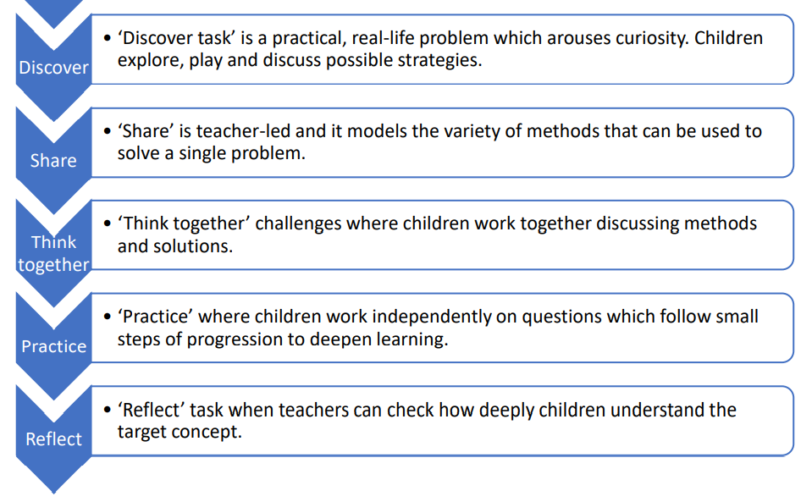
Throughout each stage of the lesson, teachers check on children’s understanding through high quality questioning enabling misconceptions to be quickly addressed. In addition, we use a range of mastery resources to challenge our more able children and deepen their understanding.

Fluent in Five
In Year 5 and 6, children have a daily Fluent in Five session dedicated to fluency, core number work and consolidation of prior learning.

Winning with Number
In EYFS to Year 4, children experience a daily fluency-based session that is progressive and builds on their essential number knowledge. Winning with Number integrates cognitive science teaching principles, extensive high-quality digital resources and a correct and detailed sequence of learning. These sessions allow for the teachers and children to experience a smooth process when putting together pre-existing ideas, facts and procedures.

Times Tables Rock Stars (TTRS)
TTRS is used by children in Years 2-6. It uses question-based games that automatically adapt to each child’s unique learning needs, helping them to recall their times tables in record speed. It is an online platform that is accessible on any device, via the app or browser, children can play anytime, anywhere, thus meaning that children can access this at home and further develop and practice their fluency of Times Tables.
Throughout the whole school approach, there is a big focus on the development of multiplication facts and core number facts, as this is crucial to all other aspects of learning within Maths.

Declarative Knowledge
Children are explicitly taught key number facts and mathematical concepts so that they are fluent. They have time to explore relationships between number facts. Over time, children are able to instantly recall and retrieve mathematical concepts taught. Children can demonstrate this knowledge by verbalising methods used. This knowledge is taught through daily with Winning with Number and Power Maths.

Conditional Knowledge
Children will apply their Declarative Knowledge through reasoning and problem-solving activities. The children have opportunities to do this through Power Maths challenges and ‘Reflect’ questions. Mathematical Sentence Starters are taught verbally and encouraged when children are discussing and sharing their work.

Leadership, Assessment and Feedback:
• Assessment informs the teaching and learning sequence. This would include:
- Daily formative assessment which is used to inform next steps planning.
- In EYFS, observations are recorded in children’s learning journals online through Tapestry and next steps are identified.
- Times tables fluency progress (Years 2-6) each term
- Winning with Number online tracker
- Termly teacher assessments
- Termly PUMA / practise SATs in Year 6
- End of unit assessments

• Feedback is given on children’s learning and acted upon quickly.
• Formative assessment within every lesson helps teachers to identify the children who need more support to achieve the intended outcome and who are ready for greater stretch and challenge through planned questioning, whiteboard assessment checkpoints or additional activities.
• In order to support teacher judgments, children are assessed termly using current and reliable tests in line with the National Curriculum for maths. Gap analysis of any tests that the children complete is undertaken and fed into future planning.
• The Maths Lead has a clear role and overall responsibility for the progress of all children in maths throughout school. Working with the rest of SLT, key data is analysed, and regular feedback is provided, to inform on progress and future actions. Maths Learning Walks, pupil conferencing and monitoring of planning is undertaken regularly

IMPACT

The impact of our maths curriculum is that:
- children become independent, confident and successful learners’ who can achieve regardless of their starting points
- Children can talk confidently about their maths knowledge and skills, both previous and current learning
- They are able to apply their skills and knowledge to more challenging problems and make appropriate relationships and connections.
- Children across the school have positive attitudes towards their learning in maths and enjoy maths lessons.
- Children will develop as critical thinkers. They will think logically and rationally in their Maths lessons, understanding the connections between different areas of maths. Learners will have the confidence to tackle problems and engage in reasoning tasks independently.
In order to see mathematical development and success, leaders and teachers will see the following mathematical behaviours from adults and children within lessons:
- High quality teaching to develop problem solving abilities.
- Teachers and other adults providing challenging problems, encouragement, and assistance in learning how to approach complex problems.
- -When confronted with challenging or unfamiliar tasks, children will exhibit persistence and confidence.

Children make progress in maths from their starting points on entry and are closing the gap
towards attaining national expectations. They are given opportunities to achieve the greater depth standard and are supported in doing so. It is our aim that all cohorts will achieve in line with or
above national expectations and that they make good progress during their time here at Fowey Primary School.

