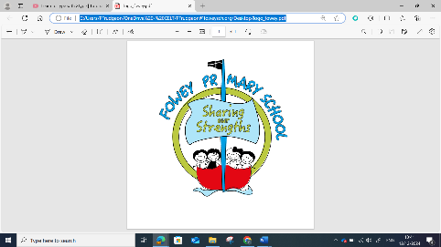
Computing Assessment Year 4
Year 4 Assessment Overview
Children will be understanding of the capabilities of the World Wide web (CS) while searching online (IT).
• They will be developing their understanding of appropriate behaviour online (DL) skills while learning about searching the Internet (IT).
At all times children will be learning about using technology safely and respectfully (DL).
• In most units for all strands, children will be developing their general information technology skills (IT).
• This overlap, repetition and reinforcement helps to give children a deeper understanding of the knowledge and skills across all strands and of their integrated nature in the real-world.
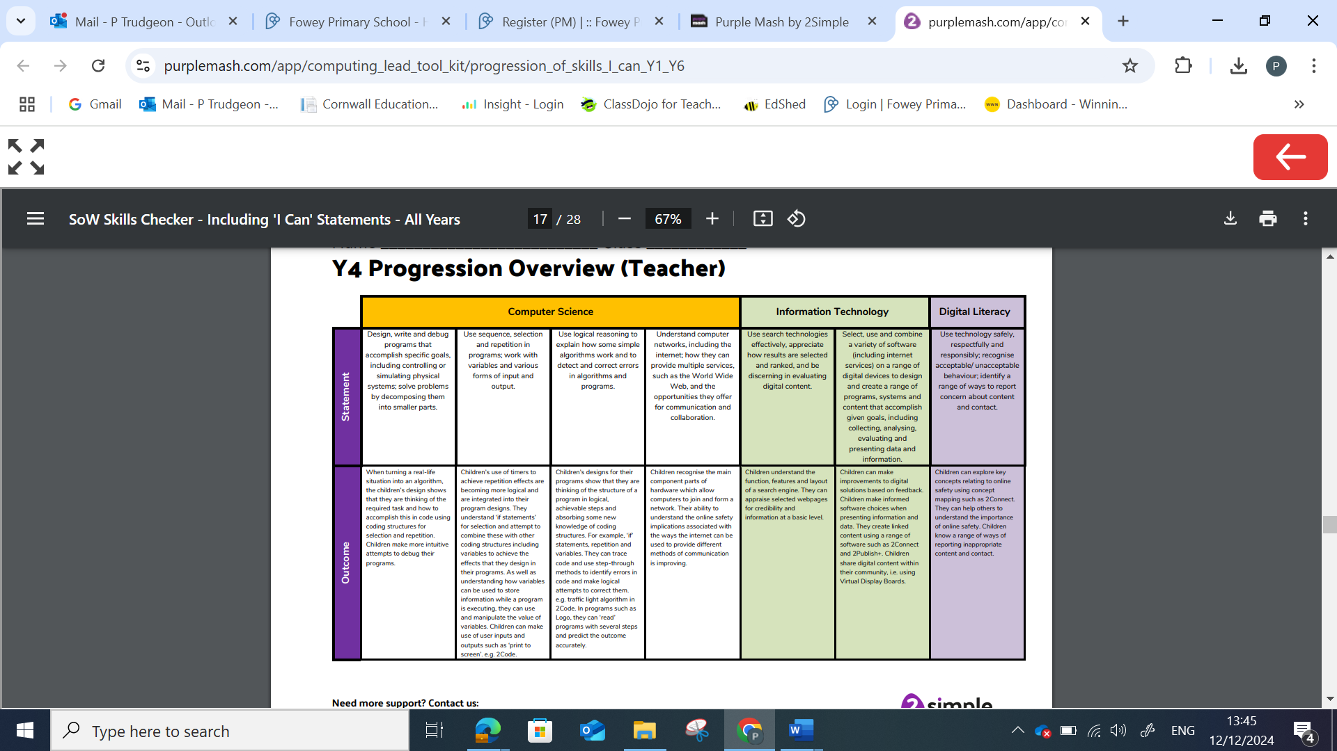

Year 4
Computer Science: Coding 4.1, Logo 4.5, Hardware investigators 4.8 | WTS | EXS | GDS
I can turn a real-life situation to solve into an algorithm, using a design that shows how I can accomplish this in code. (4.1, 4.5) |  | Rest of class
I can use repetition in my code. For example, using a loop that continues until a condition is met such as the correct answer being entered. (4.1) |  | Rest of class
I can use timers within my program designs more accurately to create repetition effects. For example, I can create a counting machine. (4.1) |  | Rest of class
I can use selection (decision) in my programming. For example, using an ‘if statement’ for a question where the program takes one of two paths. (4.1) |  | Rest of class
I can use variables within my program and know how to change the value of variables. (4.1) |  | Rest of class
I can use the user inputs and output features within my program, such as ‘Print to screen’. (4.1) |  | Rest of class
I can identify errors in my code using methods including stepping through lines of code. (4.1) |  | Rest of class
I can read programs that contain several steps and predict the outcomes with increasing accuracy. (4.1, 4.5) |  | Rest of class

Year 4
Information Technology: Writing for different audiences 4.4, Animation 4.6, Effective searching 4.7, 4.10 AI | WTS | EXS | GDS
I can create and improve my solutions to a problem based on feedback. For example, create an effective animation or musical composition. (4.6,4.9) |  | Rest of class
I can review solutions that others have created, using a checklist of criteria. (4.4, 4.6,4.9) |  | Rest of class
I can work collaboratively to create content and solutions. (4.4,4.9) |  | Rest of class
I can share digital content using a variety of applications such as: 2Blog, 2Email and Display Boards. (Across units) |  | Rest of class
I understand the purpose of a search engine and the main features within it. (4.7) |  | Rest of class
I can look at the information on a webpage and make predictions about the accuracy of the information contained within it. (4.7) |  | Rest of class

Year 4
Digital Literacy: Online safety 4.2 | WTS | EXS | GDS
I have a good understanding of the online safety rules we learn at school. (4.2 & across curriculum) |  | Rest of class
I can demonstrate how to use different online technologies safely. (4.2 & across curriculum) |  | Rest of class
I can demonstrate how to use a few different online services safely. (4.2 & across curriculum) |  | Rest of class
I know I have a right to privacy both on and offline. (4.2 & across curriculum) |  | Rest of class
I recognise that my wellbeing can be affected by how I use technology. (4.2 & across curriculum) |  | Rest of class
I can report with ease any concerns with content and contact online and know immediate strategies to keep safe. (4.2 & across curriculum) |  | Rest of class
 |  | Rest of class

