Year 5
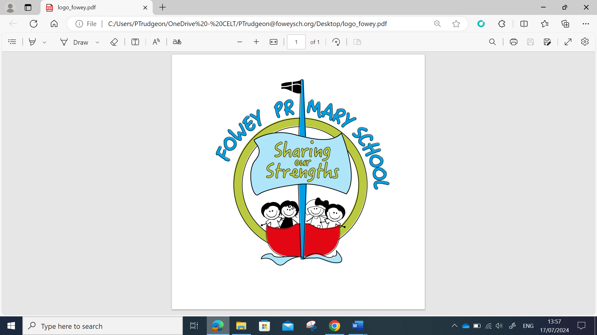 | Year 5 Autumn MTP
 | Week 1 | Week 2 | Week 3 | Week 4 | Week 5 | Week 6 | Week 7 | Week 8 | Week 9 | Week 10 | Week 11 | Week 12
Grammar and Punctuation | Ready to Write  Pronouns | Expanded Noun Phrases  Fronted adverbials | Plurals- Possessive  Inverted commas for speech | Using relative clauses |  |  | Modal Verbs | Modal Verbs | Adverbs of possibility | Adverbs |  | Assessments
Alan Peat  Sentences | Revisit sentence types |  |  |  |  |  |  | If only,
Spelling  Spelling Shed | Week 1- Words ending in ‘-tious’ and ‘-ious’  Week 2- Words ending in ‘-cious’  Week 3 - Words ending in ‘-cial’ |  |  | Week 4 - Words ending in ‘-tial’  Week 5 –Words ending in ‘-cial’ and ‘-tial’  Week 6- Challenge words |  |  | Week 7 - Words ending in ‘-ant’  Week 8 - Words ending in ‘- ance’ and ‘-ancy’  Week 9 - Words ending in ‘- ent’ and ‘-ence’ |  |  | Week 10 - Words ending in ‘-able’ and ‘-ible’  Week 11 – Words ending in ‘-ably’ and ‘-ibly’  Week 12 – Challenge words  Week 13 - Words ending in ‘-able’, where the ‘e’ from the root word  remains
Handwriting | The Ladder family |  |  |  |  |  | Assess and Review | The One Armed Robot Family |  |  |  | Practice and Review
Reading text  VIPERS Foci | Holes | Holes | Holes | Holes | Holes | Holes | Wonder | Wonder | Wonder | Wonder | Wonder | Wonder
Writing Sequence | 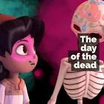  The Day of the Dead  Settings- Narrative  Can I generate adjectives, and expanded noun phrases to use in my writing?  Can I identify the key features of a fantasy narrative?  Can I generate and use fronted adverbials to enhance time and place?  Can I describe powerfully using carefully chosen words and sentences structures?  Can I use coordinating and subordinating conjunctions to generate cohesion?  Can I sequence sentences to create cohesion and flow in my writing?  Can I use varying sentence types to make my writing more atmospheric?  Can I plan paragraphs around a theme that shows a change in location, person time or event?  Can I use pronouns and nouns to avoid repetition?  Can I plan paragraphs around a theme that shows a change in location, person time or event?  Can I draft write a short fantasy narrative?  Can I edit my writing for commas splices?  Can I review and provide feedback on my own and others work?  Can I redraft my edited work? |  |  |  | 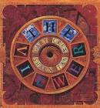  The Viewer  Perspective (Narrative)  Use pictures to generate predictions and vocabulary that reflects the setting.  Identify key features of the WAGOLL, exploring why they have been used.  Recap the order of the story and generate vocabulary about the opening scene.  Create some examples of personification and prepositional phrases.  Generate powerful adjectives and similes to set an eerie scene.  I can create two metaphors for the opening scene. I can plan the opening paragraph.  To create the opening paragraph – creating a mysterious setting.  I can create a plan for the second paragraph to include powerful adjectives and verbs/adverbs.  I can use a relative clause in my plan. I can use show don’t tell in my writing.  I can use inner thought to help increase the tension in the setting.  I can edit my writing- checking spelling, punctuation and grammar and uplevelling vocabulary where necessary.  I can edit my writing with the class, noticing areas I can improve on. |  | 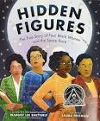  Hidden Figures  (Biography- short memoir)  (Letter writing)  Can I use pictures to generate predictions about the book and explore key vocabulary in the text?  Can I summarise key themes and details from the book?  Can I interpret the meaning of the book and generate their own titles?  Can I explore what a role model is and identify if the women in the book are role models?  Can I express my own viewpoints with explanations and reasons?  Can I explore the WAGOLL for the letter for King Charles and pick out key features and vocabulary?  Can I research and plan Katherine Johnson’s key achievements to form two key arguments?  Can I select formal vocabulary for my letter?  Can I write a letter to the King?  Can I edit my letter and improve vocabulary?  Can I explore a memoir?  Can I edit my writing with the class, noticing areas I can improve on.  Can I explain key moments in Katherine Johnson’s life and why they were important to her?  Can I create a story map about an important part of Katherine’s life?  Can I plan the memoir?  Can I write and edit the memoir? |  |  | 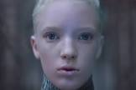  Unexpected Guest (JL Ad 2021)  Writing from different perspective  *Assessment week during this unit*
Writing Outcomes | To write their own narrative setting |  |  |  |  |  | To write a persuasive letter to King Charles and a short memoir about Katherine Johnson.

