Year 3
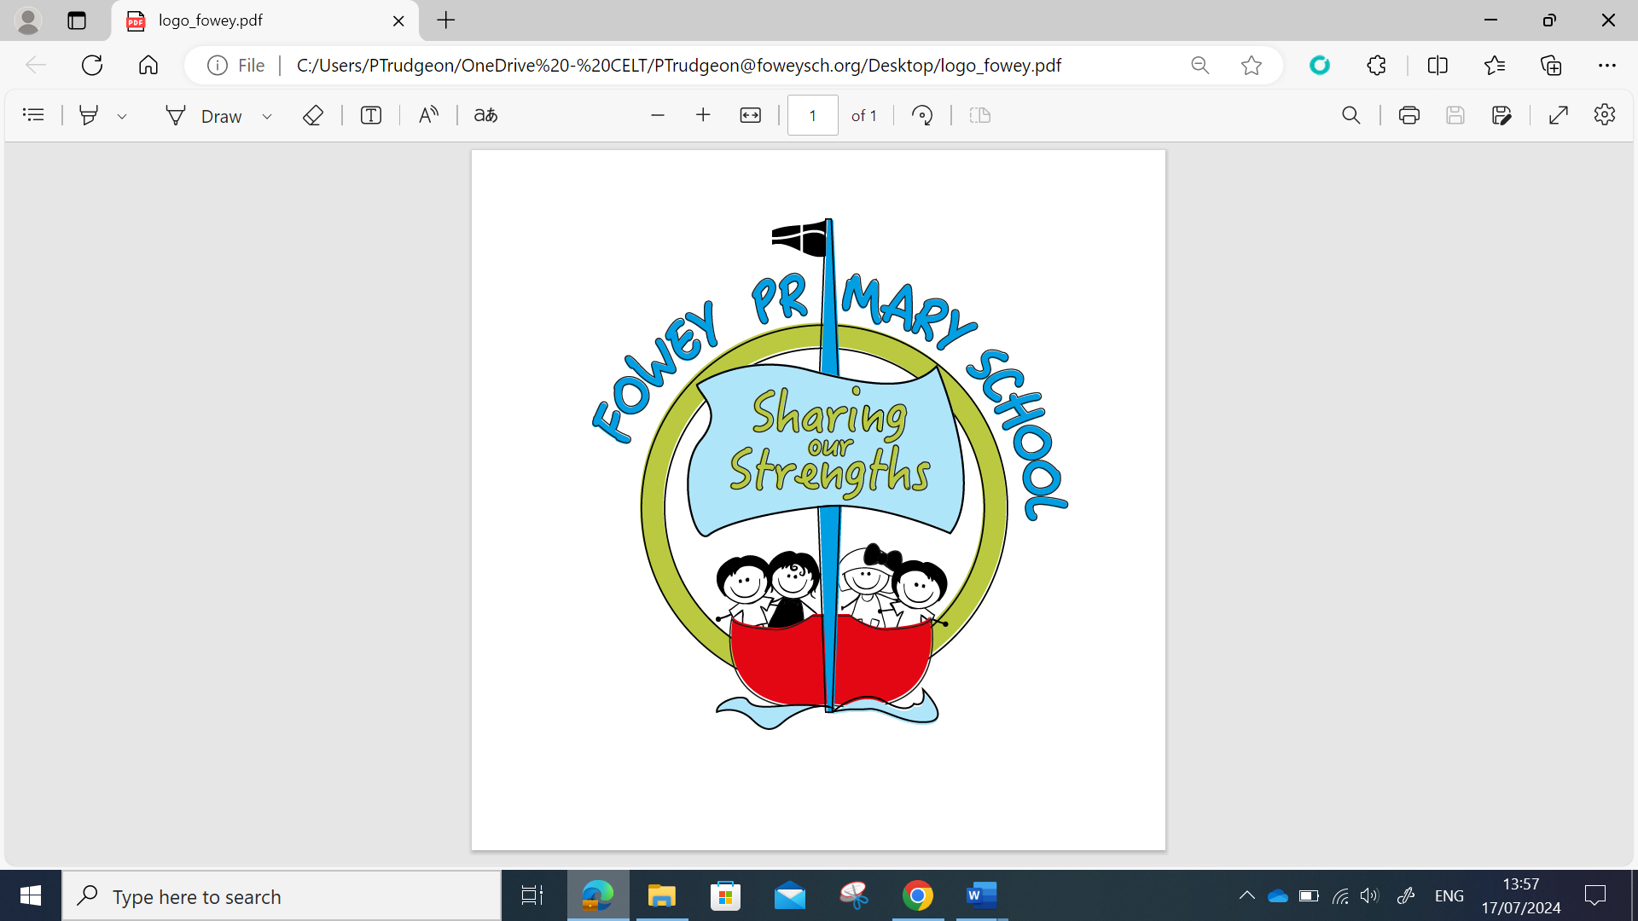 | Year 3 Autumn MTP
 | Week 1 | Week 2 | Week 3 | Week 4 | Week 5 | Week 6 | Week 7 | Week 8 | Week 9 | Week 10 | Week 11 | Week 12
Grammar and Punctuation | Ready to Write  What is a noun?  • What is a noun phrase?  • Can you identify the noun phrase in this sentence? | Ready to Write  What is a sentence?  What are the four types of sentences?  • What word types are in this sentence?  • Can you remove the adjective/adverb? Does the sentence still make sense?  • Can you remove the noun/verb? Does the sentence still make sense? | Ready to Write  Different types of sentence  How do you know this is a statement/ question/ exclamation/ command? (Provide examples without  punctuation to give it away).  • Is this a command or an exclamation sentence?  • How could you reorganise the order of words in this sentence to change the sentence type? | Expanding Sentences  What co-ordinating conjunction could you use to join these two sentences together?  • Are there any other co-ordinating conjunctions you could use instead?  • How do you know it is the correct co-ordinating conjunction to use? | Expanding sentences  What subordinating conjunction could you use to join these two sentences together?  • Are there any other subordinating conjunctions you could use instead?  • How do you know it is the correct subordinating conjunction to use? | Commas  What punctuation mark should go between these two adjectives?  • How many commas do you need in this list of items? | Apostrophes  What does this apostrophe symbol mean in this word?  • What two words have been combined to make this contraction? What letters are missing from these words? | Apostrophes  Who belongs to who in this sentence?  • Which word needs an apostrophe to show it owns an item? | Past and Present Tense  Which word is the verb in this sentence?  • Is the verb in the present or past tense? How do you know?  • What is the past form of these regular verbs?  • What is the past form of these irregular verbs? | Assess  Week | Past and Present Tense  What is the present form of ‘to be’?  • What is the past form of ‘to be’?  • What is the present participle of this verb?  • Is this sentence written in the past progressive or present progressive tense? How do you know? | Review miscon Week
Alan Peat  Sentences | Recap Year 2 Sentences |  | Introduction of Year 3 sentences  BOYS sentences, As,ly, Sentences,  Ing ed sentences,  Doubly-ly sentences |  |  | Introduction of Year 3 sentences  BOYS sentences, As,ly, Sentences,  Ing ed sentences,  Doubly-ly sentences |  |  |  | Introduction of Year 3 sentences  BOYS sentences, As,ly, Sentences,  Ing ed sentences,  Doubly-ly sentences
Spelling  Spelling Shed | Week 1-Words where the digraph ‘ou’ makes  an /ow/ sound  Week 2-Words where the digraph ‘ou’ makes a  /u/ sound  Week 3- Words where ‘y’ makes an /i/ sound |  |  | Week 4-Words ending in ‘-sure’  Week 5-Words ending in ‘-ture’  Week 6- Challenge words |  |  | Week 7-Words with the prefix ’re  Week 8-Words with the prefix dis’  Week 9-Words with the prefix ‘mis’ |  |  | Week 10- Words where ‘-ing’, ‘-er’ and ‘-ed’ are added to multisyllabic words.  Week 11-Words where ‘-ing’, ‘-en’ and ‘-ed’ are added to multisyllabic words  Week 12-Challenge Words
Handwriting | The Ladder family  (l, I, u, t, y and j) |  |  |  |  |  | Assess and Review | The One Armed Robot Family  (n, m and h) |  |  |  | Practice and Review
Reading text  VIPERS Foci | The Wind in the Willows  (Rivers) | The Wind in the Willows | The Wind in the Willows | The Wind in the Willows | The Wind in the Willows | The Wind in the Willows | The Iron Man | The Iron Man | The Iron Man | The Iron Man | The Iron Man | The Iron Man
Writing Sequence | Encanto  Setting description  1. Can I orally compose, then write sentences with expanded noun phrases?  2. Can I find nouns, verbs, adjectives, adverbs from a stimulus to describe?  3. Can I propose changes to grammar and vocabulary to improve consistency?  4. Can I generate vocabulary for a setting?  5. Can I draft a setting description? | Encanto  Setting description  1. Can I expand my sentences with effective openers for a setting description?  2. Can I edit my writing (punctuation choices)?  Character Description  3. Can I develop vocabulary and show-not-tell description for characters?  4/5. Can I write my own character description? | Encanto  Complete character descriptions  1.Can I edit and improve my writing?  2.Can I share/perform my writing to others?  Retelling of a scene using speech.  3. Can I identify speech in a conversation (using capitals and punctuation to help) and add inverted commas in the correct place?  4. Can I write speech as direct speech using inverted commas, capitals, reporting clauses, new speaker-new line?  5. Can I write a scene using direct speech using all the required features of direct speech? | Encanto  Retelling of a scene using speech, description and action.  1.Can I write speech and reporting clauses correctly using capitals, punctuation, reporting clauses and inverted commas?  2. Can I write a narrative scene using speech, action and description as well as previous sentence types?  3. Can I edit my own work and others work and make suggestions for improvements?  4. Can I read with fluency and awareness of speech, expression and phrasing? | River- Writing to inform  (Using River talk and Parts of the River from Lit Shed +)  Features of an information text  1.Can I retrieve and record information from non fiction texts?  2.Can I identify the features and structure of an information text?  3. Can I organise related information on a topic?  4.Can I use dictionaries to locate the meanings of technical vocabulary?  5.Can I use prepositional phrases to clarify physical features? | River- Writing to inform  Writing an information text on rivers  1.Can I use similes to specify?  2. Can I discuss and record ideas?  3. Can I plan and write to inform?  4. Can I plan and write to inform?  5.Can I edit my work and use simple organisational features to present my work? | The Iron Man  Writing a Character Description  1.Can I use a range of verbs for character actions?  2.Can I use repetition, similes and personification to describe a character?  3.Can I write sentences using fronted adverbials?  4. Can I use DADWAVERS to support my character descriptions?  5.Can I write a character description?  6.Can I edit and improve my writing?  Writing a Narrative Scene  1.Can I organise paragraphs around a theme?  2.Can I discuss and record ideas?  3.Can I plan the opening of a narrative?  4.Can I write the opening paragraphs of a narrative?  5. Can I compose and rehearse sentences orally, progressively building a varied and rich vocabulary and an increasing range of sentence structures?  6.Can I edit and improve my writing?  7.Can I share/perform my writing to others? |  |  | Explanations including Assessment week  Identifying features of explanation texts  Using causal conjunctions  1.Can I identify differences between explanation, instruction and information texts?  2. Can I identify the features of an explanation text?  3. Can I verbally explain a process?  4. Can I use impersonal language for effect?  5. Can I identify appropriate fronted adverbials?  6.Can I use conjunctions to indicate cause and effect?  7. Can I effectively introduce a topic?  8. Can I organise paragraphs around a theme?  9.Can I use organisational features to support the reader?  10. Can I edit and evaluate my writing?
Writing Outcomes | Write a setting description  Write a character description |  | Writing a scene description using speech |  | Writing to inform  Write own information text on rivers |  | Character description  Narrative of the Iron Man arriving. |  |  | Writing to explain  Explanation text on Mountain formation

