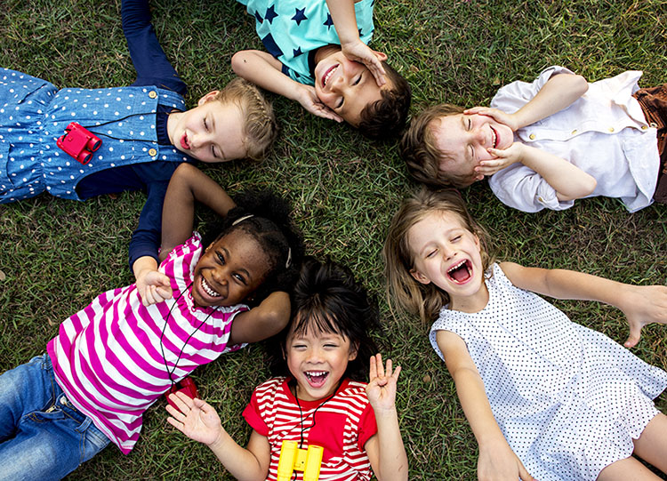

**Understanding the World**

Through story time, play and circle time, we will share information about ourselves, our experiences and our family.

We will know where we live and where we go to school. We can explore our immediate environment and express some signs of Autumn. We will walk around our school grounds to spot signs of Autumn and use this in our art work.

**Autumn 1**

**All About Me!**

**Physical Development**

We will be able to build spatial awareness, positional awareness negotiating space and obstacles safely.

We will practice movement skills such as rolling, crawling, walking, jumping, running, hopping, skipping and climbing through PE and play.

We will build core strength through sitting at carpet time on the floor and develop our small motor skills so that we can use a range of tools safely.

In the making area, we will explore using pencils for drawing and writing, and mark make using a paintbrush, fingers and other mark making tools.

We will also be able to practice fine motor skills using tweezers threading, and playdough.

**Personal, Social and Emotional Development**

This half term, through ‘We Thinkers’ discussions, circle time can talk about feelings (happy, sad, angry). We will choose what I need to complete a goal in play.

We will learn to play purposefully with equipment, play cooperatively and can seek out companionship. Through story time sessions, we can start to talk about the way we feel.

We are showing an awareness of rules and how to behave in the classroom. We are starting to become more confident when things are new and follow instructions around the classroom.

**Communication and Language**

This half term, we will be practising skills such as listening to other in small groups, using talk to pretend in our play, using talk to recall past experiences and retelling events. We will use circle time opportunities and partner talk throughout the day, so we can share our thoughts and ideas.

We will use story time at lunch and home time, where we will listen to familiar stories with increasing attention and recall, join in with repeated refrains and anticipate key events and phrases in rhymes and stories.

We will practice using prepositions such as under, on top, behind by carrying out an action and responding to instructions.

**Expressive Arts and Design**

This half term we will be exploring what we can see and hear.

We will notice, look, wonder and talk about what we can see and hear. We will play in the Making Area and the Mud Kitchen to create and explore different textures and materials.

We will use our knowledge of Autumn to create Autumn inspired artwork. We will complete self-portraits using an array of different materials to represent ourselves.

**Literacy**

We will learn to read the first 16 sounds from Read, Write Inc. We will be on the lookout for some print, such as the first letter of our name, a bus or door number or logo. We will spot the letters we know in the books we share around our classroom and on our displays.

We will learn how to read individual letters by saying the sounds for them.

We will enjoy sharing books with adults and other children, asking questions and making comments about the story.

We will be practising name writing and make marks on our pictures to represent our names and other parts of the picture that we want to give meaning to.

We will do ‘finger fit’ activities to make our fingers and hands strong for writing. We will enjoy drawing freely in the ‘message centre’ and at the ‘making table’. We will teach our sounds to other children in ‘small school’.

**Mathematics**

Through our ‘Winning with Number’ maths, we will be learning how to recognise up to 3 objects, without having to count them individually.   This half term, we will recite numbers to 5 and have a go at verbally counting up to 10. We will say one number for each item in order: 1,2,3,4,5 and recall the total from the last number said. We will begin to recognise numerals to 3.

We will match and sort objects into groups using vocabulary such as same and different. We will compare amounts by spotting more, fewer and the most.