Discovering One: Why is the sea salty?

Lantic and Cannis (EYFS and Y1) Autumn 2020
What should I already know? Year One Children  - Where would the wind take me? Ocean habitats and how the wind moves different vessels around the world  - Layers within the sea (sea bed, rocks, sand, water)- sea habitat in a bottle  - Ocean dance and movement exploration  Materials and their Properties- boat making  - Identify and name a variety of everyday materials, including wood, plastic, glass, metal, water, and rock  - Describe the simple physical properties of a variety of everyday materials  - Compare and group together a variety of everyday materials on the basis of their simple physical properties (floating and sinking).  - Exploring a sailing boat. | Key Knowledge  Living things and their habitats  Different types of Animals  Fish are cold blooded, live in water, they use gills to breathe and fins for movement.  Amphibians start out as larvae living in water and breathing through their gills, they undergo metamorphosis to become adults that live on land, breathing with their lungs. Amphibians have smooth, moist and permeable skin, allowing them to breathe through their skin.  Reptiles have a backbone, which means they are vertebrates. Most reptiles lay hard-shelled eggs, but a few give birth to live young. All reptiles have scales. Reptiles are ectothermic or cold-blooded, which means they cannot control their own body temperature.  Birds (have feathers and wings. They are warm-blooded, which means that their body is always the same temperature, and they lay eggs. Unlike humans, birds have bones that are hollow on the inside (think of a straw). This makes their bones extremely light and helps them to fly.)  Mammals have hair or fur- but in some animals this is only present before they are born!, mammary glands which they use to feed their young, a hinged jaw, three tiny ear bones. Most mammals give birth to live young.  Carnivores are animals who can only eat meat- examples include crocodiles, lizards, eagles, wolves and bears.  Herbivores can only eat plant-based materials e.g. cow, rabbit, goat, deer, locust and camel.  Omnivores can eat both plant and animal-based materials e.g. pigs, bears civets, squirrels, mice and chipmunks.  Dead, Alive or Never Living  Things that are alive need water, air and food to survive (e.g. animals and plants)  Things that are dead used to be alive but have now died (e.g. leaves, wooden materials, feathers, fossils).  Things that have never been living have never needed these things (e.g. plastic or metal objects).  Animals and their Habitats  A habitat is the natural home of an animal or plant.  Different animals and plants prefer different habitats. For example, a frog prefers a wet, dark home whereas a bird might prefer a dry home high in a tree. Animals often choose their habitats because they meet lots of their basic needs (e.g. food and shelter).  All the animals and plants in one habitat often work together.  Identify and name a variety of plants and animals in their habitats, including microhabitats (streams and rock-pools)
Key Vocabulary
Key Term | Definition
habitat | The natural home of a plant or animal
salt water | Sodium chloride in the sea makes it salty
fresh water | Water which is not salty and so is safe to drink
hydrometer | An instrument for measuring the density of liquids
evaporation | The process of turning liquid into vapour
minerals | Substances that are formed naturally in rocks and in the ground
food chain | A series of plants and animals each of which serves as food for the one above it in the chain
water cycle | The process by which water falls to the ground as rain and snow, rungs into rivers and lakes, flows into the sea, evaporates into the air and forms clouds and then falls to the ground again.

Scientific Skills

- asking simple questions and recognising that they can be answered in different ways
- observing closely, using simple equipment (using a hydrometer to test salt levels in different water samples)
- performing simple tests (using evaporation to see how different samples of water change over time and what is left when the water evaporates
- using their observations and ideas to suggest answers to questions
- gathering and recording data to help in answering questions identifying and classifying different animals and different habitats

Humans and their basic needs

find out about and describe the basic needs of animals, including humans, for survival (water, food and air).

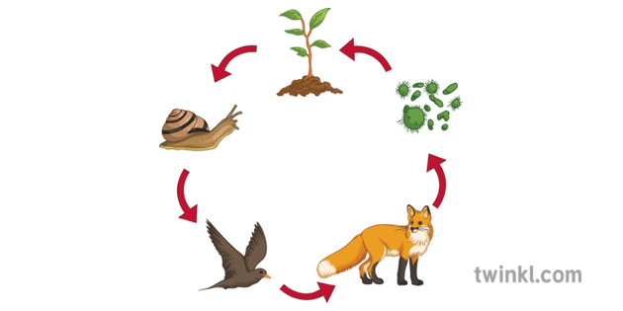

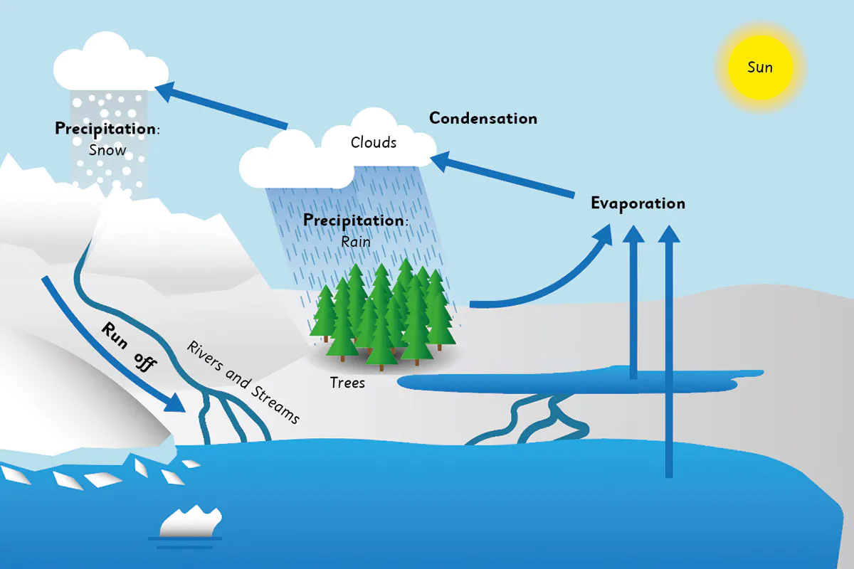
Scientific Processes  Describe how animals obtain their food from plants and other animals, using the idea of a simple food chain, and identify and name different sources of food.  Describe how water is recycled in the water cycle including the different roles of rivers, streams and the ocean.  Understand how the sun plays a key role in both food chains and the water cycle. | Key Experiences  Visit to beach and local rivers  Visit from Padstow Lobster Hatchery?  Visit to SeaLife Centre- Plymouth  Talk from Fowey Harbour team about our local river and estuary  Detailed study of a rockpool  Growing crystals  Animal Visit (Mark’s Ark?)

