FOWEY PRIMARY WHOLE SCHOOL WRITING PROGRESSION DOCUMENT
In all year groups, we use texts and experiences such as: picture books, novel studies, immersive sensory experiences and real-life experiences from visits in and out of school. In addition, writing links are sometimes made to other subject areas within the curriculum. The class teacher will choose a writing purpose linked to a specific outcome.
Children consider the purpose of their writing before exploring the success criteria for their finished pieces. Examples from texts are used to model and support teaching. Vocabulary around the unit outcome is used to supplement high-level teaching at word-level, with children encouraged to use this in their written work. Each individual teacher is responsible for the planning of writing for their class in line with the National Curriculum expectations and the following progression documents.
Planning is completed based on the needs of the children within the class and the next steps that are needed within their learning.
The structure of a unit and lessons is based on the following stages:
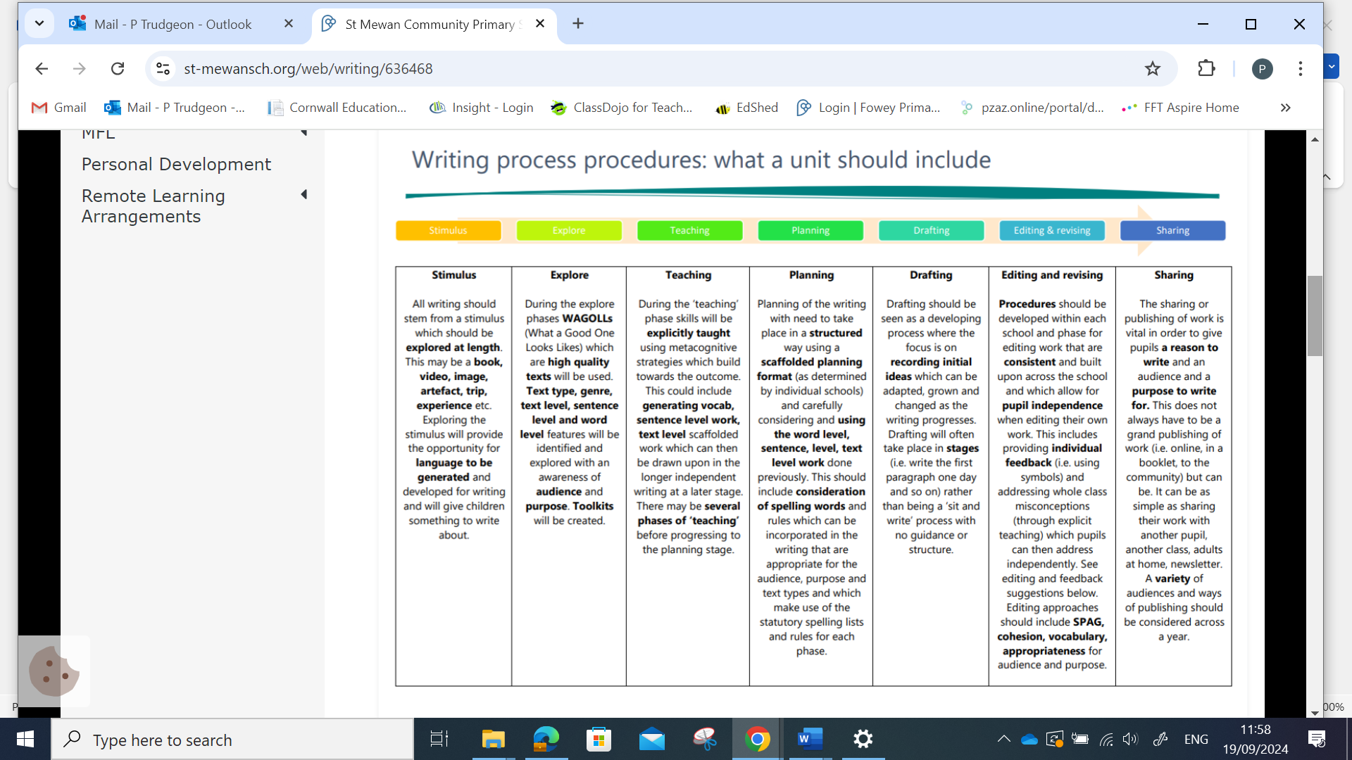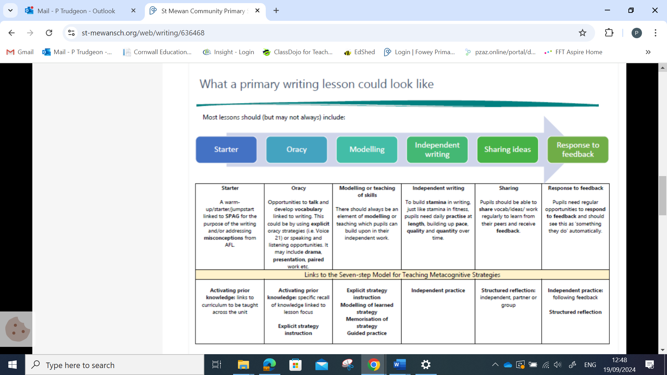

Letter formation / Handwriting
EYFS | Year 1 |  | Year 2 |  |  | Year 3 |  | Year 4 |  | Year 5 | Year 6
In addition to the previous year’s objectives, children know how to:
- Hold a pencil effectively in preparation for fluent writing using the tripod grip in almost all cases  - Write recognisable letters most of which are correctly formed | - sit correctly at a table, holding a pencil comfortably and correctly.  - continue to develop  - tripod grip of a pencil/pen.  - write some lower case and capital letters of the alphabet in the correct direction, starting and finishing in the right place.  - form digits 0-9. |  | - sit correctly at a table, holding a pencil comfortably and correctly.  - master the tripod grip of a pen/pencil.  - form lower case letters of the correct size, relative to one another.  - use spacing between words that reflects the size of the letters.  - use the diagonal and horizontal strokes needed to join letters.  - write capital letters and digits of the correct size, orientation and relationship to one another and to lower case letters.  - begin to use the diagonal and horizontal strokes needed to join letters |  |  | - Increase the legibility, consistency and quality of handwriting, e.g.: by ensuring that down strokes of letters are parallel and equidistant;  - lines of writing are spaced sufficiently so that the ascenders and descenders of letters do not touch. |  | - Use the diagonal and horizontal strokes needed to join letters and understand which letters, when adjacent to one another, are best left not joined.  - Continue to Increase the legibility, consistency and quality of handwriting, eg: by ensuring that down strokes of letters are parallel and equidistant; that lines of writing are spaced sufficiently so that the ascenders and descenders of letters do not touch. |  | - confidently use diagonal and horizontal joining strokes when writing independently to increase fluency.  - begin to choose a standard of handwriting which is appropriate for a particular task, e.g. quick notes or a final handwritten version. | - choose a standard of handwriting which is appropriate for a particular task, e.g. quick notes or a final handwritten, presented version.  - choose the writing implement which is best suited for a task  - Maintain legibility in joined handwriting when writing at speed
Planning, drafting and editing
EYFS |  | Year 1 | Year 2 |  | Year 3 |  | Year 4 |  | Year 5 |  |  | Year 6
In addition to the previous year’s objectives, children know how to:
- Retell a story or narrative using their own words after it has been read for them  - Anticipate key events in stories  - Use new vocabulary that they’ve heard in stories, non- fiction, rhymes and poems  - Make comments about what they have heard and ask questions to clarify their understanding |  | - compose a sentence orally before writing.  - Say a sentence out loud before writing it – oral rehearsal.  - sequence sentences to form short narratives.  - read their writing to check that it makes sense to themselves and to an adult.  - to begin to independently make a change to their writing so that they make their writing better.  - Develop storylines in pretend play  - Express ideas and feelings about experiences using full sentences | - write narratives about personal experiences and those of others (real and fictional).  - plan what they are going to write about, including writing down ideas and/or key words and new vocabulary eg: bubble maps  - sequence what they want to say sentence by sentence.  - make simple additions, revisions and corrections to their own writing by evaluating their writing with the teacher and other pupils  - read to check that their writing makes sense and that the correct tense is used throughout with the help of an adult where necessary.  - check for errors in spelling, grammar and punctuation with an adult |  | - use ideas from their own reading and modelled examples to plan their writing.  - begin to proofread their own and others’ work to check for errors (with increasing accuracy) and to make improvements –purple editing pens introduced  - organise their writing into paragraphs around a theme (e.g. 3 paragraphs – beginning middle and end). |  | - compose and rehearse sentences orally (including dialogue), progressively building a varied and rich vocabulary and an increasing range of sentence structures.  - consistently organise their writing into paragraphs around a theme to add cohesion and to aid the reader.  - proofread and amend their own and others’ writing, correcting errors in grammar, punctuation and spelling and adding nouns/ pronouns for cohesion using purple editing pens. |  | - plan their writing by identifying the audience for and purpose of the writing, selecting the appropriate form and using other similar writing as models for their own.  - consider, when planning narratives, how authors have developed characters and settings in what pupils have read, listened to or seen performed and use these as a basis for structuring their own writing.  - proofread work to précis (edit and shorten) longer passages by removing unnecessary repetition or irrelevant details.  - link ideas across paragraphs using cohesive devices.  - proofread their work to assess the effectiveness of their own and others’ writing, making corrections and improvements with purple pens |  |  | - note down and develop initial ideas, drawing on reading and research where necessary.  - use appropriate organisational and presentational devices to structure text and to guide the reader (e.g. headings, bullet points, underlining).  - use a wide range of devices to build cohesion within and across paragraphs.  - consistently proofread for spelling and punctuation errors.  - make changes to vocabulary, grammar and punctuation to enhance effects and clarify meaning. recognise how words are related by meaning as synonyms and antonyms and to use this knowledge to make improvements to their writing.
Audience, Purpose and Structure
EYFS | Year 1 |  | Year 2 | Year 3 |  |  | Year 4 |  |  | Year 5 |  | Year 6
In addition to the previous year’s objectives, children know how to:
- Begin and end their sentences (orally before writing)  - Sometimes consider who they are writing for eg writing a note or labelling a picture for family/school  - Consider the occasion for their writing eg to make a list for a party, write invitations | - use a number of simple features of different text types and to make relevant choices about subject matter and appropriate vocabulary choices.  - begin to write for different purposes:  - poetry, instructions, letter  - start to engage readers in stories and news telling by using adjectives to describe. |  | - write for different purposes with an awareness of an increased amount of fiction and non-fiction structures.  - use new vocabulary from their reading, their discussions about it (one- to-one and as a whole class) and from their wider experiences.  - read aloud what they have written with appropriate intonation to make the meaning clear  - use similes within their writing, knowing how these can help create images and clarity for the reader | - demonstrate an  increasing understanding of purpose and audience  - by discussing writing similar to that which they are planning to write in order to understand and learn from its structure, vocabulary and grammar.  - use the structure of a wider range of text types (including the use of simple layout devices in non-fiction).  - make deliberate, ambitious word choices to add detail.  - create settings, characters and plot in narratives.  - begin to use dialogue to convey a character. |  |  | - write a range of narratives and nonfiction pieces using a consistent and  - appropriate structure (including genre specific layout devices eg: text boxes, bullet points etc)  - write a range of narratives that are well- structured and well-paced.  - create detailed settings, characters and plot in narratives to engage the reader and to add atmosphere.  - use dialogue to convey a character and to start to advance the action. |  |  | - produce sustained and accurate writing from different narrative and non-fiction genres with appropriate structure, organisation and layout devices for a range of audiences and purposes.  - describe settings, characters and atmosphere with carefully- chosen vocabulary to enhance mood, clarify meaning and create pace.  - use dialogue to convey a character and to advance the action.  - perform their own compositions confidently using  - appropriate intonation, volume and movement so that meaning is clear.  - Use figurative language (including metaphors and personification) to add more detail and to improve description |  | - write effectively for a range of purposes and audiences, selecting the appropriate form and drawing independently on what they have read as models for their own writing (including literary language, characterisation, structure, etc.).  - distinguish between the language of speech and writing and to choose the appropriate level of formality.  - select vocabulary and grammatical structures that reflect what the writing requires (e.g. using contracted forms in dialogues in narrative; using passive verbs to affect how information is presented; using modal verbs to suggest degrees of possibility).
Sentence Structure (Including punctuation and grammar)
EYFS | Year 1 |  | Year 2 | Year 3 |  |  | Year 4 |  |  | Year 5 |  | Year 6
In addition to the previous year’s objectives, children know how to:
- Articulate their ideas and thoughts in well-formed sentences  - Express their ideas and feelings about their experiences using full sentences | - use simple sentence structures that are accurately  - Articulate their ideas and thoughts in well-formed sentences Write short sentences using a capital letter and full stop trying to leave spaces between words  - Express their ideas and feelings about their experiences using full sentences, including use of past, present and future tenses with modelling and support from the teacher  - Connect one idea to another making use of conjunctions, with modelling and support from the teacher  - punctuated with a capital letter and a full stop.  - use simple conjunctions (and, but) to link ideas in sentences.  - form simple compound sentences.  - use capital letters for names, places, the days of the week and the personal pronoun ‘I’.  - use finger spaces.  - use full stops to end sentences.  - use question marks and exclamation marks. |  | - use the present tense and the past tense mostly correctly and consistently.  - form sentences with different forms: statement, question, exclamation, command.  - use co-ordination (or/and/but).  - use some subordination (when/if/ that/because).  - use expanded noun phrases to describe and specify (e.g. the blue butterfly).  - use the full range of punctuation taught at key stage 1 mostly correctly including:  - capital letters, full stops, question marks and exclamation marks; commas to separate lists;  - Apostrophes to mark singular possession and contractions | - maintain the correct tense (including the present perfect tense) throughout a piece of writing with accurate subject/verb agreement.  - use ‘a’ or ‘an’ correctly throughout a piece of writing.  - use simple conjunctions confidently and accurately.  - use subordinate clauses, extending the range of sentences with more than one clause by using a wider range of conjunctions, including when, if, because, and although.  - use a range of conjunctions, adverbs and prepositions to show time, place and cause.  - use the full range of punctuation from previous year groups.  - Punctuate direct speech (using inverted commas) |  |  | - maintain an accurate tense throughout a piece of writing.  - use Standard English verb inflections accurately, e.g. ‘we were’ rather than ‘we was’ and ‘I did’ rather than ‘I done’.  - use subordinate clauses, extending the range of sentences with more than one clause by using a wider range of conjunctions, which are sometimes in varied positions within sentences.  - Use expanded noun phrases with the addition of ambitious modifying adjectives and prepositional phrases, e.g. the heroic soldier with an unbreakable spirit.  - consistently choose nouns or pronouns appropriately to aid cohesion and avoid repetition.  - Use all the necessary punctuation in direct speech, including a comma after the reporting clause and all end punctuation within the inverted commas  - Consistently use apostrophes for the singular and plural possession  - To use a colon and semi colon for lists |  |  | - use a range of adverbs and modal verbs to indicate degrees of possibility, e.g. surely, perhaps, should, might, etc.  - ensure the consistent and correct use of tense throughout all pieces of writing.  - use a range of conjunctions accurately, varying the position within the sentence.  - use a wide range of linking words/phrases between sentences and paragraphs to  - build cohesion, including time adverbials (e.g. later), place adverbials (e.g. nearby) and number (e.g. secondly).  - use relative clauses beginning with a relative pronoun with confidence.  - to use the passive voice.  - Use commas consistently to clarify meaning and avoid ambiguity  - Use brackets, dashes or commas to indicate parenthesis  - Use a colon or semi colon in lists to separate clauses |  | - ensure the consistent and correct use of tense throughout all pieces of writing, including the correct subject and verb agreement when using singular and plural.  - use the subjunctive form in formal writing.  - use the perfect form of verbs to mark relationships of time and cause.  - use the passive voice accurately within appropriate pieces.  - use the full range of punctuation taught at key stage 2 correctly, including consistent and accurate use of semi colons, dashes, hyphens, colons, and when necessary, to use such punctuation  - precisely to enhance meaning and avoid ambiguity
Pupils consolidate and build on previous years grammatical terms
EYFS | Year 1 | Year 2 | Year 3 | Year 4 | Year 5 | Year 6
- Sound  - Letter  - Capital letter  - Finger space  - Full stop | - Letter  - Capital letter  - Word  - Singular noun  - Plural noun  - Sentence  - Full stop  - Question mark  - Exclamation mark | - Noun  - Noun phrase  - Question  - Exclamation  - Command  - Suffix  - Adjective  - Verb  - Adverb  - Conjunction  - Consonant  - Vowel | - Preposition  - Prefix  - Clause  - Subordinate clause  - Direct speech  - Inverted commas (speech marks)  - Ellipsis  - Bullet point | - Determiner  - Pronoun  - Possessive pronoun  - Adverbial phrase  - Synonym  - Antonym  - Reporting clause | - Modal verb  - Relative pronoun  - Relative clause  - Parenthesis  - Brackets  - Dash  - Cohesion  - Commas for clarity | - Subject  - Object  - Active  - Passive  - Hyphen  - Colon  - Semi-colon

Phonics & Whole word Spelling Rules
EYFS | Year 1 | Year 2 | Year 3 | Year 4 | Year 5 | Year 6
In addition to the previous year’s objectives, children know how to:
- To continue a rhyming string.  - To hear and say the initial sound in words.  - To segment the sounds in simple words and blend them together.  - To link sounds to letters, naming and sounding the letters of the alphabet.  - To use their phonic knowledge to write words in ways which match their spoken sounds. | - To know all letters of the alphabet and the sounds which they most commonly represent.  - To recognise consonant digraphs which have been taught and the sounds which they represent.  - To recognise vowel digraphs which have been taught and the sounds which they represent.  - To recognise words with adjacent consonants.  - To accurately spell most words containing the 40+ previously taught phonemes and GPCs.  - To spell some words in a phonically plausible way, even if sometimes incorrect.  - To apply Y1 spelling rules and guidance*, which includes the sounds on the Y1 exemplification document | - To segment spoken words into phonemes and to represent these with graphemes, spelling many of these words correctly and making phonically-plausible attempts at others.  - To recognise new ways of spelling phonemes for which one or more spellings are already known and to learn some words with each spelling, including some common homophones (e.g. bare/ bear, blue/ blew, night/ knight).  - To apply further Y2 spelling rules and guidance*, see Year 2 exemplification document | - To spell words with the / eɪ/ sound spelt ‘ei’, ‘eigh’, or ‘ey’ (e.g. vein, weigh, eight, neighbour, they, obey).  - To spell words with the /ɪ/ sound spelt ‘y’ in a position other than at the end of words (e.g. mystery, gym).  - To spell words with a /k/ sound spelt with ‘ch’ (e.g. scheme, chorus, chemist, echo, character). To spell words ending in the /g/ sound spelt ‘gue’ and the /k/ sound spelt ‘que’ (e.g. league, tongue, antique, unique).  - To spell words with a / sh/ sound spelt with ‘ch’ (e.g. chef, chalet, machine, brochure). To spell words with a short /u/ sound spelt with ‘ou’ (e.g. young, touch, double, trouble, country).  - To spell words ending with the /zher/ sound spelt with ‘sure’ (e.g. measure, treasure, pleasure, enclosure).  - To spell words ending with the /cher/ sound spelt with ‘ture’ (e.g. creature, furniture, picture, nature, adventure). | - To spell words with / shuhn/ endings spelt with ‘sion’ (if the root word ends in ‘se’, ‘de’ or ‘d’, e.g. division, invasion, confusion, decision, collision, television).  - To spell words with a / shuhn/ sound spelt with ‘ssion’ (if the root word ends in ‘ss’ or ‘mit’, e.g. expression, discussion, confession, permission, admission).  - To spell words with a / shuhn/ sound spelt with ‘tion’ (if the root word ends in ‘te’ or ‘t’ or has no definite root, e.g. invention, injection, action, hesitation, completion).  - To spell words with a / shuhn/ sound spelt with ‘cian’ (if the root word ends in ‘c’ or ‘cs’, e.g. musician, electrician, magician, politician, mathematician). To spell words with the /s/ sound spelt with ‘sc’ (e.g. sound spelt with ‘sc’  - (e.g. science, scene, discipline, fascinate, crescent). | - To spell words with endings that sound like / shuhs/ spelt with -cious (e.g. vicious, precious, conscious, delicious, malicious, suspicious).  - To spell words with endings that sound like / shuhs/ spelt with –tious or -ious (e.g. ambitious, cautious, fictitious, infectious, nutritious).  - To spell words with ‘silent’ letters (e.g. doubt, island, lamb, solemn, thistle, knight).  - To spell words containing the letter string ‘ough’ (e.g. ought, bought, thought, nought, brought, fought, rough, tough, enough, cough, though, although, dough, through, thorough, borough, plough, bough). | - To spell words ending in -able and -ably (e.g. adorable/ adorably, applicable/ applicably, considerable/ considerably, tolerable/ tolerably).  - To spell words ending in -ible and -ibly (e.g. possible/possibly, horrible/horribly, terrible/ terribly, visible/ visibly, incredible/ incredibly, sensible/ sensibly).  - To spell words with a long /e/ sound spelt ‘ie’ or ‘ei’ after ‘c’ (e.g. deceive, conceive, receive, perceive, ceiling) and exceptions (e.g. protein, caffeine, seize).  - To spell words with endings which sound like /shuhl/ after a vowel letter using ‘cial’ (e.g. official, special, artificial).  - To spell words with endings which sound like /shuhl/ after a vowel letter using ‘tial’ (e.g. partial, confidential, essential).

Common Exception Words
 | Year 1 | Year 2 | Year 3 | Year 4 | Year 5 | Year 6
In addition to the previous year’s objectives, children know how to:
- To write some irregular common words. | - To spell most common exception words correctly.  - To spell days of the week correctly. | - To write some irregular common words.  - To spell days of the week correctly.  - To spell all Y1 and Y2 common exception words correctly. | - To spell many (50%-75%) of the Y3 and Y4 statutory spelling words correctly. | - To spell all of the Y3 and Y4 statutory spelling words correctly. | - To spell many (50%-75%) of the Y5 and Y6 statutory spelling words correctly. | - To spell all of the Y5 and Y6 statutory spelling words correctly
Prefixes and Suffixes
EYFS | Year 1 | Year 2 | Year 3 | Year 4 | Year 5 | Year 6
In addition to the previous year’s objectives, children know how to:
- Add s for a plural  - Add ed for past tense eg I played on the swing | - To use -s and -es to form regular plurals correctly.  - To use the prefix ‘un-’ accurately. To successfully add the suffixes –ing, –ed, –er and –est to root words where no change is needed in the spelling of the root words (e.g. helped, quickest). | - To add suffixes to spell most words correctly in their writing, e.g. –ment, –ness, –ful, –less, –ly | - To spell most words with the prefixes dis-, mis-, bi-, re- and de- correctly (e.g. disobey, mistreat, bicycle, reapply, defuse).  - To spell most words with the suffix -ly with no change to the root word; root words that end in ‘le’,‘al’ or ‘ic’ and the exceptions to the rules.  - To spell words with added suffixes beginning with a vowel (-er/-ed/- ing) to words with more than one syllable (unstressed last syllable, e.g. limiting offering).  - To spell words with added suffixes beginning with a vowel (-er/-ed/- en/-ing) to words with more than one syllable (stressed last syllable, e.g. forgotten beginning). | - To correctly spell most words with the prefixes in-, il-, im-, ir-, sub-, super-, anti-, auto-, inter-, ex- and non- (e.g. incorrect, illegal, impossible, irrelevant, substandard, superhero, autograph, antisocial, intercity, exchange, nonsense).  - To form nouns with the suffix -ation (e.g. information, adoration, sensation, preparation, admiration).  - To spell words with the suffix -ous with no change to root words, no definitive root word, words ending in ‘y’, ‘our’ or ‘e’ and the exceptions to the rule (e.g. joyous, fabulous, mysterious, rigorous, famous, advantageous) | - To convert nouns or adjectives into verbs using the suffix -ate (e.g. activate, motivate communicate).  - To convert nouns or adjectives into verbs using the suffix -ise (e.g. criticise, advertise, capitalise).  - To convert nouns or adjectives into verbs using the suffix -ify (e.g. signify, falsify, glorify). To convert nouns or adjectives into verbs using the suffix -en (e.g. blacken, brighten, flatten). | - To use their knowledge of adjectives ending in -ant to spell nouns ending in -ance/-ancy (e.g. observant, observance, expectant, hesitant, hesitancy, tolerant, tolerance, substance).  - To use their knowledge of adjectives ending in -ent to spell nouns ending in -ence/-ency (e.g. innocent, innocence, decent, decency, frequent, frequency, confident, confidence, obedient, obedience, independent).  - To spell words by adding suffixes beginning with vowel letters to words ending in -fer (e.g. referring, referred, referral, preferring, preferred, transferring, transferred, reference, referee, preference, transference).
Further Spelling Conventions
EYFS | Year 1 | Year 2 | Year 3 | Year 4 | Year 5 | Year 6
In addition to the previous year’s objectives, children know how to:
- To use initial and final sounds to read words they’ve written. | - To spell simple compound words (e.g. dustbin, football).  - To read words that they have spelt.  - To take part in the process of segmenting spoken words into phonemes before choosing graphemes to represent those. | - To spell more words with contracted forms, e.g. can’t, didn’t, hasn’t, couldn’t, it’s, I’ll.  - To learn the possessive singular apostrophe (e.g. the girl’s book).  - To write, from memory, simple sentences dictated by the teacher. | - To spell some more complex homophones and near-homophones, including here/hear, brake/break and mail/ male.  - To use the first two or three letters of a word to check its spelling in a dictionary. | - To spell words that use the possessive apostrophe with plural words, including irregular plurals (e.g. girls’, boys’, babies’, children’s, men’s, mice’s).  - To use their spelling knowledge to use a dictionary more efficiently. | - To spell complex homophones and near- homophones, including who’s/whose and stationary/stationery.  - To use the first three or four letters of a word to check spelling, meaning or both of these in a dictionary. | - To spell homophones and near homophones that include nouns that end in -ce/-cy and verbs that end in -se/-sy (e.g. practice/ practise, licence/license, advice/ advise).  - To spell words that contain hyphens (e.g. coordinate, re-enter, co- operate, co-own).

