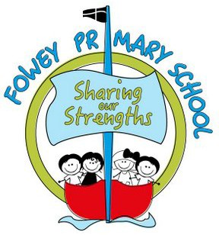

Science
at Fowey Primary School

Policy Agreed:
Policy Review Date:

Contents
- Curriculum Statement
- Teaching and Learning
- Assessment
- Planning and Resources
- Organisation
- EYFS and KS1
- KS2
- Equal Opportunities
- Inclusion
- Role of the Subject Leader

  - Curriculum Statement

Intent
The national curriculum for science aims to ensure that all pupils:
    - develop scientific knowledge and conceptual understanding through the specific disciplines of biology, chemistry and physics.
    - develop understanding of the nature, processes and methods of science through different types of science enquiries that help them to answer scientific questions about the world around them.
    - are equipped with the scientific knowledge required to understand the uses and implications of science, today and for the future.

At Fowey Primary School, we recognise the importance of Science in every aspect of daily life. As one of the core subjects taught in Primary Schools, we give the teaching and learning of Science the prominence it requires.
Science teaching at Fowey involves adapting and extending the curriculum to match all pupils’ needs. Where possible, science is linked to class Imaginative Learning Projects (ILPs), but is taught as discrete units and lessons where needed to ensure full curriculum coverage.
Science in our school is about fostering pupils’ ideas and ways of working, enabling them to make sense of the world in which they live through investigation, as well as using and applying processing skills. At Fowey pupils are exposed to high-quality teaching and learning experiences which allow them to understand how science can be used to explain what is occurring, predict how things will behave, and analyse cause and effect. The curriculum is designed to ensure pupils acquire key scientific knowledge through practical experiences; using equipment, conducting experiments, building arguments and explaining concepts confidently. They are immersed in scientific vocabulary, which aids pupils’ knowledge and understanding, not only of the topic they are studying but, of the world around them. We intend to provide all children with a broad, balanced, exciting and enticing science curriculum.

Implementation
To ensure high standards of teaching and learning in Science at Fowey, we implement a Science curriculum that is progressive throughout the school; building on prior skills and knowledge year on year. We use the PZAZ scheme, providing teachers with the appropriate scientific knowledge and resources to plan and deliver excellent science lessons.
Existing knowledge is checked at the beginning of each unit and relevant links made to the new class ILP. This ensures that teaching is informed by the pupils’ starting points and takes account of pupil voice - incorporating pupil interests.
Each topic must have elements that challenge the “Thinking Scientifically” part of the curriculum and
builds a variety of enquiry skills.
During Key Stage 1 pupils observe, explore and ask questions about living things, materials and physical phenomena. They begin to work together to collect evidence to help them answer questions and to link this to simple scientific ideas. They begin to evaluate evidence and use reference materials

to find out more about scientific ideas. They share ideas and communicate them using scientific language, drawings, charts and tables, with the help of ICT if it is appropriate.
At Key Stage 2 pupils learn about a wider range of living things, materials and physical phenomena. They make links between ideas and explain things using simple models and theories. They apply their knowledge and understanding of scientific ideas to familiar phenomena, everyday things and their personal health. They think about the effects of scientific and technological developments on the environment and in other contexts. They carry out more systematic investigations, working on their own and with others. Pupils use a range of reference sources in their work. They talk with confidence about their work and its significance, using a wide range of scientific language, conventional diagrams, charts and graphs, with the help of ICT if it is appropriate.

Impact
An active approach to science at Fowey School results in a fun, engaging, high-quality science education, that provides pupils with the foundations for understanding the world. Our engagement with the local environment ensures that pupils learn through varied and first-hand experiences of the world around them.
The impact and measure of this ensures pupils not only acquire the appropriate age-related knowledge linked to the science curriculum, but also skills which equip them to progress from their starting points, and within their everyday lives.
By the time they leave Fowey School, all pupils will have gained a wide variety of skills linked to both scientific knowledge and understanding as well as scientific enquiry/investigative skills. In addition, they will have acquired a rich vocabulary enabling them to articulate their understanding of taught concepts with high aspirations for themselves to study further should they choose, work and lead a successful adult life.
Subject Leader monitoring has shown:
- Pupils enjoy working scientifically and apply their skills and knowledge independently
- Pupils of all abilities feel success in science lessons
- Pupils benefit from practical lessons – this impacts positively on their use and understanding of a wide range of high-quality vocabulary and scientific concepts
- Pupils talk with passion about science and the world around them
- Teachers plan lessons that meet the needs of all learners
- Teachers are secure in their subject knowledge
Impact of science at Fowey School is carefully tracked and measured by…
- Termly triangulated monitoring of pupils’ science outcomes in workbooks.
- Termly learning walks to monitor science teaching – successes and feedback given to teachers.
- Pupil conferencing explicitly linked to science.

Teaching and Learning
At Fowey School, Science is taught by individual class teachers, and takes place within the classroom or, in our ever-developing outdoor areas. Science at our school, regularly involves pupils in practical work through small group activities as well as whole class. Teaching methods are wide ranging and include whole class teaching, experimental learning, discovery methods, problem solving, open ended investigations, or a mixture of these. At Fowey, there is a belief that pupils learn best through enquiry-based learning, although we recognise there is a shift in learning style as they progress through the school from Reception to Year 6.
We recognise that in every class, pupils have a wide range of scientific abilities, and we ensure that we provide suitable learning opportunities for all pupils by matching the challenge of the task to the ability of the pupil. We achieve this in a variety of ways:
    - setting tasks which are open-ended and can have a variety of responses.
    - setting tasks of increasing difficulty.
    - grouping pupils by ability within the room and setting different tasks for each ability group where appropriate.
    - carefully grouping pupils in mixed ability groups where appropriate.
    - providing resources of different complexity, matched to the ability of the pupil.
    - using teaching assistants to support the work of individual pupils or groups.
    - incorporating high order questions that apply to scientific thinking and extending the most able in science.
Furthermore, pupils are encouraged to ask their own questions and to be given opportunities to use their scientific skills and research to discover the answers. Curiosity is celebrated within each classroom.
Teachers ask a range of questions which enable all pupils to take part in lessons, listening carefully to answers and moving learning forward. They use both open and closed questions and allow time to think.
Teachers use precise questioning in class to test conceptual knowledge and skills, and assess pupils regularly to identify those with gaps in learning, so that all pupils ‘keep up’.
New vocabulary and challenging concepts are introduced through direct teaching and this progresses throughout the school.
Working Scientifically skills are embedded in lessons and these ensure skills are developed throughout the pupils’ school career. The key knowledge for each ILP/unit and across each year group is mapped into the science progression map.

Assessment
Pupils are assessed continually throughout the year, with the teacher giving feedback orally, through marking children’s work and verbally. Children review their work each lesson against ‘I can…’ statements. Achievement of these is then verified by the teacher, with reference to the outcomes of work and responses during lesson. These, as well as regular assessment tasks, inform teachers’ completion of termly reports to parents.

Planning and Resources
Fowey school has adopted the PZAZ scheme, to provide teachers with the support materials required to ensure science is taught with accuracy and confidence. Each unit is resourced with a powerpoint presentation which is adapted to suit the MCS format and the individual needs of the class. This includes: a lesson plan; an instructional video demonstrating all the experiments taught; knowledge organisers; assessment materials and a skills map. The scheme also provides a range of materials that can be used across the key stages such as information about scientists and lists of complimentary literature.
Teachers plan on a proforma consistent with the whole school teaching and learning policy and the objectives of planning in science are as follows:
    - To set clear achievable learning objectives for pupils.
    - To ensure work is matched to pupils’ capabilities, experience and interest.
    - To ensure progression, continuity and subject coverage is systematic throughout the school.
    - To ensure there are a range of scientific investigations taught.
    - To plan assessment opportunities throughout units of work.
    - To provide criteria for the monitoring and evaluation of teaching and learning.
Curriculum planning in science is carried out in three phases (long-term, medium-term and short-term). The long-term plans map the scientific topics studied in each term during the key stage. Sometimes these do not fit neatly into school terms and are therefore supplemented by a 36 week plan so that it is clear to teachers how curriculum is covered over the academic year. Medium-term plans give further detail and lesson objectives are provided by the subject leader who ensures that all statutory requirements of the national curriculum are covered. The class teacher is responsible for expanding the medium-term plans to produce short-term plans. Topics in science are planned so that they build upon prior learning. We ensure opportunities for all ability groups to develop skills and knowledge throughout each unit. Re- visiting, reinforcement and extension of learning is also built into the Science scheme of work, so that pupils are increasingly challenged as they move through the school.

Skills development
Effective science teaching should develop the key scientific skills of:
    - Hypothesising and predicting.
    - Planning and carrying out investigations.
    - Observing and measuring.
    - Presenting results by appropriate means, including use of ICT.
    - Evaluating results and drawing conclusions.
Effective science teaching should also contribute to the cross curricular skills of:
    - Discrimination
    - Enquiry
    - Reasoning
    - Creative thinking
    - Evaluation
    - Problem solving
    - Communication
    - Collaboration
    - Manipulation

Organisation
Science will be taught by the class teacher weekly from year 1 through to year 6 for the duration of at least an hour. In EYFS science content is taught through the ‘Understanding the World’ strand of the curriculum.
A weekly science club is provided after school which is open to all KS2 pupils. Pupils have the opportunity to explore scientific phenomena in fun and practical ways as well as in a less formal environment and a smaller group.

EYFS and KS1
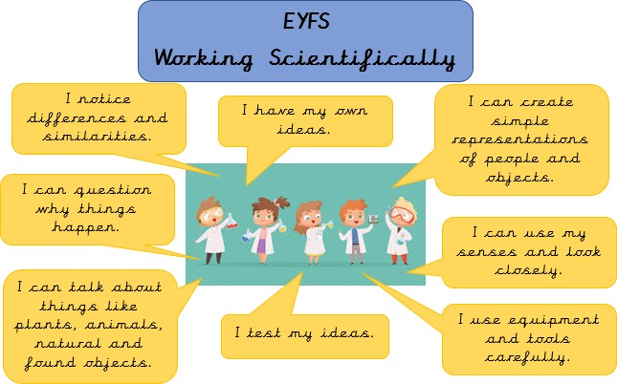

The Foundation Stage deliver science content through the ‘Understanding of the World’ strand of the EYFS curriculum. This involves guiding pupils to make sense of their physical world and their community through opportunities to explore, observe and find out about people, places, technology and the environment. They are assessed according to the Development Matters attainment targets.

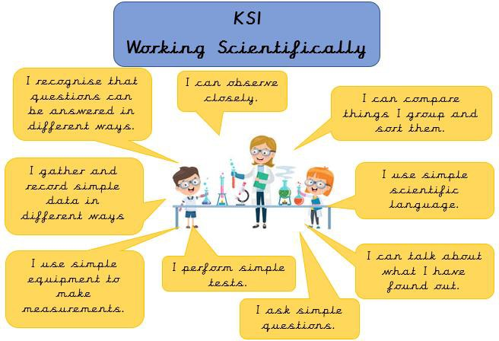

The principal focus of science teaching in key stage 1 is to enable pupils to experience and observe phenomena, looking more closely at the natural and humanly-constructed world around them. They should be encouraged to be curious and ask questions about what they notice. They should be helped to develop their understanding of scientific ideas by using different types of scientific enquiry to answer their own questions, including observing changes over a period of time, noticing patterns, grouping and classifying, carrying out simple comparative tests and finding things out using secondary sources of information. They should begin to use simple scientific language to talk about what they have found out and communicate their ideas to a range of audiences in a variety of ways. Most science learning should be carried out through the use of first-hand practical experiences and there should also be some use of appropriate secondary sources, such as books, photographs and videos.
‘Working scientifically’ is described separately in the programme of study but must always be taught thoroughly and clearly related to the teaching of substantive science content in the programme of study.
Pupils should read and spell scientific vocabulary at a level consistent with their increasing word reading and spelling knowledge at key stage 1.

KS2
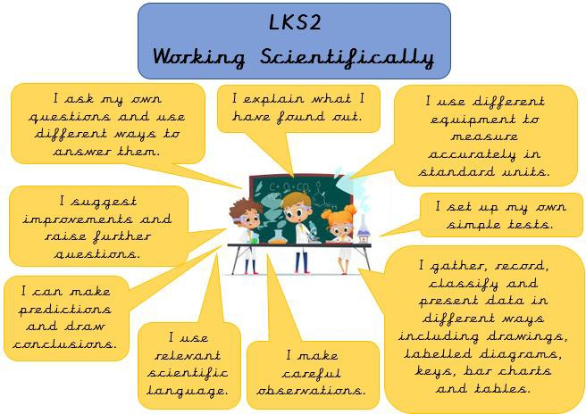

The principal focus of science teaching in lower key stage 2 is to enable pupils to broaden their scientific view of the world around them. They should do this through exploring, talking about, testing and developing ideas about everyday phenomena and the relationships between living things and familiar environments and by beginning to develop their ideas about functions, relationships and interactions. They should ask their own questions about what they observe and make some decisions about which types of scientific enquiry are likely to be the best ways of answering them, including observing changes over time, noticing patterns, grouping and classifying, carrying out simple comparative and fair tests and finding things out using secondary sources of information. They should draw simple conclusions and use some scientific language, first, to talk about and, later, to write about what they have found out.
‘Working scientifically’ is described separately in the programme of study but must always be taught thoroughly and clearly related to the teaching of substantive science content in the programme of study.
Pupils should read and spell scientific vocabulary correctly and with confidence using their growing word reading and spelling knowledge.

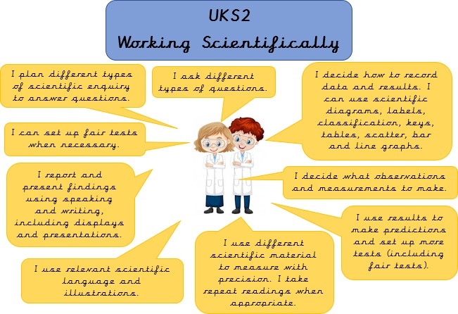

The principal focus of science teaching in upper key stage 2 is to enable pupils to develop a deeper understanding of a wide range of scientific ideas. They should do this through exploring and talking about their ideas; asking their own questions about scientific phenomena; and analysing functions, relationships and interactions more systematically. At upper key stage 2, they should encounter more abstract ideas and begin to recognise how these ideas help them to understand and predict how the world operates. They should also begin to recognise that scientific ideas change and develop over time. Pupils should select the most appropriate ways to answer questions using different types of scientific enquiry, including observing changes over different periods of time, noticing patterns, grouping and classifying, carrying out comparative and fair tests and finding things out using a wide range of secondary sources of information. Pupils should draw conclusions based on their data and observations, use evidence to justify their ideas, and use their scientific knowledge and understanding to explain their findings.
‘Working scientifically’ is described separately in the programme of study but must always be taught thoroughly and clearly related to the teaching of substantive science content in the programme of study.
Pupils should read, spell and pronounce scientific vocabulary correctly.

Equal Opportunities
At Fowey we are committed to promoting equal opportunities irrespective of socioeconomic background, gender, disability and ethnicity in all areas of the curriculum. We believe all pupils should have access to and participation in the learning of science and to be supported in this process.

Inclusion
At Fowey School, we are committed to providing all pupils with an equal entitlement to scientific activities and opportunities regardless of race, gender, culture or class.
In school we aim to meet the needs of all pupils by differentiation in our science planning and by providing a variety of approaches and tasks appropriate to all learners. This involves providing opportunities for pupils with SEND to complete own projects with support, to develop speech and language skills as well as scientific skills and knowledge. This will enable pupils with learning and/or physical difficulties to take an active part in scientific learning and practical activities and investigations as well as achieve the goals they have been set. Some pupils will require closer supervision and more adult support to allow them to progress whilst more able children will be extended through differentiated activities that challenge and extend. When presented with a greater level of challenge it is the intention that more able pupils will progress to a higher level of knowledge and understanding realising their potential. Teachers will ensure that a range of strategies are used which include and motivate all learners; ensuring that optimum progress is made throughout each part of the lesson.

Role of the Subject Leader
The leadership of the science curriculum is the responsibility of the subject leader who:
- ensures the school has an effective science curriculum for staff to follow. They ensure staff new to the school, including ECTs understand the science curriculum and how to deliver it effectively;
- supports colleagues in their teaching by keeping them informed in current developments in science primary education;
- writes a subject action plan, informed by the whole school improvement plan;
- carries out triangulated monitoring to identify strengths across the school, CPD priorities and inform action planning;
- delivers and/or sources appropriate training for staff;
- tracks progress across the school with particular emphasis on identified target pupils;
- leads planning, preparation and effective execution of world science day and/or STEAM events;
- ensures science resources required to deliver effective class teaching, are looked after and updated/replaced as necessary.
- plays an active role in the Trust primary science group and ensures content is disseminated to staff.
Policy Agreed: Autumn 2022 Policy Review Date: Autumn 2023

