**Year 5 Autumn**

**Science:**

**Properties and changes of materials**

**Intent: To identify different materials and to be able to identify changes of state, both reversible and irreversible.**

**Sequence of lessons:**

1. **To discuss the irreversible change that takes place during burning.**
2. **To classify substances as acid, alkali or neutral.**
3. **Can I demonstrate that dissolving, mixing and changes of state are reversible changes?**
4. **Can I understand that some materials will dissolve in liquid to form a solution?**
5. **Can develop a knowledge of solids, liquids and gases to decide how mixtures might be separated?**
6. **Can I compare and group together everyday materials on the basis of their properties?**

**Key Vocabulary: Thermal, electrical, insulator, conductor, change of state, mixture, dissolve, solution, soluble, insoluble, filter, sieve, reversible, change, irreversible, change, burning, rusting, new material, pure, impurity**

**Impact:**

**Children understand the importance and significance of the story of Rama and Sita to Hindus.**

**Impact:**

**Children can describe the journey of a river from source to mouth. They can describe the stages of the water cycle.**

**Impact:**

**Children can describe change/continuity in Ancient Egypt.**

**RE**

**A Hindu Story: Rama and Sita**

**Intent: To consider the story of Rama and Sita and what it means to Hindu people.**

**Sequence of lessons:**

1. **An ancient story.**
2. **Four sons for the King of Ayodhya.**
3. **Rama and Sita leave the kingdom.**
4. **Rama, Sita and the demon Ravana.**
5. **Rama and Sita return.**
6. **Understanding the story of Rama and Sita.**

**Key Vocabulary: Hinduism, believers, Ramayana, Lakshmana., kingdom, Vishnu, embodiment, decree, hanuman, Diwali.**

**Geography:**

**Rivers**

**Intent: To discover the River Indus - its source, course, human interactions with environment. Know how rivers get their water - the source, springs, the water cycle.**

**Sequence of lessons:**

1. **The mighty River Indus.**
2. **The changing River Indus.**
3. **How rivers get their water.**
4. **How a river shapes the land: the young river.**
5. **How a river shapes the land: the mature river.**
6. **Britain’s longest river: the River Severn.**

**Key Vocabulary: mountain, Tibet, mountain range, Himalayas, glaciers, monsoon, tributaries, riverbed, dams, reservoirs, canals, irrigation, turbine, hydro-electric, spring, source, water cycle, surface run off, evaporation, transpiration**

**History: Ancient Egypt**

**Intent: To identify location and origin in settlements around the Nile. Know how the power structures (pharaohs, the double crown) were linked to the geography of Egypt. Understand how Ancient Egypt changed over time.**

**Sequence of lessons:**

1. **The Importance of Howard Carter’s discovery.**
2. **How did the Ancient Egyptians live?**
3. **How did Ancient Egypt change over time?**
4. **What did Ancient Egyptians believe?**
5. **What did Ancient Egyptians believe about death?**
6. **How did the Ancient Egytians write?**

**Key Vocabulary: archaeologist, excavate, tomb, pharoah, hieroglyphics, civilization, papyrus, cartouche, embalm**

**Year 5 Autumn**

**Impact:**

**Children can group materials based on their properties using more complex vocabulary. What thermal and electrical insulators are, as well as conductors.**

**PE: Gymnastics**

**Intent: In this unit pupils develop their understanding of the attacking and defending principles of invasion games. In all games activities, pupils have to think about how they use skills, strategies and tactics to outwit their opponents.**

**Sequence of lessons:**

1. **To explore different passes and apply them to different situations.**
2. **To develop movement skills to lose a defender in different situations.**
3. **To communication with my team, move into space and the ball towards goal.**
4. **To defend an opponent and know when to try to intercept.**
5. **To develop the shooting action under pressure.**
6. **To use and apply skills, principles and tactics to a game situation.**

**Key Vocabulary: defence, attacking, invasion, communication, honesty, tactics**

**Art/DT**

**Intent:**

**Explore the purpose of the space race era, combining drawing and collagraph print making to create a futuristic image.**

**Sequence of lessons:**

1. **Can I explore the purpose and effect of imagery?**
2. **Can I understand and explore decision making in creative processes?**
3. **Can I develop drawn ideas through printmaking?**
4. **Can I test and develop ideas using sketchbooks?**
5. **Can I apply an understanding of drawing processes to revisit and improve ideas?**

**Key Vocabulary: cold war, collagraph, composition, culture, decision, evaluate, futuristic, printing plate, repetition, Retrofuturism, revisit, space race, stimulus. technique**

**Impact:**

**To make sure all children feel that they have a sense of self and knowhow they fit in.**

**PSHE**

**Getting to know each other**

**Intent: To develop an understanding of who I am and how I fit in.**

**Sequence of lessons:**

1. **Can I help others feel welcome?**
2. **Can I try to make our school community a better place?**
3. **Can I think about everyone’s right to learn?**
4. **Can I show that I care about other people’s feelings?**
5. **Can I work well with others?**
6. **Can I follow our learning charter?**

**Key Vocabulary: opportunities, motivation, appreciation, refugee empathise, prejudice, participation, persecution, conflict, migrant, challenges, wealthy privilege deprive,**

**Computing: Coding**

**Intent:**

**To understand how alternative planning allows us to build ideas and how coding can effect changes that happen.**

**Sequence of lessons:**

1. **Can I review and simplify code to make a playable game?**
2. **Can I understand what a simulation is and program one?**
3. **Can I explainwhat decomposition and abstraction are in Computer Science?**
4. **Can I use friction and understand what a function is?**
5. **Can I understand what the different variable types are and how they are used differently?**
6. **Can I begin to explore text variables when coding?**

**Key Vocabulary: algorithms, debug, decomposing, execute, program, sequence, simulating, variables,**

**Impact:**

**Children can play a fair and tactical netball game.**

**Impact:**

**Children can create their own artwork by making a collagraph, printing and then designing their space inspired artwork.**

**Impact:**

**Children know how to build and code their own ideas.**

**Year 5 Autumn**

**Music**

**Composition notation**

**Intent:**

**Based on the theme of Ancient Egypt, children learn to identify the pitch and rhythm of written notes and experiment with notating their compositions, developing their understanding of staff notation.Sequence of lessons:**

1. **Sing with accuracy, fluency, control and expression**
2. **To explore and use different forms of notation.**
3. **To understand note length**
4. **To read simple pitch notation**
5. **To use hieroglyphs and stave notation to write a piece of music**

**Key Vocabulary:**

**Accuracy, backing track, balance, composition, control, crotchet, dotted minim, ensemble, expression, fluency**

**MFL**

**French**

**Intent:**

**Reviewing noun gender, article-noun agreement and adjective placement while exploring monster and body part vocabulary; identifying key facts using cognates and other language detective skills; writing and presenting paragraphs about a ‘Fantastic French beast’ creation.**

**Sequence of lessons:**

1. **To investigate a text for clues to understand new words.**
2. **To identify nouns by their gender, number and meaning.**
3. **To apply knowledge of French nouns and gender agreement to a short piece of writing.**
4. **To perform a finger rhyme in French**
5. **To apply knowledge of vocabulary and grammar to a piece of writing.**

**Key Vocabulary:** **le corps, la tête, la bouche, le nez, les yeux**

**Maths**

**Power Maths and White Rose are used to support our teaching of Maths.**

**Children will be developing their understanding of Place Value within 1,00,000.**

**They will then move on to Addition and Subtraction strategies, estimating answers and looking at inverse operations, before tackling problem solving techniques.**

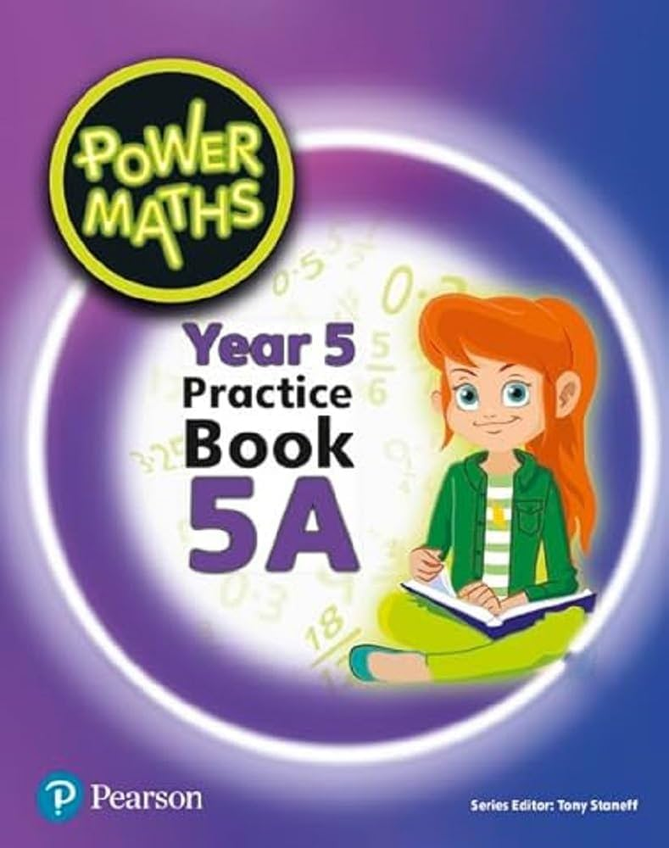

**English**

**Year 5 will be using the text ‘Holes by Louis Sachar,’ for the Autumn term.**

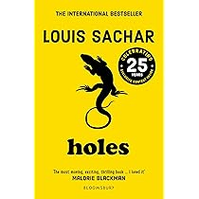

**This term, they will be completing a fantasy narrative unit based around the short clip ‘Day of the Dead.’**

**They will then be writing a shorter descriptive narrative based on the book ‘The Viewer.’**

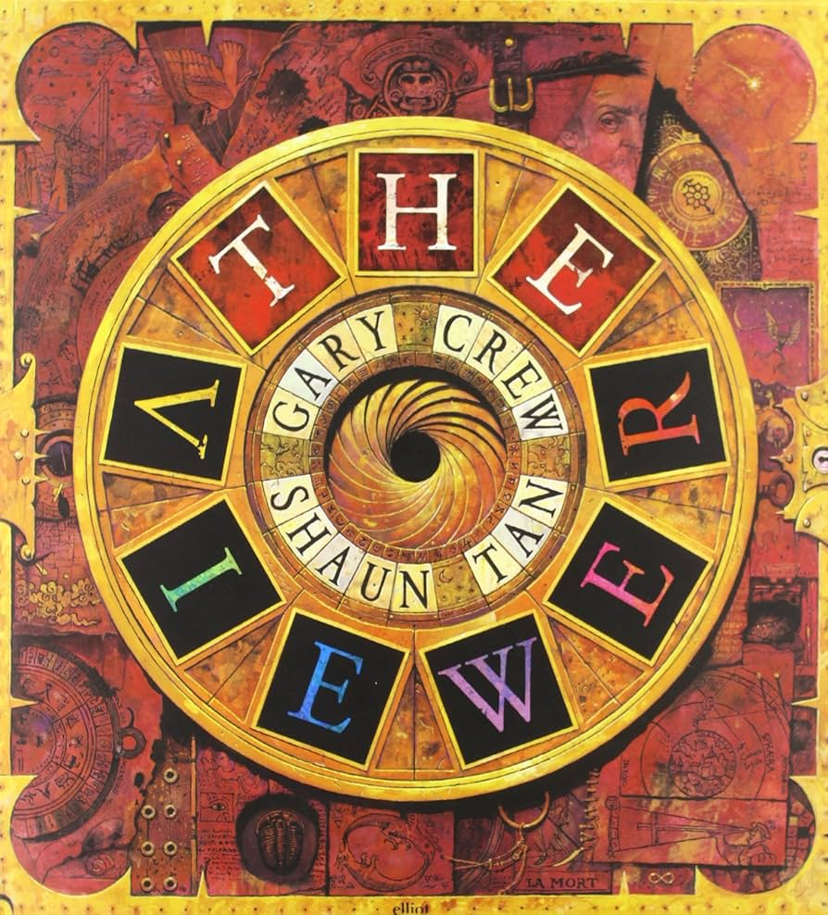

**Key Vocabulary:**

**Impact:**

**Children can sing using different note length and with accuracy, fluency and expression. They can sing following pitch notation.**

**Impact:**

**Children can apply their knowledge of grammar and vocabulary to compose a piece of French writing.**