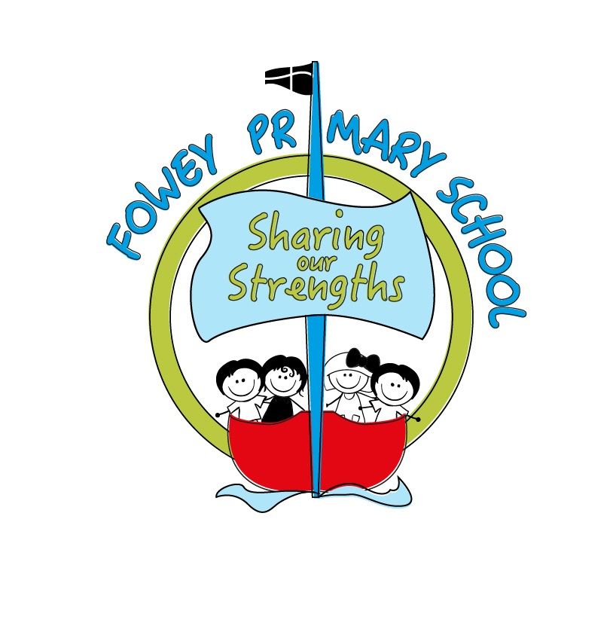

 | EYFS and Year One | Year 2 and Year 3 | Upper KS2
History
(pink objectives are explicitly taught in Geography lessons)
Understanding Chronology | Begin to understand that time is passing and the differences between events that are happening now and events that have happened in the past (Art 1).  Put significant events in their lives in order.  Begin to understand the concepts of distant past, recent past and present.  Beginning to think about the impact of historical events/people. | Order events within a project.  Understand the order in which different historical events studied happened using a simple ‘broad strokes’ approach and relating these to events within children’s own memory (e.g. understand and explain that the stone age happened before the great fire of London, which happened before the COVID 19 epidemic).  Give examples of how things have changed in this time. | Understand the order in which different historical events studied happened using nuanced language and talk about how changes have impacted history (e.g. explain the differences in homes lived in by people in the Indus Valley, those in ancient Egypt and those in Cornwall in the Industrial Revolution).  Understand that different areas of the world were very different at different points in history.  Talk in depth about their project in relation to other historical events and the impact of these, linking to modern day.
Using sources | Use primary sources by talking to people (first-hand accounts), photographs and visits.  Ask questions to find out more about People or photographs.  Give your own opinions and ideas. | Use primary sources by talking to people, looking at artefacts in museums, visiting and examining archaeological sites (Bath for the Romans and Carn Euny/Chysauster for Iron/Bronze age studies) and paper based secondary sources (e.g. books).  Offers opinions and facts with some reasoning.  Distinguishing between fact and opinions and given reasons.  Understand that history is made up of an interpretation of different sources. | Understanding the difference between primary and secondary sources.  Use primary sources in context (both in school and on visits) and complete research on the internet to identify more secondary and primary source material.  Compare historical sources and suggest the validity of these.  Describe what we need to make a source reliable.  Check information with different sources- especially online.  Use a variety of reliable sources to gain a deeper understanding of history.
Historical Enquiry | Ask questions to find out more information.  Who? Where? When? Why? | Answer simple questions relating to the project.  Children pose own questions to gain a greater understanding of a historical source or artefact.  Identify significant events within a historical period (e.g. when the Romans came to Britain) and think about how these events affected Britain at this time. | Generate purposeful questions.  Begin to use questions to understand significant events.  Identify significant events, make connections, identify contrasts and trends
Analyse significant people/events in history | Talk simply about why something has happened showing their understanding (e.g. explain why the great fire of London spread or why Florence Nightingale and Edith Cavell had to make changes to healthcare).  Explorers Francis Drake and journeys from Plymouth and Christopher Columbus (Geography 2)  Talk about what we have learned or how these events/changes impact us now. | Explore a particular event and how it affected people at the time (drought in the Indus Valley).  Question why something happened and how it impacted people. | Question why something happened and how it impacted people long term.  A detailed study of a particular famous person and their historical legacy from at least two different points of view (Richard Trevithick and the Industrial Revolution).

Geography
(yellow objectives are explicitly taught in maths lessons, green objectives are explicitly taught in science lessons)
 | EYFS and Year One | Year 2 and Year 3 | Upper KS2
Locational Knowledge | Know that the world is made up of land and water.  Know that countries have a capital city and that ours is called London.  Name and locate the world’s seven continents and five oceans  Name, locate and identify characteristics of the four countries of the UK and the location of London and Cornwall. Locate Fowey on a map of Cornwall and the place where you live. | Locate at least five countries, using maps to focus on Europe (including the location of Russia) and North and South America  Name and locate the countries of the UK and their capital cities, the counties of Cornwall, Devon and two others. Identify the seas surrounding the UK. | Locate the world’s countries, using maps to focus on Europe (including the location of Russia) and North and South America, concentrating on their environmental regions, key physical and human characteristics, countries, and major cities  Name and locate counties and cities of the United Kingdom, geographical regions and their identifying human and physical characteristics, key topographical features (including hills, mountains, coasts and rivers), and land-use patterns; and understand how some of these aspects have changed over time  Identify the position and significance of latitude, longitude, Equator, Northern Hemisphere, Southern Hemisphere, the Tropics of Cancer and Capricorn, Arctic and Antarctic Circle, the Prime/Greenwich Meridian and time zones (including day and night)
Place Knowledge | Understand geographical similarities and differences through studying the human and physical geography of a small area of the United Kingdom (Fowey) and of a small area in a contrasting non-European country (Ushuaia, Chile- link with Francis Drake and Straits of Magellan). | Understand geographical similarities and differences through the study of human and physical geography of a region of the United Kingdom, a region in a European country (Northern Italy) and a region within South America (Mexico or Guatamala)
Human and Physical Geography | Identify seasonal and daily weather patterns in the United Kingdom and the location of hot and cold areas of the world in relation to the Equator and the North and South  Poles  Use basic geographical vocabulary to refer to:  key physical features, including: beach, cliff, coast, forest, hill, mountain, sea, ocean, river, soil, valley, vegetation, season and weather  key human features, including: city, town, village, factory, farm, house, office, port, harbour and shop (Science 1) | Describe and understand key aspects of physical geography, including: climate zones, biomes and vegetation belts, rivers, mountains, volcanoes and earthquakes, and the water cycle (Science 2 and 4) | Human geography, including: types of settlement and land use, economic activity including trade links, and the distribution of natural resources including energy, food, minerals and water
Geographical Skills and Fieldwork | Use world maps, atlases and globes to identify the United Kingdom and its countries, as well as the countries, continents and oceans studied at this key stage  Use simple compass directions (North, South, East and West) and locational and directional language [for example, near and far; left and right], to describe the location of features and routes on a map  Use simple fieldwork and observational skills to study the geography of their school and its grounds and the key human and physical features of its surrounding environment. | Use maps, atlases, globes and digital/computer mapping to locate countries and describe features studied  Use the eight points of a compass, four and six-figure grid references, symbols and key (including the use of Ordnance Survey maps) to build their knowledge of the United  Kingdom and the wider world  Use aerial photographs and plan perspectives to recognise landmarks and basic human and physical features; devise and use a simple map, construct basic symbols in a key | Use fieldwork to observe, measure, record and present the human and physical features in the local area using a range of methods, including sketch maps, plans and graphs, and digital technologies.

